学校代码： 10246
学 号： 18110740128



博 士 学 位 论 文
（学术学位）

探索生态系统服务在群体共享价值中的位置
Exploring the situatedness of ecosystem services within the shared values of groups
院 系： | 环境科学与工程系
专 业： | 环 境 管 理
姓 名： | CHIKE CHUKWUENYEM EBIDO
指 导 教 师： | Professor Marie K. Harder
完 成 日 期： | 2022年 05月 日

ABSTRACT
Ecosystem services (ESS) are vital for human survival and smooth functioning of biodiversity. The Millennium Ecosystem Assessment reports that the world’s ecosystem services have declined in the past 50 years more than at any other time in human history. This decline underscores the need for accurate valuations and effective management of the world’s ecosystems. Since the revolutionary publication on the value of the world’s ecosystem services in 1997, there have been several initiatives by governments and other agencies to develop systems and frameworks for classification and valuation of ecosystem services including the Millennium Ecosystem Assessment (MEA), The Economics of Ecosystems and Biodiversity (TEEB), the Common International Classification of Ecosystem Services (CICES) among others. These initiatives have been applied at local, national and regional scales. Most of the frameworks recognize 4 categories of ecosystem services – provisioning, regulating, cultural and supporting services – with minor variations.
Most valuation studies of ecosystem services have focused mainly on the economic values of these services by using monetary and market-based measures. Some other studies have also looked at ecological values such as primary productivity, habitat, and food chain value, land cover, species richness etc. However, the social and cultural values of these ecosystems have been understudied and largely neglected in valuation studies. Consequently, more studies have been involved in assessing provisioning and regulating services than cultural services principally because the former are easier to measure and acquire a monetary value than the later. This concentration on monetary valuation of ecosystem services have been severally criticized as an attempt to commodify nature – a concept considered as being opposed to environmental ethics.
This study was designed to contribute to the non-monetary valuation of ecosystem services and is specifically focused on assessing the situatedness of ecosystem services within the shared social values of different groups. The aim of this thesis was to investigate the elicitation and articulation of shared values of different groups in a community and their influence on the valuation of ecosystem services. It explores how ecosystem services are embedded in the culture and values framework of different groups. This study was conducted in Nigeria, Senegal and Indonesia. It utilized a hybrid framework that combined the values-based approach of the WeValue InSitu crystallization process (WVICP) and the analytical framework of the Millennium Ecosystem Assessment (MEA). It also employed focus group discussions to establish the authenticity of the values elicited.
The results of this thesis reveal that ecosystem services are found to exist within the general values frameworks of different groups. This proves that ecosystem service research is context-dependent and should be culturally constructed. It was also shown that the types of values elicited varied across groups and contexts. This indicates that group roles and local contexts have an impact on values types and dimensions. The study further revealed that the three MEA categories (provisioning, regulating and cultural services) of ecosystem services were identified within the values frameworks of the groups involved in this study. It was also observed that some values statements contained characteristics of different ESS categories and were thus classified as hybrids.
These results are significant for several reasons. First, it proposes a new approach to non-monetary valuation of ESS that is non-biased. This ensures authenticity. Secondly, it is an important contribution to integrated valuation because it incorporates different dimensions of values and different domains of life. Thirdly, it is an indication that the WeValue Insitu crystallization process can be applied to other frameworks for the generation of cultural values of ecosystem services in valuation studies. Fourthly, it this approach promises to be very useful in integrating local and indigenous knowledge. This is possible because all the output from the process is entirely produced by the participants and not the facilitators.
The innovations of the study is in the development of a new method for eliciting cultural values of ecosystem services without any biases and also a new way of visually displaying the placement of ecosystem services in the shared values framework of a group in a way that would be helpful for policy makers.
Keywords: Ecosystem services; shared values; situated; valuation; WeValue Insitu crystallization process; classification, framework

中文摘要
生态系统是指环境中生物（生命）和非生物（非生命）维度之间的相互作用，以及影响这些相互作用的因素，而人类从生态系统中获得的利益称之为生态系统服务（ESS）。生态系统服务是生态系统以及构成生态系统的生物多样性维持和实现人类生活的条件和过程（《布劳曼日报》，2017年），它对人类生存和生物多样性的顺利运行至关重要。《千年生态系统评估》报告称，过去50年来，世界生态系统服务的下降幅度超过了人类历史上的任何其他时期。这种下降突显了对世界生态系统进行准确评估和有效管理的必要性。自1997年有关世界生态系统服务价值的革命性出版物发表以来，各国政府和其他机构采取了多项举措，以开发生态系统服务分类和评估的系统和框架，包括千年生态系统评估（MEA），生态系统和生物多样性经济学（TEEB）、国际生态系统服务共同分类（CICES）等。这些倡议已在地方、国家和区域各级得到实施。大多数框架认可4类生态系统服务 -- 供应、调节、文化和支持服务，但不同框架之间的区分差异较小。
大多数生态系统服务价值评估研究主要集中在这些服务的经济价值上，通过使用货币和基于市场的措施。其他有一些研究也关注了生态价值，如初级生产力、栖息地、食物链、土地覆盖、物种丰富度等。然而，生态系统的综合价值在很大程度上被忽视，其社会和文化价值在评估调查中并未得到充分研究。相比于文化服务，评估生态系统供应和调节服务的研究更多，主要是因为后者比前者更容易衡量和获得货币价值。这种对生态系统服务货币估值的关注被批评为试图将自然商品化 -- 这是一种被认为与环境伦理背道而驰的概念。
本研究旨在为生态系统服务的非货币价值评估做出贡献，并特别侧重于评估生态系统服务在不同群体共享社会价值中的位置和处境。本论文旨在调研社区中不同群体价值观的获取和表达及其对生态系统服务价值评估的影响，它探讨了生态系统服务如何嵌入不同群体的文化和价值观框架。本研究包含以下五个具体目标：
1.提供生态系统服务价值的证据（即位于更广泛的群体共享价值范围内）
2.开发一套以获取生态系统服务文化价值的无偏见方法。
3.应用该方法判定尼日利亚东南部不同利益相关者群体对生态系统服务的文化价值观。
4.证明通过该过程得出的关于ESS的共同价值观的真实性。
5.证明标准WeValue审议流程对于明确ESS的本地共享价值的具体有效性。
本研究旨在回答以下调研问题：
- ESS价值是否存在于非环境团体的价值观念范围内？
- 无需催促推动就能成功获取该ESS价值吗？
- 得出的ESS价值是否有效地符合千年生态系统评估的分类类别？
- 引出的价值观是否真实，其真实性能否得到证明？
- WeValue Insitu流程在生态系统服务综合评估中是否有效？
这项研究在尼日利亚、塞内加尔和印度尼西亚进行，调研规模主要以发展中国家的村落和半村落为主要考察区域，研究对象为典型的社会群体，没有专业环境科学家或环境专家组的参与。本研究采用定性研究的方式，用基于价值的模式将WeValue Insitu结晶过程（WVICP）与千年生态系统评估（MEA）的分析框架相结合，搭建一个混合概念框架。还利用焦点小组讨论来评定所引出价值观的真实性。
本文的研究结果表明，生态系统服务普遍存在于不同群体的价值观框架内。这证明了生态系统服务研究应当是基于背景环境的，并且应该从文化的角度进行构建。研究还表明，不同的群体和环境中所引发的价值观类型是不同的，这表明群众角色和当地情景对价值观的类型和维度有所影响。该研究进一步揭示，生态系统服务的三个MEA类别（供应、调节和文化服务）在本研究中所涉及的群体价值观框架内被发现和定义。研究结果还观察到一些包含不同于ESS类别特征的价值观陈述，这些被归类为混合价值观。
本研究对生态系统服务价值的综合评估提供重要贡献。首先，它提出了一种无偏见的ESS非货币式评估价值的新方法，这确保了真实性。其次，它包含不同的价值范围和不同的生活领域，维护了评估的广泛性和全面性。第三，研究证明了WeValue Insitu流程可以被应用于其他研究生态系统服务文化价值的框架。第四，这种方法有望在整合地方和土著知识方面实现高效益，因为调研过程中的所有结论输出都完全由参与者本身而不是促进或组织者生成。
这项研究的创新之处在于建立了一种新方法，可以在没有偏见的情况下获取生态系统服务的文化价值观；与此同时开发一种可以直观地展示生态系统服务在群体共享价值观框架中位置的新模式，从而对决策者有所帮助；本研究中使用的WeValue流程确保了一个综合协调的评估过程，无需经过严密复杂的程序来进行不同的评估和价值汇总，帮助消除评估过程中可能出现的二分化。这是一个可以用来生成不同价值观类别的简单途径，如果被机构采用，预计将节省时间并降低ESS估值成本。
关键词：生态系统服务；共同价值观；混合价值观；位置/处境；评估价值；WeValue Insitu结晶过程；分类；框架；陈述

TABLE OF CONTENTS
ABSTRACT i
中文摘要 iii
TABLE OF CONTENTS v
LIST OF FIGURES xiii
LIST OF TABLES xvi
LIST OF ABBREVIATIONSCHAPTER ONE xvii
CHAPTER ONE 1
INTRODUCTION AND BACKGROUND 1
1.1 Introduction to the Study 1
1.2 Background of the Study 1
1.2.1 Ecosystem Services and Human Wellbeing 2
1.2.2 Valuations – Why Value? 4
1.2.3 The Challenge of Cultural Ecosystem Services (CES) 6
1.2.4 Integrating indigenous and local knowledge (ILK) 7
1.3 Problem Statement 7
1.4 Purpose of the Study 8
1.5 Research Questions 9
1.6 Conceptual Framework 10
1.7 Nature of the Study 11
1.8 Definitions 12
1.9 Scope and Delimitations 14
1.10 Limitations 14
1.11 Significance of the Study 15
1.12 Main Research Content 16
1.13 Innovations of the Study 18
1.14 Road Map Diagram of the Thesis Work Carried Out 20
1.15 Summary 23
CHAPTER TWO 24
LITERATURE REVIEW 24
2.1 Understanding Ecosystem Services 25
2.1.1 Early Works on Ecosystem Services 25
2.1.2 Classification frameworks – MEA, IPBES, CICES, TEEB 26
2.1.3 Ecosystem Services – Provisioning, Regulating, Cultural and Supporting Services 27
2.1.4 Cultural Ecosystem Services (CES) 29
2.1.4.1 Defining Cultural Ecosystem Services 29
2.1.4.2 Characteristics of Cultural Ecosystem Services 32
2.1.4.2.1 Intangibility and Incommensurability 32
2.1.4.2.2 Human co-production 32
2.1.4.2.3 CES are Place-based 32
2.1.4.3 The Challenges of CES Research 33
2.2 Exploring the Needs in Ecosystem Service Research 33
2.2.1 Outstanding challenges to integrating cultural services 33
2.2.2 The need to consider all stakeholders 34
2.3 Localization of Ecosystem Service Research 35
2.3.1 Indigenous and Local Knowledge 35
2.3.2 Situated Knowledge and Practice 36
2.4 Deliberation 37
2.4.1 Deliberation and the Formation of Values 37
2.4.2 Factors That Affect Deliberation 39
2.4.3 Different styles of deliberations 42
2.5 Valuation Pathways 43
2.5.1 Deliberative valuations 44
2.5.1.1 The Deliberative Value Formation (DVF) Model 44
2.6 Values and value types 46
2.6.1 Value Types 46
2.6.2 Values of ecosystem services 47
2.6.2.1 Total Economic Value 47
2.6.2.2 Shared Social Values 50
2.6.2.2.1 How Shared Values are assessed 53
2.6.2.2.2 Current gaps in ESS valuations - Situating ESS in the Values Framework 57
2.6.2.2.3 Our Fresh Approach for ESS 57
CHAPTER THREE 60
METHODOLOGY 60
3.0 Overview 60
3.1 The Need for Qualitative Research 61
3.2 Research Design 62
3.2.1 Study site and Group Choice 64
3.2.2 Preparation of Localized Wevalue Materials 66
3.2.2.1 Key Informant Interviews 66
3.2.2.2 Translation and/or Transcription of the Interview Data 68
3.2.2.3 Development of Local Trigger Lists 68
3.3 Data Collection Methods 69
3.3.1 The Wevalue Insitu Crystallization Process (WVICP) 70
3.3.1.1 Contextualization Stage 71
3.3.1.2 Photo Elicitation Stage 72
3.3.1.3 Triggering and Negotiating Meaning Stage 73
3.3.1.4 Framework Construction and Narrative 74
3.3.2 Focus Groups 74
3.3.2.1 Focus Group 1 – Test for Authenticity 75
3.3.2.2 Focus Group 2 – Perspectives Explorations (PEXs) concerning the Environment 75
3.4 Data Analysis Methods 75
3.4.1 Transcription and Translation of the Qualitative Dataset 76
3.4.2 Thematic Coding of the Qualitative Dataset 76
3.4.3 Classification using the Analytical Framework (Millennium Ecosystem Assessment Framework) 77
3.4.3.1 Cultural Ecosystem Services (CES) 78
3.4.3.1.1 Spiritual and Religious (SPR) 78
3.4.3.1.2 Recreation and Ecotourism (RCR) 79
3.4.3.1.3 Aesthetic (AES) 79
3.4.3.1.4 Inspirational (INSP) 79
3.4.3.1.5 Sense of Place (SOP) 79
3.4.3.1.6 Cultural Heritage (CH) 80
3.4.3.1.7 Cultural diversity & Identity (CDI) 80
3.4.3.1.8 Knowledge systems (KS) 80
3.4.3.1.9 Social relations (SR) 81
CHAPTER FOUR 83
RESULTS 83
4.0 Overview 83
4.1 Situated Shared Values (Values Frameworks and Envelopes plus Narratives) of Village Councilors in Ufuma 84
4.1.1 Village Councilor Group 8 (VC8) 84
4.1.1.1 Value Statements of VC8 86
4.1.1.2 Narratives and Values Statements for VC8 87
4.1.2 Village Councilor Group 9 (VC9) 89
4.1.2.1 Value Statements of VC9 91
4.1.2.2 Narratives and Values Statements for VC9 91
4.1.3 Visual Display of the Situated Shared Values of the remaining Groups of Village Councilors in Ufuma 95
4.1.3.1 Village Councilor Group 1 (VC1) 95
4.1.3.2 Village Councilor Group 2 (VC2) 97
4.1.3.3 Village Councilor Group 3 (VC3) 98
4.1.3.4 Village Councilor Group 4 (VC4) 99
4.1.3.5 Village Councilor Group 5 (VC5) 100
4.1.3.7 Village Councilor Group 7 (VC7) 102
4.1.4 Ecosystem Analysis of the Village Councilor Groups in Ufuma 103
4.1.4.1 Situatedness 103
4.1.4.2 Variation /not across these Groups 103
4.1.4.3 ESS Categories Elicited and Identified 104
4.1.4.4 Connection with Ufuma context 104
4.2 Situated shared values (Values Frameworks and envelopes plus Narratives) of other Village Committees (Youth; Women; Health) in Ufuma 107
4.2.1 Village Youth Committee VY12 107
4.2.1.1 Narratives and Values Statements for VY12 108
4.2.2 Village Health Committee VH13 113
4.2.2.1 Narratives and Values Statements for VH13 113
4.2.3 Village Women Committee VW 14 116
4.2.4 Ecosystem Analysis of the Village Committees in Ufuma 118
4.2.4.1 Situatedness 118
4.2.4.2 Variation /Not Across These 3 Groups 119
4.2.4.4 ESS categories elicited and identified 119
4.2.4.5 Connection with Ufuma context 120
4.3 Situated shared values (Values Frameworks and envelopes plus Narratives) of village councilors in Nanka 121
4.3.1 Village Councilors Group 10 (VC10) 122
4.3.2 Village Councilors Group 11 (VC 11) 123
4.3.3 Ecosystem Analysis of Village Councilor groups in Nanka 124
4.3.3.1 Situatedness 124
4.3.3.2 Variation across these 2 groups 125
4.3.3.4 Connection with Nanka context 125
4.3.3.5 Variation with roles, including comparison with 4.1, 4.2 results 126
4.4 Situated shared values (Values Frameworks and envelopes plus Narratives) of Secondary School Teachers in Nsukka and Ufuma 127
4.4.1 Teachers Group 4 (T4) 128
4.4.2 Teachers Group T5 129
4.4.3 Visual Display of the Situated Shared Values of the remaining Groups of Teachers in Nsukka 130
4.4.3.1 Teachers Group T1 131
4.4.3.2 Teachers Group T2 132
4.4.3.3 Teachers Group T3 133
4.4.3.4 Teachers Group T6 134
4.4.4 Groups of Teachers in Ufuma 135
4.4.4.1 Teachers Group T7 135
4.4.4.2 Teachers Group T8 137
4.4.4.3 Teachers Group T9 138
4.4.5 Ecosystem Analysis of Groups of Secondary School Teachers (T1 – T9) 139
4.4.5.1 Situatedness 139
4.4.5.2 Variation /not across these 2 groups 139
4.4.5.3 Variation with roles, including comparison with 4.1, 4.2, 4.3 results 140
4.6 Summing up 144
CHAPTER FIVE 145
DISCUSSION 145
5.0 Overview 145
5.1 Determining Values Shared at the Group Level 145
5.2 Insights Concerning Classifications of ESS Values 146
5.3 Who Is Appropriate To Be Engaged To Contribute ESS Values Information? 148
5.4 Impact of Group Roles and Ecosystem Context 149
5.5 Work Towards Situated, Integrated, ‘Translated’, Authentic Values 150
5.6 Hybrid Values, Values Plurality and Pluralistic Valuations 153
5.7 Culture and ESS Valuation 154
5.8 Cultural Ecosystem Services – Implications for Group Voice 156
5.9 The WVICP and its Usefulness in Valuation Frameworks 156
5.10 Authenticity of Values Elicited (Issues on Authenticity) 157
5.11 Implications for Sustainability 157
5.12 Indicators for Cultural Valuations 158
5.13 Environmental Responsibility 158
5.14 Limitations 159
5.15 Future work 159
5.15.1 Investigating the Impact of Group Roles 159
5.15.2 The Impact of a Second Session Of The WVICP 160
CHAPTER SIX 162
CONSIDERATION OF A WIDER RANGE OF CASES (INDONESIA AND SENEGAL) 162
6.0 Overview 162
6.1 Situated Shared Values (Frameworks) of Groups in Indonesia 162
6.1.1 Situatedness – 163
6.1.2 Variation /Not Across These Groups – 163
6.1.3 ESS Categories Elicited and Identified – 164
6.2 Situated Shared Values (Frameworks) of Groups in Senegal 165
6.2.1 Situatedness 165
6.2.2 Variation /Not Across These Groups 166
6.2.3 ESS Categories Elicited and Identified 166
6.3 Discussion 167
CHAPTER SEVEN 169
CONCLUSIONS AND RECOMMENDATIONS 169
7.0 Overview 169
7.1 Contributions of this Thesis 171
7.1.1 Contributions to Ecosystem Services 172
7.1.2 Contributions to shared values studies 172
7.1.3 Contributions to Environmental Management 172
7.2 Further Research Suggested 173
7.3 Limitations 174
REFERENCES 175

LIST OF FIGURES
Figure 1: Linkages between ecosystem services and human well-being. 4
Figure 2: The conceptual framework for this study 11
Figure 3: Road map diagram of the thesis work carried out 21
Figure 4: The deliberative value formation (DVF) model. Source: [154] 45
Figure 5: Total Economic Value. Source: ^{[1]} 49
Figure 6: Shared and social values framework. Source: ^{[34]} 51
Figure 7: Main types of values (according to IPBES). Source: ^{[41]} 53
Figure 8: Research Design Flow Chart 64
Figure 9: General Overview of the Data Collection and Analysis Methods 70
Figure 10: Steps in the WeValue InSitu Process. 71
Figure 11. A visual display of the Values Statements and Narratives of Village Councilor Group VC8 in Ufuma 85
Figure 12: A visual display of the Values Statements and Narratives of Village Councilor Group VC9 in Ufuma 94
Figure 13: A visual display of the Values Statements of Village Councilor Group VC1 in Ufuma. 96
Figure 14: A visual display of the Values Statements of Village Councilor Group VC2 in Ufuma 97
Figure 15: A visual display of the Values Statements of Village Councilor Group VC3 in Ufuma 98
Figure 16: A visual display of the Values Statements and Narratives of Village Councilor Group VC4 in Ufuma 99
Figure 16: A visual display of the Values Statements and Narratives of Village Councilor Group VC5 in Ufuma 100
Figure 17: A visual display of the Values Statements and Narratives of Village Councilor Group VC6 in Ufuma 101
Figure 18: A visual display of the Values Statements and Narratives of Village Councilor Group VC7 in Ufuma 102
Figure 19: A visual display of the Values Statements and Narratives of the Village Youth Committee VY12 in Ufuma 112
Figure 20: A visual display of the Values Statements and Narratives of the Village Health Committee VH13 in Ufuma 116
Figure 21: A visual display of the Values Statements of the Village Women Committee VW14 in Ufuma 118
Figure 22: A visual display of the Values Statements and Narratives of Village Councilor Group VC 10 in Nanka 123
Figure 23: A visual display of the Values Statements and Narratives of Village Councilor Group VC 11 in Nanka 124
Figure 24: A visual display of the Values Statements and Narratives of Secondary School Teachers Group T4 in Nsukka 129
Figure 25: A visual display of the values statements and Narratives of Secondary School Teachers Group T5 in Nsukka 130
Figure 26: A visual display of the Values Statements and Narratives of Secondary School Teachers Group T1 in Nsukka 131
Figure 27: A visual display of the Values Statements and Narratives of Secondary School Teachers Group T2 in Nsukka 132
Figure 28: A visual display of the Values Statements and Narratives of Secondary School Teachers Group T3 in Nsukka 133
Figure 29: A visual display of the Values Statements and Narratives of Secondary School Teachers Group T6 in Nsukka 134
Figure 30: A visual display of the Values Statements and Narratives of Secondary School Teachers Group T7 in Ufuma 136
Figure 31: A visual display of the Values Statements and Narratives of Secondary School Teachers Group T8 in Ufuma 137
Figure 32: A visual display of the Values Statements and Narratives of Secondary School Teachers Group T9 in Ufuma 138
Figure 33: Values envelopes of various groups, indicating the situatedness of ESS and which were purely ESS, NON-ESS and HYBRIDS 152
Figure 34: A schematic representation of the microprocesses found in line-by-line analysis of transcriptions of the main Crystallization Stage of a WeValue InSitu process (see Odii B. 2021 for details). They start with an External Stimulus (ES) provided by a list of Trigger Statements provided by the facilitator, and proceed via sub-processes of Polanyi’s tacit-to-explicit translation (TET). PD=Primary Denotation, ReO=ReOrganization, A= Assimilation, G=Groping, R=Reflection, DS=Designation, ReI=ReIntegration, RR= Read Result ^{[23]}. 153
Figure 35: Values envelopes of various groups in Indonesia indicating the situatedness of ESS 164
Figure 36: Values envelopes of various groups in Senegal indicating the situatedness of ESS 167

LIST OF TABLES
Table 1: Sample definitions and types of ‘Cultural Ecosystem Services’ or Equivalent 30
Table 2: Different sets of criteria used for comparing participatory methods . 40
Table 3: Overview of methods that can be used to assess shared, plural and cultural values 54
Table 4: Description of the basic categories of Ecosystem Services 77
TABLE 5: A summary of all those shared values statements produced by each of the 9 Village Councils of Ufuma which contained reference to ecosystem services, with the meaning contained coded as a proportion of any of the MEA ESS categories that seems applicable (Figures are rounded and presented as percentages). 105
Table 6: A summary of all the shared values statements produced by each of the 3 Village Committees (Youth (VY12), Health (VH13) and Women (VW14)) in Ufuma which contained references to ecosystem services, with the meaning contained coded as a proportion of any of the MEA ESS categories that seems applicable (Figures are rounded and presented as percentages). 120
TABLE 7: A summary of all the shared values statements produced by each of the 2 Village Councils of Nanka which contained references to ecosystem services, with the meaning contained coded as a proportion of any of the MEA ESS categories that seems applicable (Figures are rounded and presented as percentages). 126
Table 8: A summary of all the shared values statements produced by each of the 9 groups of teachers in Nsukka and Ufuma which contained references to ecosystem services, with the meaning contained coded as a proportion of any of the MEA ESS categories that seems applicable (Figures are rounded and presented as percentages). 140
Table 9: Examples of statements made which indicated perceived authenticity of the shared values Statements and Frameworks produced from the WeValue InSitu process 142

LIST OF ABBREVIATIONS

MEA – Millennium Ecosystem Assessment

TEEB – The Economics of Ecosystems and Biodiversity

CICES – Common International Classification of Ecosystem Services

IPBES – Intergovernmental Platform on Biodiversity and Ecosystem Services

ESS – Ecosystem Services

CES – Cultural Ecosystem Services

WTP – Willingness To Pay

WTA – Willingness To Accept

WVICP – WeValue Insitu Crystallization Process

UK NEA – United Kingdom National Ecosystem Assessment

CHAPTER ONE

INTRODUCTION AND BACKGROUND

1.1 Introduction to the Study
This study deals with the exploration of the situatedness of ecosystem services within the envelope of shared social values of groups. It is an attempt to describe how environmental values of ecosystem services can be more clearly identified within a wider envelope of other human values, and then classified using an internationally recognized framework – the Millennium Ecosystem Assessment. It is evident that everyone on earth depends on ecosystems for their survival yet the Millennium Ecosystem Assessment ^{[1]} reports that there has been a massive decline of these services in the last 50 years, and more than at any other time in human history. It is further disturbing that this depletion of natural capital is attributable to anthropogenic activities aimed at meeting the increasing needs of a growing population. The restoration and protection of the world’s ecosystems is a responsibility that would involve valuations and trade-offs across different values domains. The first of such valuation studies was conducted in 1997 and reported by Robert Costanza ^{[2]} in the prominent journal NATURE, and involved economic estimates of the value of the ecosystem services. Several other studies have followed with focus on different valuation approaches and different value. This study is an academic contribution to the ecosystem service discourse with an emphasis on shared values of ecosystem services and in particular including the cultural categories which have received less attention in literature. It is expected to aid decision-making processes for biodiversity conservation.

1.2 Background of the Study

1.2.1 Ecosystem Services and Human Wellbeing
Ecosystems refer to the interactions between biotic (living) and abiotic (nonliving) dimensions of the environment together with the factors that affect these interactions. An ecosystem is a dynamic complex of plant, animal, and microorganism communities and the nonliving environment, interacting as a functional unit ^{[1]}. These systems are found both in the terrestrial and aquatic habitats and are important areas of study and research for biologists, ecologists and environmental scientists. The benefits that humans derive from the ecosystems are referred to as Ecosystem Services (ESS). Ecosystem Services are the conditions and processes through which ecosystems, and the biodiversity that makes them up, sustain and fulfill human life ^{[3]}. There are different systems of classification of ecosystem services but the Millennium Ecosystem Assessment proposes 4 categories namely provisioning, regulating, cultural and supporting services.

Provisioning services include food, fuel and other materials derived from the environment and are also referred to as ecosystem goods. Regulating services are those involving the proper functioning of the environment like water purification, carbon sequestration etc. Cultural services refer to benefits that have to do with a sense of wellbeing and aesthetics. Supporting services are necessary for the production of all other ecosystem services. Some examples include biomass production, production of atmospheric oxygen, soil formation and retention, nutrient cycling, water cycling, and provisioning of habitat. Although the concept has been in existence, it was popularized by the Millennium Ecosystem Assessment ^{[1]}.

There have been several attempts at having a more-standardized classification of ESS by some international initiatives like Millennium Ecosystem Assessment (MA) in 2005; The Economics of Ecosystems and Biodiversity (TEEB) carried out in 2007 – 2010 ^{[4]}; The Intergovernmental Science-Policy Platform on Biodiversity and Ecosystem Services (IPBES) established in 2012 ^{[5]}; and The Common International Classification of Ecosystem Services (CICES) which was proposed in 2009 and later revised in 2013 ^{[6]}. These classification schemes have produced basically similar classifications with minor variations.

The concept of ecosystem services concerns its contribution to human wellbeing (HWB). There are varying definitions of human wellbeing ^{[7]} but most works agree that it is made up of different components comprising basic material needs for a good life, freedom and choice, health, good social relations, and personal security ^{[1]}. Furthermore, a distinction is sometimes made between determinants of wellbeing and constituents of wellbeing ^{[8]}. Human wellbeing provides a crucial connection between society and nature because it allows environmental issues to be assessed in the context of other factors that influence individuals and groups like culture, infrastructure, etc. ^{[9]}. Just as is the case of social components of ecosystem services, the concept of human wellbeing has been insufficiently researched or elaborated upon in ESS literature. Instead, the few studies on HWB have been restricted to the economic and health aspects. This is further emphasized by the use of GDP as an indicator for human wellbeing – a situation considered as too narrow from societal and environmental perspectives ^{[10]} ^{[11]} . Figure 1 below shows the linkages between different ecosystem services to the components of human wellbeing.

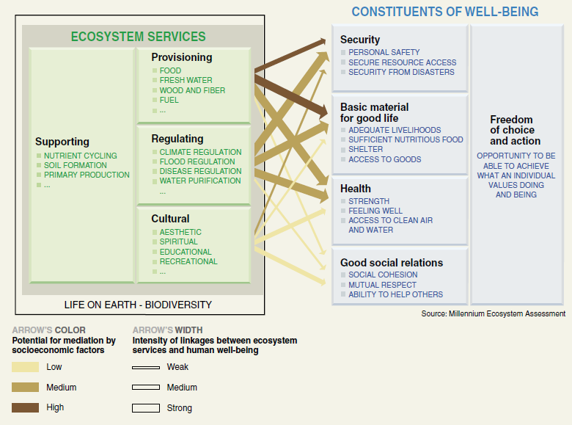
Figure 1: Linkages between ecosystem services and human well-being. Source: ^{[1]}

Figure 1 above indicates that all the ecosystem services have links to the different components of human wellbeing at varying degrees of intensity. Supporting services are responsible for the proper functioning of the other services. Hence, its link to human wellbeing occurs indirectly.

1.2.2 Valuations – Why Value?
In order to effectively manage ecosystems and the services they offer, it is necessary to ascertain and incorporate the value of the service or benefit, to incorporate into policymaking ^{[5][1]}. Values are conceptualized in different ways involving two approaches – a utilitarian approach that focuses strictly on the instrumental values or benefits that human beings derive from the service, and a non-utilitarian approach which considers only the intrinsic and ethical values of the service. Similarly, valuation can be described in different ways as a process of assigning importance ^{[12]}, human expressions of preferences ^{[13]} or expressing a value for a particular good or service in a certain context ^{[1]}.

One of the greatest criticisms of the conventional monetary valuation methods of ecosystem services is its attempt at commodification of the environment ^{[14,15][16]}. Even with the numerous studies carried out on the total economic value of ecosystems, there is still an underestimation of ecosystem services and it is now well-established that it is hard to define the cultural value and navigate the different tools for measuring them ^{[17]}. Unfortunately, the social and cultural dimensions of the values of these Ecosystem services have often been relegated and their importance barely understood – primarily because they are so hard to measure ^{[18]}.

^{[19]}reports that most assessments of ecosystem services simplify the complexity of these systems and this may lead to inaccurate ecosystem services supply and flow estimations. The importance of incorporating this complexity in ecosystem assessments for evidence-based decision-making is identified, suggesting that there is a need to adapt assessment approaches at different spatio-temporal scales ^{[1]}.

In this research, we adopted a values-based approach - the WeValue approach - intuitively designed originally, and developed to aid civil society groups elicit in their own bespoke statements what is meaningful and worthwhile to them as a community of practice ^{[20]} ^{[21]}. The bespoke statements when built into frameworks were then used in the development of measurable local indicators for the groups ^{[18]}. A variant of it – the WeValue InSitu process reported in ^{[22]}and conceptualized as the WeValue InSitu crystallization process in ^{[23]} - was trialed and seen to be successful in the development of indicators in the sub-field of Climate Change Adaptation for local adaptation planning ^{[24]}, and sustainable land remediation ^{[23,25]}, hence its adoption for this study.
This study proposes that this WeValue InSitu approach would be useful in eliciting from people about what they value about their ecosystems. These ideas can potentially be made into indicators for cultural valuation, and integrated into ESS valuation and decision-making tools, by governments and other policy makers. This approach has been seen in other sustainability-related fields as land remediation ^{[26]}and local adaptation plans ^{[27]}. The role and purpose of indicators is to summarize, synthesize or aggregate data and information in a format that is understandable for decision-makers ^{[28]}. Hence, the indicators formed from WeValue InSitu are expected to convey complex realities of social values of ESS to specific decision contexts, and as such embody a way to transfer knowledge from science to policy.

1.2.3 The Challenge of Cultural Ecosystem Services (CES)
According to ^{[29]}, despite the immense value of ESS to society, no relevant market exists where these values are expressed. Although widely recognized, the benefits provided by many natural ecosystems are still poorly understood, quantified and underappreciated ^{[30]}. As a result, in spite of the crucial ecological, cultural, and economic importance of these ESS, ecosystems are continually deteriorating worldwide as the value of ecosystems to human welfare is still underestimated and the ES are not, or are only partly, captured in conventional market economics ^{[31]}. It is economically foolish that human culture has an important influence on how forests and other ecosystem goods are utilized, yet its influence on ecosystem service (ES) use and valuation remains underexplored ^{[32]}. There is therefore a need to carry out more-complete valuation of ESS without omitting the cultural dimensions of value.

1.2.4 Integrating indigenous and local knowledge (ILK)
There are increasing numbers of statements in the conclusions of ESS studies on the importance of eliciting shared values through deliberations by local actors and stakeholders instead of using only expert-led opinions in the valuations of ecosystems ^{[33]}. ^{[34]} insist that shared values synthesized through deliberative mechanisms are different, more robust and more resilient than those obtained through arithmetically aggregating the plural values of diverse individuals. He suggested that future research should explore in further detail how different types of processes elicit or construct different types of values, and how this might enhance the reflection of subtle, transcendental, cultural, and communal values in contextual values and value-indicators. ^{[35]} also advocate for the need to ensure that valuation of ecosystem services are locatable and accountable. This thesis aims to accomplish that, using the WeValue InSitu process.

1.3 Problem Statement
There has been a more substantial and largely irreversible decline in the world's ecosystem services within the last 50 years than at any other time in known human history and this could grow significantly worse in the next half century unless drastic measures are taken ^{[1]}. The reason is simple – while there has been a growing rise in demand for ecosystem services, a commensurate rise in supply is lacking, leading to unsustainable consumption of the world’s ecosystem goods and services.
Unfortunately, much of the earlier studies carried out to ascertain the value of the world’s ecosystem services utilized solely economic estimates ^{[2]} - a step that commodified the world’s natural capital and completely excluded other forms of value(s) such as the shared social and cultural values ^{[36,37]}. Among the different classifications of ecosystem services developed by the Millennium Ecosystem Assessment, the Cultural Ecosystem Services (CES) are the least studied and least understood.
Admittedly, cultural ecosystem services are inherently problematic in that they are intangible, non-material and difficult to measure ^{[38]}. The problematic nature of cultural ecosystem services is that they are rooted in culture and cannot be fully understood if the focus is just on environment knowledge. Hence, recent literature is increasingly calling for the recognition that the values of ecosystem services are relational, context-dependent, and culturally constructed, and need to be operationalized as such ^{[39–41]}.
This would involve the integration of local knowledge and perspectives in local and even regional assessments ^{[42,43]}; requiring that the authentic, shared and social values of the local people be captured through an unbiased mechanism that does not attempt to separate culture and nature but which captures a locally accountable envelope of shared values. This thesis would therefore focus on solving the problem the non-monetary valuation of ecosystems services by generating and identifying situated shared and social values of ecosystem services of local groups in a way that it is understood within the context of their wider human values.

1.4 Purpose of the Study
This is a qualitative research investigation to facilitate the elicitation and articulation of the shared values of different groups in a community, so that their influence on the valuation of ecosystem services can be determined more systematically.
The specific objectives of this study are
- To produce evidence of situated values about ecosystem services, (i.e. situated within the wider shared values of the group)
- To develop a systematic non-biased methodology for the elicitation of cultural values of Ecosystem Services.
- To apply the method to determine the cultural values of ecosystem services of different stakeholder groups in Southeast Nigeria.
- To demonstrate the authenticity of the shared values about ESS elicited through the process.
- To demonstrate the specific usefulness of the standard WeValue deliberation process to making local shared values of ESS explicit.

1.5 Research Questions
This study aims to answer the following questions
- Do ESS values exist within the values envelopes of non-environmental groups?
- Can this ESS values be successfully elicited without nudging?
- Do the elicited ESS values effectively fit into the classification categories of the Millennium Ecosystem Assessment?
- Are the elicited values authentic and can their authenticity be proven?
- Is the WeValue InSitu process effective in the integrated valuation of ecosystem services?

1.6 Conceptual Framework
The framework used in this study is a hybrid that combines the values-based approach of the WeValue InSitu crystallization process (WVICP) and the analytical framework of the Millennium Ecosystem Assessment (MEA). The WVICP is a toolkit developed to assess the previously intangible, values-related aspects of projects and activities carried out by civil society organizations ^{[18]} but it has been proved to be a useful application in other fields such as sustainable land remediation ^{[26]}, climate change ^{[27]} and even transformative learning ^{[44]}. The process is able to elicit and crystallize the intangible shared values of a group and make it readily available for input into any other framework. Values, in this study, are statements of the topmost important things as perceived by a group. The WVCIP is able to produce envelopes of shared social values which give a much needed cultural perspective and context to any plans ^{[24]}.
The elicited values are further analyzed using the Millennium classification system. This enables each values statement to be examined for details of ecosystem services. The MEA was commissioned and carried out between 2001 and 2005 with the aim of assessing ecosystem change and its consequence on human wellbeing. This framework provides the foundation for other systems like The Economics of Ecosystems and Biodiversity (TEEB) and The Common International Classification of Ecosystem Services (CICES). The MEA has been used in various studies notably in the UK (UK NEA – UK National Ecosystem Assessment) where it was used to provide a comprehensive overview of the state of the natural environment in the UK and a new way of estimating the national wealth ^{[45]}. Below is a diagrammatic representation of the conceptual framework used in this study.
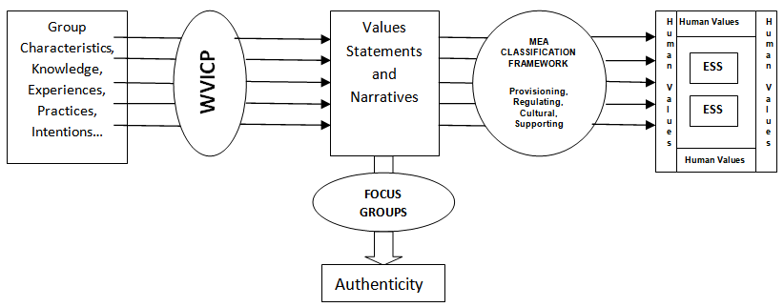
Figure 2: The conceptual framework for this study

1.7 Nature of the Study
This study is an exploratory research investigation of the usefulness of the WeValue InSitu process in eliciting and identifying the cultural values of ecosystem services and the situatedness of these values within the wider values framework of the group.
The study was carried out using qualitative methods. Qualitative research makes use of unstructured, contextual and non-numeric data to produce deep understanding of phenomena usually within the natural settings of the participants ^{[46,47]}. Although qualitative research methods have been criticized by some as lacking rigour and being biased ^{[48]}, it is considered a complementary method that helps to explore perplexing and complicated situations and produce deeper meanings to 'how', 'what' and 'why' questions ^{[49,50]}.

Since this study required obtaining the perceptions and opinions of participants regarding their values - most of which cannot be expressed in terms of numbers - it was necessary to adopt a qualitative methodology that involved deliberations, focus group discussions and other standard methods of analyzing and interpreting qualitative data.
A recent study describes qualitative research as being useful in understanding how knowledge and experience are situated, co-constructed and historically and socially located. This is typical of lived-experience designs which help to develop meaning or theory from the context of the people who have undergone the experience ^{[50]}.

Consequently, the validity of this research is neither dependent on sampling validity nor statistical significance, but rather on other components of measurement validity. It is important to note that whereas statistical significance represents measurement validity in the natural and physical sciences, it is quite different in social practice research where validity measurement contains different components such as the quality of an indicator that makes it seem a reasonable measure of some variable (face validity); the degree to which a measure covers the range of meanings included within a concept (content validity); the appropriateness of the chosen indices to represent their chosen typology factors (criterion validity) etc ^{[51]},

1.8 Definitions
Ecosystem Services – These are benefits that humans derive from the ecosystems

Cultural Ecosystem Services – The intangible immaterial benefits derived from ecosystems.

Values - Although the term value refers to several distinct concepts, in general values can be considered as evaluative beliefs about the worth, importance, or usefulness of something or about moral principles ^{[15]}. ‘Value’ is used to describe the worth of something, an opinion about that worth, or a moral principle ^{[52]}. Values can be a measure of the importance of a thing or experience, or can refer to underlying ideals ^{[53]}.

Valuation: The process of expressing a value for a particular good or service in a certain context (e.g., of decision-making) usually in terms of something that can be counted, often money, but also through methods and measures from other disciplines (sociology, ecology, and so on).
Valuation is an exercise to appraise two or more options to provide information and guidance for personal and collective decision-making ^{[15]}
Situatedness – Embeddedness in a culture. It is a theoretical position that posits that the mind is ontologically and functionally intertwined within environmental, social and cultural factors ^{[54]}. In this study, it signifies the existence of environmental values and ecosystem services within the wider envelope of the shared social values of a group.

Hybrid Values – Values statements that contain a mix of the characteristics of different value types. These values cannot be easily disaggregated into different value types.

Narratives – The cultural context within which stories are told, framed and interpreted, referring to social, cultural, collective, historical or master narratives that express a society’s values and beliefs and shape storytelling ^{[55][56]} ^{[57]}.
A concise account of the values statements of a group usually produced after the construction of a values framework which summarizes the values statements. It aids in understanding the overall values framework.

Human Wellbeing - “a state that is intrinsically and not just instrumentally valuable (or good) for a person or a societal group” ^{[58]}.

1.9 Scope and Delimitations
This study focused in-depth on shared social values for cultural ecosystem services. The definition of values in this study was purely cultural perceptions of importance and devoid of any monetary estimates. The study was conducted in Africa (Nigeria and Senegal) and Asia (Indonesia) in countries which are considered to be developing countries. Furthermore, the groups that were chosen for this study included typical social groups and there were no involvements of professional environmental scientists or environmental-expert groups.

The description of the sites chosen may be classified as rural and semi-rural. The study did not involve groups in urban settings. Although there are considerations of a wider range of cases in the developing world context, similar studies may be needed in the western world among developed countries to finally confirm a wider sphere of applicability. Moreover, the study was delimited to a certain number of group types namely village councilors, teachers and members of village committees who were mostly farmers and traders.

1.10 Limitations
The limitation of this study lies in the fact that only a single framework developed by the Millennium Ecosystem Assessment (MEA) was used. Other frameworks, notably that of the Intergovernmental Platform on Biodiversity and Ecosystem weren’t used here. This may lead to arguments on the comprehensiveness of the study. Furthermore, the MEA is a much older framework than the IPBES framework although the IPBES builds on the foundation of the classifications proposed by the MEA.

Secondly, this study was limited by the inability of the researcher to work with a much larger number of groups and group types – a situation that was created by the prevalence of the Covid-19 pandemic which led to lockdowns during the period of fieldwork. A wider scope of application is needed for a more generalizable output.
Finally, there are logistical and procedural difficulties associated with conducting research in a different language and culture than that of publication. The duration that the participants were willing to spend for the deliberation sessions was also an important factor that needed to be carefully managed. Although the language and time factors were overcome by the researcher, there was need to constantly manage the power dynamics during the deliberative processes.

1.11 Significance of the Study
This study demonstrates significant contributions in advancing theory by proposing a new approach towards non-monetary valuation of ecosystem services that is non-biased. The non-biased style of eliciting statements of what is important to the group ensures that only authentic values are captured, that is values which are considered owned and accountable to the group.
Again, the effectiveness of the WVICP in eliciting different dimensions of values is a significant contribution towards integrated valuation. This is believed to achieve similar objectives as pluralistic valuations of ecosystem services being advocated in the IPBES framework ^{[41]}.
The successful and undisruptive application of WVICP outcomes to the MEA framework is indicative of possible compliance with other classification frameworks. It would be a useful tool for researchers and valuation experts in ecosystem services research.
Finally, the study presents an uncomplicated way for integrating local knowledge in valuation settings. The context-specific nature of the values elicited ensures that indigenous ideas are not separated from results. Moreover, it effectively resolves the problem of nature-culture dichotomy by presenting a consolidated envelope of human values within which are situated ecosystem services.

1.12 Main Research Content
In Chapter One, we introduce the main contents of this study showing the background of the problems and the evolution of the ecosystem service concept. The problem statements, purpose of the study and research questions are also presented. Afterwards a concise account of the conceptual framework is presented along with the nature of the study. Definitions of terms used in the study are also outlined and the scope, delimitations and limitations of the study clearly portrayed. Finally, the significance of the study in advancing theory and practice is highlighted.

Chapter Two is an analysis of a selection of literature on the ecosystem service agenda. It chronicles the earlier works done in the ecosystem domains and the transitions that it has undergone from a majorly economic focus to a more comprehensive agenda that includes social and cultural considerations. Furthermore, work on classification systems, valuation frameworks and deliberative methodologies are also considered. The place of local and indigenous knowledge systems in ecosystem service research is also discussed.

Chapter Three is a well documented presentation of the methodology of this research. It lays out in sequential steps- the methods that were employed during the course of this research. In this chapter, the research design is discussed. The criteria for the choice of study sites and groups are also explained. The processes involved in the localization of the WeValue InSitu crystallization processes, the deliberative process proper including the framework construction and narratives are also presented. The procedure for transcribing, translating and coding the workshop data are well explained. Afterwards, the chapter details the process of analyzing and classifying the values statements using the Millennium Ecosystem Assessment framework.

Chapter Four is a presentation of the results of the study. First of all, the values frameworks of the 23 groups used in this study are documented and presented. Then a group by group analysis of the shared values framework is carried out showing the situatedness of the environmental values within the wider shared values of the groups’ values envelopes. An attempt is also made to show the values types elicited in terms of which classification of ecosystem services they fall into. The results also show which ecosystem services are most elicited among the different groups. It also shows which of the elicited environmental values are hybrid values.

Chapter Five is a discussion of the findings in the study. It shows the relationship between the findings of this study and other current relevant literature. It discusses the idea of situated environmental values and why it is relevant to ecosystem research. In addition to this, the impact of group roles on ecosystem service valuations is discussed. An analysis of the perceptions of ecosystem services in different site contexts is also discussed.
Chapter Six is a generalization of the design and consideration of a wider range of cases. In this Chapter, the WeValue InSitu crystallization process of several other groups in Indonesia and Senegal are analyzed for the existence of ecosystem services. The identified services were then classified using the framework designated for this study. The chapter shows the similarity and peculiarities of the study when done in different geographical locations.
Chapter seven is a conclusion of the study and emphasizes the significance of the study. It also presents the contributions of the study to ESS research, valuation methods, indicator development and policy applications.

1.13 Innovations of the Study
There are four major innovations contained in this study:
- A new method for eliciting cultural ecosystem services – this study utilized a novel approach to eliciting and capturing cultural ecosystem services. This was achieved by using a values-based approach – WVICP – to elicit an envelope of human and social values within which cultural ecosystem services were identified.

- A method for eliciting environmental values in an unbiased way – the need to produce environmental values in an unbiased way underscores the necessity of removing all forms of incentives or nudging activities in environmental valuations. The deliberations were not designed to focus on environmental themes but on a general theme of human values. The products of the process are ‘pure’ and valid.
- A way to visually display the placement of ecosystem services in the values of a group – this thesis has also advanced a new way of visualizing shared values and ecosystem service data. This data visualization style gives an overall perspective of the values envelope of a group and details the occurrence of ecosystem services and their relative locations in the values framework. It will greatly aid researchers and policy makers to make quick and reliable decisions.
- A method that ensures integrated valuation and removes dichotomy in the valuation process – the WeValue process used in this study ensured an integrated process that did not have to go through the rigorous procedure of carrying out different valuations and values aggregation afterwards. This was a simple method that produced diverse values categories. It is expected to save time and reduce cost of ESS valuations if adopted by agencies.

1.14 Road Map Diagram of the Thesis Work Carried Out
Stage 2: Literature Review

Ecosystem Services: Definition, Types, Classification Frameworks
Valuation Methods of Ecosystem Services
Trends and Gaps in Ecosystem Research
Stage 1: Preliminary Research & Development of Research Questions

Background Studies on Ecosystem Services
Introduction to WeValue Processes
Training on the Facilitation of WeValue InSitu processes
Stage 4: Multiple Exploratory Case Studies

WeValue Fieldwork in Nigeria – total of 23 workshops in 3 sites in Nigeria
Perspectives Exploration Focus Group Events
Post workshop Interviews (25)
x
Stage 3: Methodology Development

Localization of Shared Values Approach
Development of MEA Classification Protocol
Situating Environmental Values
Production of Values Envelopes
Stage 5: Transcription and Translation of Workshop Data

Transcription of Workshop Data
Translation of Workshop Data
Thematic Coding of Workshop Data

Stage 6: Classification Using the MEA Framework

Classification of Values Statements using MEA Framework
Comparative assessment of ESS based on group roles
Comparative Assessment of ESS with reference to Site
Stage 7: Generalization and Consideration of a Wider Range of Cases

Analysis of WeValue InSitu Workshop Data (Indonesia)
Analysis of WeValue InSitu Workshop Data (Senegal)

Stage 8: Synthesis, Discussions and Conclusion

Contributions to ESS Research
Contributions to Policy
Further useful work

Figure 3: Road map diagram of the thesis work carried out
As shown in Figure 3, this study was carried out in 8 stages.
The first stage was an introductory phase where the author was involved in the searching of literature. Preliminary studies on ecosystem services were carried out in order to gain knowledge of current trends, develop research ideas and identify gaps in the literature that needed to be filled. The author was also exposed to the WeValue InSitu crystallization process during which he participated in several trainings on the process for facilitating the deliberative process. This stage lasted for around 6 months.
The second stage was a period of review of relevant literature. At this stage, a thorough search of the literature that dealt with the identified gaps was carried out. At this stage, more focus was given to literature about cultural ecosystem services, shared values and different methods of participatory and deliberative valuations of ecosystem services.
In stage three, there was a fine-tuning of the methodology for the research. At this stage, decisions were made on the framework to be used; the sites to be sampled and the exact format of the workshops were formulated. In addition, the WeValue InSitu crystallization process was localized and adapted for use in the context of the selected sites. Again, the groups to be used were selected and their willingness and availability confirmed.
Stage four involved the execution of multiple exploratory workshops to elicit and crystallize the shared values of the different groups. These workshops were carried out over a period of 12 months in different locations in Southeast Nigeria. The workshops also involved pre and post-workshop interviews which are standard practices in the WeValue InSitu crystallization process.
Stage five was a period for analyzing the data derived from the workshops. During this stage, the author was involved in transcription and translation of the raw files. The transcripts were further coded thematically for the occurrence of environmental values and ecosystem services. At this stage all references to persons and places were anonymized for further work.
Stage six was a major part of the project that involved the actual classifications of the identified environmental values using the MEA classification framework. Comparisons were also made between different groups based on site and location-specific contexts of their ecosystems.
Stage seven involved the consideration of a wider range of cases in 2 other countries – Senegal and Indonesia. The purpose was to test the hypothesis about the situatedness of environmental values in other contexts. This was achieved using non-expert groups and produced similar results as the processes carried out in Nigeria.
Stage eight is the final stage and would involve the analysis of the data gathered from this study and how it fits into the current literature. The ability of the findings of this study to fill the research gap will also be explored. Finally, recommendations would be made and the contributions of this thesis described.

1.15 Summary
This chapter provides an overview of the objectives and background of the study highlighting the questions that the research sets out to answer. It has also summarized the innovations and significance of the study including the contributions to theory, practice and policy. The roadmap and main contents of this thesis are also clearly laid out, and the scope, delimitations and limitations of the study are given. In the next chapter, an in-depth review of associated literature will be conducted to further delineate the purpose of the study and justify why this study should be carried out.

CHAPTER TWO

LITERATURE REVIEW
In this chapter, the focus is to explore the significant body of research that has been done on the subject of ecosystem services. The aim is to highlight significant advances, and more deeply explore the trends in the field of ecosystem service research in order to call attention to the gaps that exist and how this study intends to fill these gaps. The concept of values will also be discussed and how it is being incorporated in the study of ecosystem services along with the various methods that are being used for the valuation of ecosystem services. It is necessary at this stage to more clearly display the history of this field of study and how it has evolved over the years.

This chapter is broken down into six major sections. It begins with background information on ecosystem services, briefly highlighting the history and earlier work done in the field. It also set out the various types of ecosystem services and the classification frameworks that have been developed and used in this field.

The second section discusses the research gaps and needs in the current work on ecosystem services by exposing the need to integrate the cultural services in more studies on ecosystem research. We argue that the relative ease in the valuation of provisioning services should not be a reason for the neglect of the cultural services. In the third section, an exploration of the (need for) localization of ecosystem service research, and the place of indigenous and local knowledge in valuation studies, are examined. These are highly important considering the contextual nature of ecosystem services.

The fourth section surveys the theme of deliberation and how it is being used in valuation studies in ecosystem services. Since it is the basic tool of use in qualitative studies of this nature, we discuss how it is involved in values formation, the factors that affect it, how it can be used in valuation studies and the different styles of deliberation. The principles for assessing a successful deliberative exercise are also discussed. Section five deals with the valuation pathways, including deliberative valuation. It also highlights the Deliberative Value Formation model (DVF) and shows the three components of the model.

Finally, an analysis of the concept of values in Ecosystems services is presented. It is expected to show the subjective nature of values, the different classifications of values based on different frameworks of reference. It concludes with the current gaps in ESS valuation and an evaluation of our approach to eliciting and crystallizing shared values of ecosystem services.

2.1 Understanding Ecosystem Services

2.1.1 Early Works on Ecosystem Services
In an article published by ^{[2]}, an attempt was made to give an estimate of the monetary value of the world’s biosphere. At that time, it was estimated to be worth US$33 trillion per year – a value which comprised both traded and non-traded commodities. This was considered an outrageous postulation as that figure was even larger than the global gross GDP. This remarkable work by Constanza sparked a lot of debates and counter arguments but the aim had been achieved – the interest of researchers on ecosystem service research had been ignited, and what followed was a flurry of publications and citations which demonstrated that ecosystem services were much more important to human wellbeing than conventional economics had allowed ^{[59]}.

The study by Constanza led to a new type of economics – ‘ecological’ economics with the objective of developing approaches for accounting for the value of ecosystem services. The foremost of these is a four-year study commissioned by the United Nations to further expand the frontiers of this research. It was named the Millennium Ecosystem Assessment ^{[1]}.
The MEA did a lot of pioneer work in categorising the identified ecosystem services. According to their study, there were four categories of ecosystem services namely provisioning, regulating, cultural and supporting ecosystem services. The supporting services category is considered a substructure that undergirds the other three categories. Its impact is usually indirect and occurs over a long period of time. These four categories are still in use and widely adopted by majority of researchers till date.

2.1.2 Classification frameworks – MEA, IPBES, CICES, TEEB
There have been several attempts at having more standard classifications of ESS by some international initiatives since after the Millennium Ecosystem Assessment (MA) in 2005. The Economics of Ecosystems and Biodiversity (TEEB) carried out in 2007 – 2010 was designed to mainstream the values of ecosystems into decision-making processes ^{[4]}. The Common International Classification of Ecosystem Services (CICES) which was proposed in 2009 and later revised in 2013 was developed for integrated environmental and economic accounting ^{[60]}. The current and most recent version of CICES (V5.1) was developed in 2017. CICES offers a relatively high level of detail in a nested hierarchical structure of ‘taxonomical levels’ ^{[61]}. It was originally developed as part of work on the revision of the System of Environmental and Economic Accounting (SEEA) led by the United Nations Statistical Division (UNSD). CICES attempts to improve on the MEA by creating a more rigorous structure that fosters practical use. It includes all the MEA categories except the supporting services because of its focus on direct services ^{[62]}. CICES also allows for geographical and thematic scalability. These classification schemes have produced basically the same classifications with minor variations.

The Intergovernmental Science-Policy Platform on Biodiversity and Ecosystem Services (IPBES) established in 2012 was a response to decision-makers’ requests regarding the state of ecosystem services ^{[5]}. The IPBES framework broadly contains 3 foci of values - Nature, Nature's Contribution to People and a good quality of life. The IPBES framework integrated the MEA categories of provisioning, regulating and cultural services as part of Nature's Contributions to People. Additionally the framework recognizes 3 value types - intrinsic, instrumental and the more recent relational which aids in the perception and understanding of other value types ^{[41]}. Thus, the relational values help to mitigate the human-nature dichotomy present in traditional economic valuations ^{[63]}. This leads us to seek ways to developing valuation pathways for human perceptions of ecosystem value ^{[64,65]}).

2.1.3 Ecosystem Services – Provisioning, Regulating, Cultural and Supporting Services
The definition of ecosystem services given by ^{[2]} was retained by the MEA thus: “Ecosystem services are the ecological characteristics, functions, or processes that directly or indirectly contribute to human wellbeing: that is, the benefits that people derive from functioning ecosystems” ^{[2]}. As is the norm in conventional economics, there have been attempts at further differentiating between ecosystem goods (such as food and water) and ecosystem services (such as flood and disease control) but they have been conflated to ecosystem services to represent the full range of benefits (both tangible and intangible) ^{[1]}.

Provisioning services are those benefits that deal with the normal market goods like fibre, fuel, food etc. The regulating services are concerned with maintaining the environment – disease regulation, flood regulation, erosion control etc. The cultural ecosystem services on the other hand are the non-tangible services derived from the environment. It includes things like aesthetic, educational and inspirational values. The ecological economists have been able to measure the provisioning and regulating services and attach some sort of monetary value as a measure of its worth. However, the cultural services are difficult to measure and associate with any monetary or financial worth. Hence, the valuation of cultural ecosystem services remains a significant challenge that cannot be solved by econometric formulas but by a thorough understanding of culture and the shared values of groups. ^{[14]} and ^{[66]} report progress in the integration of ecological economics into decision making processes but the challenge still persists and demands the incorporation of fresh approaches especially from fourth-pillar sustainability indicators ^{[18]}. Supporting services represent services necessary for the production and maintenance of all other ecosystem services. Examples include soil formation and retention, nutrient cycling, biomass production; water cycling etc. It has received relatively little attention possibly because they do not have a direct impact on human wellbeing and also to avoid cases of double counting in valuation studies.

At this juncture, it is necessary to take a closer look at cultural ecosystem services with a view to understanding the types, constituents, characteristics and the need to measure them.

2.1.4 Cultural Ecosystem Services (CES)

2.1.4.1 Defining Cultural Ecosystem Services
There are many definitions of cultural ecosystem services. This is attributed to the continuously evolving developments in the field and the alternative classification frameworks generated by different researches ^{[67]}. Another problematic issue is about the definition of ‘culture’ in ecosystem services. While some define culture as consisting of worldviews and practices ^{[68]}, others view it as a complex and multifaceted term encompassing way of life, the identity of a group, or particular social processes ^{[69]}. An exhaustive presentation of the definitions of CES is not intended in this work; however, Table 1 shows the different definitions obtained from different sources.
Table 1: Sample definitions and types of ‘Cultural Ecosystem Services’ or Equivalent (Source: ^{[70]})
Source | Definitions of CES or equivalent
^{[2]} | Described as the aesthetic, artistic, educational, spiritual and/or scientific values of ecosystems
^{[71]} | Ecosystem services which deliver the following life fulfilling functions:  Aesthetic beauty; Cultural, intellectual, and spiritual inspiration; Existence value; Scientific discovery; Serenity
^{[72]} | Natural ecosystems provide ‘information functions’ that contribute to spiritual enrichment, cognitive development and recreation. These include:  Aesthetic information, Recreation, Cultural and artistic information, Spiritual/historic information, Science and education
^{[1]} | Described as being the non-material benefits people obtain from ecosystems through spiritual enrichment, cognitive  development, reflection, recreation, and aesthetic experiences, including:  Cultural diversity, Aesthetic values, Spiritual and religious values, Social relations, Knowledge systems Sense of place, Educational values, Cultural heritage values, Inspiration Recreation and ecotourism
^{[73]} | Socio-cultural services provide:  Spiritual/philosophical contentment; A benign social group, including access to mates and being loved; Recreation/leisure; Meaningful occupation; Aesthetics; Opportunity values, and capacity for cultural and biological evolution (comprising knowledge/education resources, and genetic resources)
^{[69]} | Cultural values include ‘cultural’ attributes (e.g. stories and myths) as well as attributes considered a part of nature which  are valued culturally, and comprise:  forms (physical, tangible and measureable aspects of landscape or space); relationships (spanning the human-nature continuum i.e. people-people, people-landscape, and purely ecological (landscape) interactions); practices (both human practices and natural processes e.g. traditions, events, ecological and natural processes)
UK National Ecosystem Assessment  ^{[74]} | CES are the environmental spaces (where people interact with each other and the natural environment) and cultural practices (the activities linking people with each other and the natural environment) that benefit human wellbeing in material and non-material ways. CES give rise to the cultural goods and benefits that people obtain from ecosystems.  Cultural goods comprise:  Leisure, recreation and tourism goods; Education and ecological knowledge goods; Health goods; Religious and spiritual goods;  Heritage goods  Cultural ecosystem benefits refer to the following dimensions of wellbeing:  Identity (belonging, sense of place, spirituality); Experience (tranquillity, inspiration, escape, discovery); Capability (knowledge, health, judgement, dexterity)
^{[75]} | Cultural services are an ecosystem’s contribution to the non-material benefits (e.g. capabilities and experiences) that arise from human-ecosystem relationships. The categories of CES are:  Subsistence; Outdoor recreation; Education and research (nature-based); Artistic (nature-based); Ceremonial (place-based)
Common International Classification of  Ecosystem Services  (CICES v4 2013)  ^{[60]} | Cultural services are the non-material, and normally non-consumptive, outputs of ecosystems that affect the physical and mental states of people. Cultural services are the physical settings, locations or situations that alter the physical or mental states of people, and whose character are dependent on living processes. The categories of cultural services are:  Physical interactions (use of plants, animals and land-/seascapes); Intellectual interactions (either scientific, educational, heritage/cultural, entertainment, and aesthetic); Spiritual and symbolic interactions (symbolic, sacred/religious); Other interactions (existence and bequest)

It is evident from the table above that there are different conceptualizations about cultural ecosystem services and understandably so because they are context-dependent by nature. We shall proceed to look at the characteristics of this group of ecosystem services which make them peculiar and not fitted for the conventional market-based valuations.

2.1.4.2 Characteristics of Cultural Ecosystem Services

2.1.4.2.1 Intangibility and Incommensurability
Cultural ecosystem services are difficult to measure because they are non-material especially to the economist. This is the most obvious reason given by most ecological economists as the problem of cultural ecosystem services. The incommensurability exists because there is no standard basis of measuring them ^{[76]}. The exception to the intangibility of CES is with reference to artifacts and sites that are tangible and popularly referred to as environmental spaces ^{[68]} .

2.1.4.2.2 Human co-production
Cultural ecosystem services are heavily reliant on social interactions for their production ^{[77]}. This involves human relationships and common practices since cultural values can only be formed as a result of human perceptions of ecosystem services ^{[78]}. ^{[79]} explains that these values are not created apriori but through active interactions with ecosystems. Furthermore, ^{[39]} emphasizes the importance of relationships both between people and nature, and between people involving nature, as being the crux of CES.

2.1.4.2.3 CES are Place-based
Cultural ecosystem services have been empirically proven to be place-based ^{[70][68][80]}. Studies have found that participants frequently used some location-specific expressions to articulate their values of certain CES ^{[81]} and this goes further to confirm that these cultural values cannot be generalized across different contexts since different locations produce different expressions of CES based on unique experiences of the people ^{[82]}.

2.1.4.3 The Challenges of CES Research
In comparison to other types of ecosystem services, determining exactly what counts as a CES is not straightforward ^{[83,84]} and the scientific understanding of CES have been insufficiently studied due to difficulties in identifying and valuing their attributes ^{[85,86][75]}. This has led to paucity of information needed for decision-making processes. As a result, it is reported that many CES is routinely omitted from ESS assessments in preference for more easily quantifiable options ^{[78,87]}.
Additionally, ^{[15]} report that culture is both pervasive and elusive. Culture is considered a very complex concept because of difficulties in arriving at a consensus of meaning from different disciplinary perspectives ^{[88]}. This is primarily because of the broadening of previously static concepts of culture to include processes ^{[68]}. Consequently, there may not be an emergence of uniform approaches to culture but differences will persist for different purposes and contexts ^{[89]}.
Based on the understanding of the challenges of studying and valuing CES, it is important to describe the gaps identified in literature and which will form the basis for the work in this thesis. The next session gives an analysis of the needs currently being encountered in ESS research presented using the lenses of the research questions.

2.2 Exploring the Needs in Ecosystem Service Research

2.2.1 Outstanding challenges to integrating cultural services
The accepted method for economic analyses involves dealing with both supply and demand cycles. However, the majority of ESS research has focused only on the supply of ecosystem services and neglected to a large extent the demand aspect ^{[90]}, ^{[91]}). This is manifested in the use of only market-related values and the neglect of non-market components associated with human wellbeing ^{[92]}. This is a fundamentally deficient system of accounting. The solution to this would be to consider the full range of ecosystem services as conveyed by a wider range of stakeholders without restrictions based on expertise. In other words, stakeholders should be integrated in environmental valuations who are not environmental expert but just normal members of the community. Such people’s perspectives must be taken into account and their perceptions of benefits accruing from ESS captured ^{[93–95]}.
The need to integrate diverse cultural perceptions and indeed view these services with cultural lenses is the focus and the main agenda of the Intergovernmental Platform on Biodiversity and Ecosystem Services (IPBES). The IPBES formulated a new concept which they termed Nature’s Contributions to People (NCP) as a replacement for the term Ecosystem Services (ESS). The NCP represents all the contributions (both negative and positive) that nature makes to people. It provides for 2 lenses – a generalizing perspective which accepts that nature and humans are distinct and separate, and a context-specific perspective which views humans and other-than-human systems as being one and intricately linked ^{[42]}. The generalizing perspective is well aligned with the conventional economics but the context-specific perspective allows for and accommodates the intangible and non-market values in valuation processes. Interestingly the NCP approach recognizes that the two views should be included in valuation studies. However, it views culture as crucial in understanding the links between humans and their biophysical environment and calls for the integration and operationalization of indigenous and local knowledge in studies.

2.2.2 The need to consider all stakeholders
Stakeholder perspectives remain a very vital consideration in ecosystem service research ^{[96][69,90,97–100]}. Its importance is further emphasized when the focus is on cultural ecosystem services that involve multiple value dimensions ^{[101]}. Stakeholders are defined as those who are affected by or can affect a decision
A pertinent question to ask is “What kinds of stakeholders should be involved in ESS research?” Several studies provide useful insight for dealing with this. For example ^{[102]} carried out extensive studies to develop a systematic approach for identifying, classifying and engaging stakeholders for water resource management. In addition, a distinction is made between different categories of stakeholders and publics. Specifically, ^{[103]} differentiated between citizens (lay people, the pure public), consumers (service users, the affected public), and advocates (experts and interest groups, acting as the partisan public). This classification may be considered an indication of the levels and types of engagement carried out.

There is now a new advocacy for high levels of local stakeholder involvement in which management is decentralized to the smallest appropriate scale ^{[104]} with calls for some form of responsibility transfer from institutional actors and experts to other stakeholders, target groups and citizens - users targeted by, affected by or simply interested in the decision ^{[105]}. Even then, stakeholder engagement should require the incorporation of best practices that ensure a balance of power achieved through highly skilled facilitation and an integration of local and scientific knowledge ^{[106]}.

2.3 Localization of Ecosystem Service Research

2.3.1 Indigenous and Local Knowledge
Several studies have been carried out on local and indigenous knowledge and its importance in the study of the environment including to what extent it should be integrated in decision making ^{[107]}. It is being studied in disaster management ^{[108]}; sustainable development ^{[109]} etc. While some studies are cautious as to the extent of acceptance, others advocate that it has a strong potential in aiding management decisions. For example, some studies recognize that there are conceptual, methodological, practical, and ethical challenges in studying and applying indigenous knowledge ^{[110]}. However, others argue that the problems associated with co-opting indigenous knowledge into scientific discourses can be resolved by conceptualizing indigenous knowledge as a way of knowing, a process or practice rather than what is known hence advocating for more emphasis on epistemology and less on content ^{[111]}.
Whichever divide one is in, the concept of indigenous ecological knowledge cannot be disregarded as studies have shown that they are critical and important in the governance and survival of local communities. ^{[112]} reports how indigenous fisher folk responded effectively to an ecological disaster in the Western Solomon Islands. These responses were linked to intergenerationally transmitted oral histories, stories and myths. To a large extent, these indigenous knowledges have proven to be resilient and deeply embedded in the socio-economic and cultural environments in which they are found ^{[113]}.
Another study reports difficulty in understanding the tacit and embodied character of indigenous and local ecological knowledge ^{[114]}; a situation which can be ameliorated using values based approaches as reported by ^{[23]}.

2.3.2 Situated Knowledge and Practice
Closely aligned with indigenous knowledge is the concept of situated knowledge. These are peculiar practices engaged by the locals and tailored to their own specific needs and conditions. These are not ‘textbook’ practices but ingenious innovations by indigenous people to overcome challenges, meet needs or live peacefully. Situated knowledge is a knowledge that is embedded in and thus affected by the concrete historical, cultural, linguistic, and value context of the knowing person (APA Dictionary of Psychology). This is critical in determining the success or otherwise of policy interventions in a community. For example, the payment for ecosystem services (PES) initiative is an economic approach to conserving biodiversity. However, its efficiency and effectiveness was greatly affected by negotiations with and actions of local stakeholders ^{[115]}. Hence, approaching knowledge as a situated practice draws attention to the contexts of engagement ^{[116]}.

2.4 Deliberation
Deliberation in a group context has been defined by ^{[117]} as a sort of discussion that involves the careful and serious weighing of reasons for and against some proposition. This is in contrast to an interior process by which an individual weighs reasons for and against courses of action.

2.4.1 Deliberation and the Formation of Values
Deliberation has been found to be useful in promoting changes in understanding, behaviour, practices and decisions of groups. It is necessary to examine how this concept affects values formation and alignment, including its involvement in how and to what extent values become shared and expressed in group settings ^{[118]}.
The formation of values during the deliberative process is thought to occur through the phenomenon termed ‘social learning’ ^{[119]}. Many different conceptualizations of social learning have been proposed ^{[119–121]}. In some literature, it is the process through which learning takes place while in others, it is about the number of participants involved in the learning process. However, ^{[119]} gives a comprehensive description of social learning as one in which there is a change in one’s understanding of the world through a process of social interaction and at the scale of social units or communities of practice.
Social learning, a principal component of group deliberation ^{[122]}, can result in long-lasting effects by strengthening relationships, enhancing participants’ understanding of differing perspectives and emergence of informed opinions ^{[123,124]} . This is seen in deliberative workshops where stakeholder participation often leads to co-production of knowledge and has been beneficial in the conservation of social ecological systems by changing people’s understanding of and behaviour towards the natural environment ^{[125,126]}.
A further argument about deliberation is the extent to which it influences change and values formation. Here, a distinction is made between medium-term and shorter-term deliberation. Medium-term deliberative processes are said to occur over a period of weeks or even months, e.g. an ongoing political negotiation where people are swayed into taking decisions and forming shared values on the basis of superior arguments or more altruistic environmental interests (Gifford, 2008; Miller, 2000).
Although ^{[122]} argues that the shorter-term deliberative processes may not result in changing contextual values, evidence abounds that they are nonetheless useful in short-term interventions that can still lead to value change. An excellent example of shorter-term deliberations is facilitated workshops which have been implicated in value change and modification in diverse environmental, political and cultural scenarios ^{[127,128]} ^{[129]}.

2.4.2 Factors That Affect Deliberation
Another important factor of consideration in deliberative processes is the way the processes are framed and designed and how these framings affect the values formed. A studies on the monetary values of a nature conservation scheme by ^{[130]} demonstrate this. While the participants in the former agreed that their willingness to pay reflected their true values, the participants in the later felt that they were not able to meaningfully identify their values. The difference between the two studies was that the first involved in-depth discussions while the discussions in the second were peripheral. The participants in the second study proposed a more democratic valuation process. It is concluded therefore that the depth of engagement and intensity of deliberations affect the outcomes of the process.
Furthermore, the diversity of participants, group composition and even the style and method of facilitation affect outcomes in the deliberative process ^{[118]}. The composition of the groups and diversity of perspectives influenced which values were discussed and agreed upon and the extent to which participants learned from each other ^{[131–133]}. Effective facilitation helps to balance power and communication inequalities which in turn prevents ‘dysfunctional consensus, biased outcomes or exacerbating conflict ^{[106,134,135]}. Facilitation must be impartial and independent, as far as possible, for these benefits to be seen, otherwise facilitation may exacerbate power inequalities and bias outcomes ^{[136]}. Additionally, the subtle consequences of group power that privileges certain knowledge over others and decides what information is included in the deliberative process ^{[137]} must be dealt with by including and empowering marginalized groups and also acknowledging and respecting all knowledge claims ^{[138]}. Capacity to deliberate due to prior experience, educational level, professional status etc also affects the deliberative outcomes ^{[104]}.
Tables 2 and 3 present the different sets of criteria for appraising participatory and deliberative methods and the principles for designing and evaluating public participation processes. These sets of criteria underscore the need for a carefully designed and well implemented deliberative exercise. Researchers can therefore apply these indices to verify the quality of their adopted participatory methods. Thus, the WeValue crystallization process which was used in this study can be appraised using the criteria for participatory-deliberative methods which are inclusion, procedure and outcome ^{[139]}.
In other words, the participatory-deliberative workshops must fulfill the inclusion criteria by ensuring that relevant stakeholders participate in a context of power balance. Secondly, the process must include opportunities for open and honest deliberation, knowledge sharing and a way of verifying authenticity and transparency. Finally, the output from such a process should be an agreed-upon line of action, independent of external influence and having valid applications to policy ^{[139]}.
Table 2: Different sets of criteria used for comparing participatory methods ^{[140]}.
Set | A | B | C | D | E
Author | ^{[141]} | ^{[142]} | ^{[139]} | ^{[143]} | ^{[144]}
Assessed methods | Participatory | Participatory | Participatory-deliberative | Deliberative | Deliberative
Field of study | Science and technology policy (env. risks) | Natural (forest) resource management | Environmental policy processes | Decision making in the health sector | Appraisal of common goods
Criteria | Acceptance:  - representativeness  - independence  - early involvement  - policy influence  - transparency  Process:  -resource accessibility - clear task definition - structured decision making  - cost-effectiveness | Capabilities:  - understanding complexity  - aggregability  - supporting policy decisions accuracy, etc.  Use:  - identification of stakeholders  - knowledge elicitation  - flexibility  - cultural sensitivity  - analytic or creative  Products:  - communication and learning  - co-learning  - transferability of results  - rapid implementation, etc. | Inclusion:  - participation (popular or stakeholder)  - motivations  - power relations  Procedure:  - opportunity for true deliberation  - knowledge sharing  - methods  - transparency and verifiability  Outcome:  - consensus / compromise  - independence (who defines the objectives)  - policy applicability | Representation:  - legitimacy & fairness  - representativeness of the sample  - Way of selection, etc.  Structure:  - degree of citizens’ control  - deliberation  - credibility of the process  - Who is listening, etc.  Information:  - accessibility  - readability  - who chooses the information  - Who chooses the experts - interpretations, etc.  Outcome:  - consensus  - better and more legitimate decisions  - more informed citizens, etc. | Rationality:  - roles  - capacity  -value dimensions - relevant groups  Interaction of agents:  - form of communication  - principle of participation  - rights  Character of the good:  - degree of complexity (type of risk)  - delineation in time and space

Table 2 above describes the different participatory and deliberative processes that have been applied in different fields of study such as science and technology policy, natural resource management, environmental policy, health and appraisal of common goods. It also includes the criteria for assessment.
Deliberation is important because it makes explicit the otherwise tacit knowledge of the participants and enables them to clearly articulate and express their real thoughts and intentions about different matters. It gives the participants the opportunity to question, contest and openly evaluate ideas that have never been discussed. This process helps them to realize and adopt values for things they now consider as of profound importance to them. This is considered a very useful process in the valuation of ecosystem services where local stakeholders are required to make decisions, choices and tradeoffs about seemingly conflicting interests (^{[129,145,146]}.
It is necessary to briefly outline the different styles of deliberation that can be used in deliberative processes. The chosen style should depend on the purpose of deliberation and the participants involved in such deliberations.

2.4.3 Different styles of deliberations
In classifying engagement processes, ^{[106]} distinguishes four major types of engagement processes thus;
- Top-down one-way communication and/or consultation – this involves the initiation and direction of engagement from the top-down usually by an organization with decision-making power. Although they consult the public and stakeholders, it is simply for the purpose of communicating decisions to them because they still retain decision-making power.
- Top-down deliberation and/or coproduction – Engagement is initiated and led from the top-down. This is different in that there is a two-way discussion that enables the decision-making body to better understand and explore suggestions from stakeholders in order to make more robust and better accepted decisions.
- Bottom-up one-way communication and/or consultation – This involves the initiation of engagement by the stakeholders/public. In this process, the stakeholders persuade the decision-making bodies to make the decision-making process open to scrutiny and engagement.
- Bottom-up deliberation and/or coproduction – engagement is initiated and led by stakeholders and involves a two-way discussion with other stakeholders in order to make a decision.
However, for the purpose of this research, we have adopted a fifth participatory method which will be briefly defined here.
- Our Approach – WeValue InSitu Crystallization process – uses a process that de-emphasizes hierarchy or vertical relationships and projects horizontal relationships ^{[18]}. More details are given in Chapter 3.

2.5 Valuation Pathways
The difficulty in capturing the values of nature as a result of differences in context and worldview of different beneficiaries is attributed to the fact that it does not follow formal, objective and economic pathways but are culturally constructed ^{[41,64,147]} ^{[40]}. Hence it requires a lot of effort in eliciting and securing the views of the participants. The translation of the local concepts to outsiders is also a factor that must be considered especially in judging the validity of the values captured.
There are ongoing attempts at developing ‘culture-based indicators’ for the valuation of ecosystem services ^{[38,61,148,149]}. These studies continue to bring up many tensions associated with interpreting and judging results ^{[150]}. A recent study that used photographs to elicit intangible values of groups in the Pacific Island reports the difficulties encountered in the interpretations given by local people versus the interpretation presented by the researchers ^{[151]}. Thus, photos although suitable for eliciting deeper-held meanings, can also introduce biases. Similar issues arise in some deliberative methods that strive to obtain locally valid valuations of ecosystem services ^{[64,129]}.
In the next few paragraphs, we will review the different methods used in the valuation of ecosystem services and also look at where the gap still exists.

2.5.1 Deliberative valuations
Deliberative valuation is a term used to portray the group-based valuation of ecosystem services.
It is a process whereby people are able to exchange views and experiences, practice deep listening and reflection, negotiate meanings and interests and finally make decisions about a subject matter – ecosystem services in this case ^{[104,152]}. Methodologically, it is rooted in ‘talk’ and the process of getting people to carry out an in-depth discussion on a topic or theme. It is primarily focused on helping people to express themselves and gaining an understanding on why people think, feel and do things the way they do.
Since the outputs of the deliberative process are usually statements of values of importance, it is frequently utilized in non-monetary valuations of ecosystem services. The group context of the deliberative process usually forces a shift from personal welfare to a more comprehensive socially equitable assessment of the issues at hand ^{[153]}.

2.5.1.1 The Deliberative Value Formation (DVF) Model
The understanding of deliberation and its role in eliciting, forming and shaping values is the motivation for the creation of the DVF model. ^{[154]} developed the deliberative value formation (DVF) model which includes three components -
1. An understanding of the key factors that influence how deliberation forms values;
2. An understanding of the potential outcomes of deliberation in a valuation context;
3. A chain of influence that conceptualizes deliberative value formation as a translation of transcendental values into contextual values and value indicators, and links the key components that constitute this process.
Below is a schematic of the DVF model showing the interactions that take place between the deliberative processes, the factors affecting it and the values formed. The potential outcomes are also displayed.
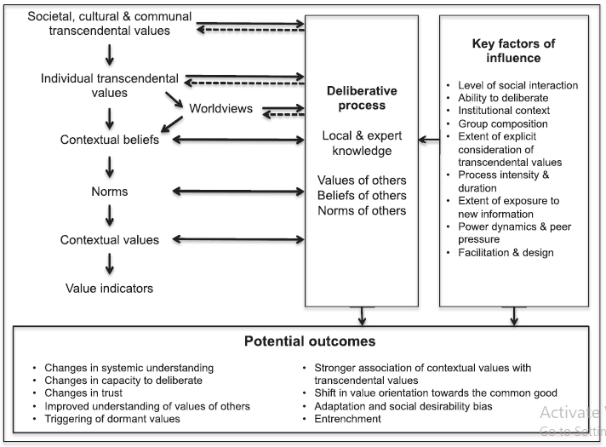
Figure 4: The deliberative value formation (DVF) model. Source: [154]

The deliberative value formation model shown above depicts the relationship between the deliberative process, the factors that affect it, the types of values formed and the potential outcomes of the process. The WeValue crystallization process accommodates the values, beliefs and norms of the participants and is useful in forming shared values.

2.6 Values and value types
The definition of values in any empirical study is determined by the way it is measured ^{[52]}. Consequently, several definitions and conceptualizations of values have been presented. The definition of values is also dependent on the field of knowledge or discipline in focus ^{[83]}. Hence there are different understandings of value in psychology, economics etc. However, ^{[155]} presents an encompassing definition of values as concepts or beliefs about desirable states or behaviours that transcend specific situations, guide selection or evaluation of behaviour and events and are ordered by relative importance. They are measures of worth and importance of something ^{[53]}. Whereas ecosystem services contribute to benefits people obtain from ecosystems, values reflect how important those services are to people ^{[82]} . Hence, a single ecosystem service can have multiple values ^{[156]}. ^{[157]} suggested that CES like aesthetics, inspiration, spirituality and sense of place, represented conceptual, ‘first-order’ held values

2.6.1 Value Types
As with the definition, so is the classification of values in different studies. ^{[70]} distinguishes between ‘held’ and ‘assigned’ values. ‘Held’ values are particular end-states of existence which are personally and socially preferable and necessary for human wellbeing ^{[158,159]}. They determine how people interpret their surroundings, decisions and behaviour ^{[156]}. Held values have also been found to be important for co-producing cultural ecosystem services by influencing how the environment is perceived by people ^{[160]}. ‘Assigned’ values on the other hand are contextual representations of the worth or importance of an object to a person or group ^{[83]}. It is in this sense that the values of ecosystem services ^{[161]} , green spaces ^{[162]} and other environmental attributes are often discussed.

Valuation deals with the assessment of trade-offs towards achieving a goal. An understanding of the values of ecosystem services for example aids in making decisions regarding environmental management options ^{[163]}. ^{[163]} further distinguishes between three overarching categories of values – ideal, real/objective and subjective values. They describe ideal values as relating to non-physical objects and the determinant of value is the goodness imparted on them (e.g. justice, liberty etc). Real/objective values emphasize scientific rationality and their validity is established through scientific processes. The third category - subjective values, are derived from the perceptions of individuals or social groups and they are socially constructed and therefore not fixed or absolute ^{[164]} . It is the subjective category that accommodates shared and social values of groups [^{[165]}, ^{[152]}–, ^{[166]}].
The next section of this review provides insights into the different values of ecosystem services being studied in ESS literature.

2.6.2 Values of ecosystem services

2.6.2.1 Total Economic Value
In describing the values of ecosystem services, the Millennium Ecosystem Services (MEA) also recognizes the concept of Total Economic Value (TEV). The Total Economic Value (TEV) is a framework of valuation which is based on the concept of utilitarian benefits obtained from ecosystem services ^{[1]}. It seeks to assign values based on the utilities that are served by the ecosystem. It divides values into three broad categories – Use, Non-use and Option Values ^{[1]}. The Use values are values that are utilized for consumption or production purposes. They may be obtained from tangible or intangible services and are further divided into direct use and indirect use values. Ecosystem services with direct use can either be consumptive - when their use results in the depletion of resources available for other people’s use (e.g. harvesting of food or fuel) or non-consumptive when their use does not result in the depletion of resources available to others (e.g. recreation, water sports etc.). These two types correspond to the MEA categories of provisioning and cultural services ^{[1]}.
Indirect Use values are indicative of the values of those ecosystem services that are not utilized directly but help to promote the consumption or enjoyment of other services. Things like soil, nutrient recycling, pollination, waste assimilation etc fall under this category and they correspond to the MEA categories of supporting and regulating services ^{[1]}.
The non-use values are also referred to as existence value or passive values. It is valuable simply because it exists. Some researchers posit that it has an overlap with option values. Option values signify ecosystem services that are not currently being utilized but hold value by the assurance of their existence for future use either directly or indirectly. In simple terms, they provide options for use by future generations ^{[167]}. A typical example is bequest ^{[168]}.
Figure 5 is a schematic showing the different classifications of the Total Economic Value of ecosystem services.
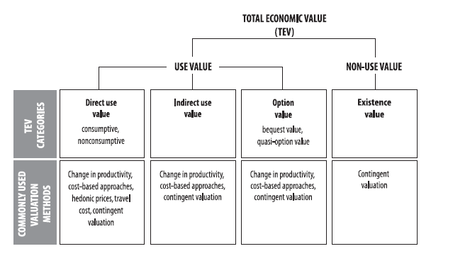
Figure 5: Total Economic Value. Source: ^{[1]}
The figure above is a diagrammatic presentation of the different classifications of total economic value into two broad classes – Use Value and Non-use Value. The Use value is further divided into direct, indirect and option use values while the non-use value is essentially composed of existential value. The commonly used valuation methods for the different value classes are also shown in the diagram. The TEV is an aspect of economic valuation that involves the utilization of different techniques like the Willingness to pay (WTP) or the Willingness to accept payment (WTA). The WTP is slightly different from the WTA in that WTP is used when an individual is not the owner of the service while WTA is used when the individual is the owner of the service. Over time, WTA has been found to be consistently higher than WTP. As a result, WTP is more widely used because it presents a more conservative estimate. The WTA and WTP are all classified as part of contingent valuation method which seeks to estimate the economic value of some services ^{[169]}.
Another method used in economic valuations is the concept of benefit transfer which deals with the transfer and superimposition of the estimates of the economic value of a service in a particular location on the same service in another location. A subject of much controversy, it has been modified with certain conditions including that the characteristics of the location being valued must be the same with that of the primary location providing the value ^{[170]}. Choice modeling like Choice experiments involves making a choice between different alternatives of a particular ecosystem. Here, the participants are required to choose their favourite alternative out of several including the status quo ^{[170]}.

2.6.2.2 Shared Social Values
A value type advocated by proponents of a non-economic method of valuation is shared social values. It is considered to be significantly important especially in the cultural ecosystem discourse. As the name suggests, shared values imply values that are owned not by an individual but by a group or community. The term ‘social’ is indicative of the context and process through which such values are formed which is basically through a social process of deliberation. Therefore, the notion of ‘shared or ‘social values’ represents those values that we come to hold and assign through our interactions with others in one way or another, informing and shaping a concept of the common good ^{[34]}. The term ‘shared values’ has often been used to refer to guiding principles and normative values that are shared by groups or communities or to refer to cultural values more generally ^{[34]}. They may be cultural norms, public interests or contextual values. ^{[34]} developed a shared and social values framework in which shared values are classified following five non-mutually exclusive dimensions – value concept, value provider, elicitation process, value scale and value intention.
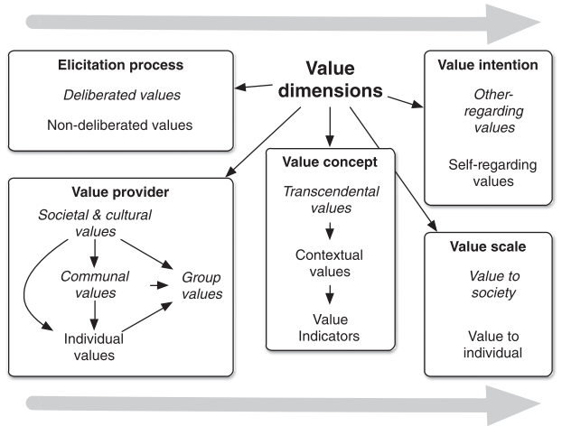
Figure 6: Shared and social values framework. Source: ^{[34]}
The value concept deals with three concepts – transcendental values, contextual values and values indicators. Transcendental values are guiding principles that transcend specific situations. They determine how people judge and justify actions and behaviours. Contextual values are opinions of worth or importance that is assigned to something while value indicators a measure of the worth or importance of a thing either monetarily or in non-monetary terms.
The value provider signifies the entities that provide the value whether they are societies, communities, groups or individuals. The elicitation process seeks to differentiate between the values produced through a deliberative process versus a non-deliberative process. The value scale describes the scope, the magnitude and the reach of value expression. It could either be at the individual level or societal level ^{[34]}. The final dimension of Kenter’s classification framework is value intention. Values intention explains whether values are self-focused or other-centered/altruistic.
The Intergovernmental Panel on Biodiversity and Ecosystem Services (IPBES) also makes a case for three types of values based on people’s relationship with nature and nature’s contributions to people (NCP). They include intrinsic, instrumental and relational values ^{[171]}. Intrinsic values are values inherent in nature. They are not ascribed or generated by people but independent of human experience or valuation ^{[41]}. Instrumental values are ascribed to nature as a means of achieving human preferences. These values are indicative of the human needs met. Relational values are values that do not directly emanate from nature but are derivative of our relationships with it and our responsibilities towards it ^{[39]}
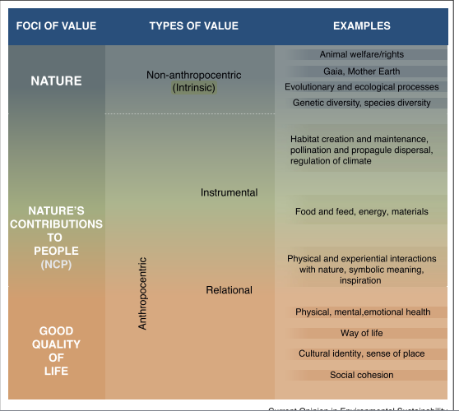
Figure 7: Main types of values (according to IPBES). Source: ^{[41]}

2.6.2.2.1 How Shared Values are assessed
Similar to the economic valuation of ecosystem services, there are several methods that have been adopted for the valuation of shared values of ecosystem services. These methods are deeply rooted in the adoption of deliberative procedures. Furthermore, some studies have been carried out to incorporate monetary variables in the valuation of ecosystem services. An example is the concept of deliberative democratic monetary valuations which are aimed at eliciting a group’s willingness to pay for a good or service. It is just one of the several other variants of deliberative methods. Table 3 gives an overview of the different valuation methods used in assessing shared values.
Table 3: Overview of methods that can be used to assess shared, plural and cultural values ( Adapted from ^{[34]})
Technique |  | Description
Deliberative | In-depth discussion groups | Group (usually 4 – 8 people) discussions (often repeated), during which participants shape the terms of discussion, develop themes in ways relevant to their own needs and priorities.
Deliberative | Citizen’s juries | A small cross section of the general public who come to a considered judgement about a stated policy issue / problem through detailed exposure to, and scrutiny of, the relevant evidence base. Group responds by providing a recommendation or ‘verdict’.
Deliberative | Deliberative opinion polls | Technique designed to observe the evolution of the views of a large citizen test group as they learn about a topic. Typically the group votes on the issues before and after an extended debate.
Analytical-deliberative | Participatory modelling | The involvement of stakeholders in the design and content of analytical models that represent ecosystem services and their benefits under different spatial and temporal conditions.
Analytical-deliberative | Deliberative monetary valuation | Techniques that use formal methods of group deliberation to come to a decision on monetary values for environmental change. May be allied to survey-based techniques (contingent valuation or choice experiments) or use a non-econometric approach to establish values (e.g. by incorporating citizen’s juries).
Analytical-deliberative | Deliberative multi-criteria analysis | Techniques that involve groups of stakeholders designing formal criteria against which to judge the non-monetary and (sometimes) monetary costs and benefits of different management options as the basis for making a decision.
Interpretive, potentially deliberative | Participatory mapping/GIS | A group of stakeholders consider or create a physical or digital map to indicate landscape features that are valuable (and/or problematic). Participants may also rate or rank these features for importance. Map layers can also incorporate photo, video, artwork, poetry etc.
Interpretive, potentially deliberative | Storytelling | Participants are asked to tell stories about their experiences of or in relation to places. These may be reflected upon in a group setting to discuss values related to these experiences.
Interpretive, potentially deliberative | Interviews | Participants are interviewed about their values, beliefs and preferences. Group interviews allow for deliberation and are similar to in-depth discussion groups. However, in group interviews, terms are set by the interviewer rather than the group.
Interpretive | Media analysis | Use of a range of textual analysis tools (particularly content, frame and discourse analysis) on (mass) media outputs and social media content over a selected period of time.
Interpretive | Desk-based cultural history study | A wide range of qualitative techniques including ethnography and participant observation, genealogy, life history methods, dramaturgical analysis, textual analysis of various sorts including discourse, content and frame analysis.
Interpretive | Other interpretive methods | A wide range of qualitative techniques including ethnography and participant observation, genealogy, life history methods, dramaturgical analysis textual analysis of various sorts including discourse, content and frame analysis.
Psychometric deliberative | Values compass | This method asks participants to consider which of their individual transcendental values are most important by ranking or rating them, and then asks to discuss the degree to which these values are important for one’s community, culture or society. Values can also be ranked or rated on a group basis.
Psychometric | Subjective well-being indicators | These can be used to assess how and the degree to which places contribute to one’s well-being, and are thus highly suitable for assessing the value of cultural ecosystem services using a quantitative non-monetary metric.
Psychometric | Other psychometric | Psychometric testing refers to the measurement of psychological phenomena and processes, e.g. knowledge, experience, attitudes, values, beliefs, norms. Psychometric models can be used to better understand the impact of deliberative processes on values.

The table above contains a variety of techniques used in assessing the shared values of groups. It can be noted that each method is suited for a particular context and usage depends on the objective of the researcher, the prevailing circumstance and training or expertise on the chosen method. The WeValue crystallization process which is used in this study is a combination of deliberative, participatory and interpretive processes.

2.6.2.2.2 Current gaps in ESS valuations - Situating ESS in the Values Framework
The nature-culture dichotomy prevalent in many conceptualizations of the ecosystem ^{[2]} ^{[172]} is responsible for the over-emphasis on the tools and outcomes of environmental management (supply) with a resultant effect of insufficient attention being paid to the realistic, localized circumstances of using the tools and producing the effects (demand) ^{[173]}. These practical, local, social and material contingencies are referred to as situated practices. There are increasing calls to consider situated managing agencies, actors and their practices in environmental management so as to inform new areas of critical intervention ^{[173]}. Situated knowledge require that the object of knowledge be pictured as an actor and agent, not as a screen or a ground or a resource^{[174]}. The adoption of this situated practice perspective in ESS research will ensure that ESS knowledge is locatable and accountable ^{[151]}.

2.6.2.2.3 Our Fresh Approach for ESS
The persisting challenge of producing and incorporating culturally appropriate indicators is reported in other domains. For example, sustainable development, which has three established pillars – financial, environmental and social, still advocates for a fourth category, a values-based dimension ^{[175]} ^{[18,176]}). Similarly UNESCO ^{[177,178]} and The UN Food and Agricultural Organization (FAO) also promote a cultural perspective ^{[179,180]}. These are considered to be operationalizable at group levels using an intersubjective values-based indicator approach (^{[18,181]}). This approach has been refined to form the WeValue InSitu crystallization process (WVICP) ^{[22,27]}.

The WeValue InSitu crystallization process was originally designed to help in generating localized, authentic indicators. It was first utilized with civil society organizations who expressed a need to capture the worth of their work using their own indicators and not the conventional key performance indicators which adopted a top-down approach. It was co-developed through action research in a European Union Seventh Framework Program research project ^{[21]}; ^{[20]}). It has been refined and used to crystallize the intangible values of several groups ^{[23]}. The main product of a WeValue InSitu crystallization process is the contextual depiction of the situated shared values of a group using their own words (For example see Figure 8) also described as their values frameworks. The frameworks are accompanied by a narrative which gives meaning to the statements of values, usually done for the benefit of external people.
The WeValue InSitu crystallization process is conducted using a workshop format that lasts for 2 – 6 hours for groups of 3 – 15 persons (for ease of management). It has been used in Botswana ^{[27]}; Nigeria ^{[26]}; UK ^{[44]}; India, Indonesia and Senegal (https://actionagainststunting.org) and several other countries and group contexts ^{[22]}.
The prospects for the usefulness of the WeValue InSitu crystallization process is reinforced by some of its features. First, it is highly flexible and not restricted to any expert group. It possesses a wide range of applicability and can accommodate diverse beneficiaries of ecosystem services including the local people. Secondly, it exhibits a high degree of authenticity since participants report that it represents their shared values ^{[24]}. Thirdly, the values elicited and crystallized are known to fit into a naturally existing envelope of things considered important to the group ranging from values about family ties, religion and spirituality to environment. So, statements about ESS are found to co-exist naturally with other values of similar importance to the group. The next characteristic of this approach is that it does not interfere with the ideas of the group hence the facilitator only guides the deliberative process but never contributes to the content. Fifthly, since the process involves a lot of sharing, participants usually enjoy the process ensuring improved engagement and participation ^{[24]}.
In summary therefore, the WeValue InSitu crystallization process could be useful in reducing the tensions reported in some studies on cultural ecosystem services. This study aims at eliciting situated shared values of ESS by first assisting the local groups to clearly express what is important to them in their own way and thereafter inspect the envelopes of values statements for the existence of ESS-related values.

CHAPTER THREE

METHODOLOGY

3.0 Overview
In this study, our aim was to explore and identify the situatedness of environmental values and ecosystem services among other social values of a group. The norm in ecosystems research has been to conduct valuation studies in isolation from other human values of the group. In this chapter, we outline the specific methods that were engaged in this study. Our specific aim is to show how we can elicit envelopes of shared and social human values and then retrospectively identify the ecosystem services and environmental values situated within these envelopes of shared values.

This chapter provides a roadmap of the methodology that was followed in answering the research question presented in Chapter one. The fundamental methodology involved the use of the WeValue InSitu process to generate the comprehensive range of shared values of individual groups. The choice of the groups is given later in this chapter.

Since the WeValue processes are always localized, several operations were carried out prior to the main session. This involved key informant interviews, translation, transcription and coding analysis of the interviews and generation of trigger lists. After the WeValue sessions, the elicited values were further authenticated by the local people as being valid and representative of their true values. An exploration of the perspectives of the participants towards ecosystems was conducted immediately after the WeValue InSitu processes and the data recorded. Both the authentication procedure and the perspectives exploration of the groups were carried out using focus group interviews. Semi-structured interviews were also conducted individually on the participants 2-10 days after the WeValue process in order to obtain data about the effectiveness of the process. Afterwards, the qualitative dataset obtained from the WeValue process i.e. the values envelopes of the various villages were analyzed using the framework of the Millennium Ecosystem Assessment to ascertain which of the value statements were ecosystem service-related (ESS-related). These were then classified into the different categories recognized by the MEA.
The Millennium Ecosystem Assessment was chosen in this study because it was easy to operationalize and demonstrate clearly. Other studies affirm the flexibility of this framework and the ease of applicability (^{[182,183]}; ^{[184–186]}. The details of the methods are presented later in this chapter.

Therefore, for the purpose of this study, we have accordingly divided the methodology into two parts – Data Collection methods and Data Analysis methods. However, there is a preparation phase just before the commencement of the data collection stage. The data collection methods include all the procedures carried out from the commencement of the WeValue InSitu process right up to the end of the WeValue process. The data analysis methods commence from the coding process, through the production of the values envelopes to the identification and final classification of ESS-related statements using the MEA framework.

3.1 The Need for Qualitative Research
This study employed qualitative rather than quantitative methods in the execution of the research objectives. By their nature, cultural services provided by ecosystems cannot be properly studied outside of their natural setting. This explains the reason for the adoption of case studies described as datasets in this study. The contextual nature of this study demands that the participants be investigated for not only the services valued but the motivations for such values. Such data cannot be effectively captured by numbers like in the neoclassical economic arena, hence the need for a more appropriate research design.
Secondly, the subjectivity associated with the studies on cultural values makes it difficult, if not impossible to design a single metric for evaluation. The obvious consequence is that policy makers have a difficult time arriving at an appropriate decision that is suitable and which can be generalized across different sites.
^{[46]} report that qualitative research is useful in producing holistic understandings of rich, contextual and generally unstructured non-numeric data. This is usually achieved by engagement in conversations with research participants in their natural settings ^{[47]} where they are able to produce answers to ‘how’ and ‘why’ questions ^{[187]} which are well suited for exploratory and descriptive studies ^{[187]} .

3.2 Research Design
The WeValue InSitu workshops were conducted in three sites. The samples were chosen based on convenience and their willingness to participate in the study. In this study, three major group types were chosen – village councilors, village committee members and teachers. The only standard requirement was that they were to be a community of practice, i.e. those who had worked or were working together. None of the group samples of members were required to be experts in any field. Furthermore, due to the nature of the study and time required to effectively and sufficiently carry out meaningful discussions and obtain contributions, the number of participants per group was restricted to 3 – 8 persons per group. The workshops typically lasted an average of 2-3 hours per session.
Since the research design was exploratory, the groups were not intended to be representative but indicative and to allow for an investigation and survey of the situatedness of the shared environmental values amongst envelopes of other shared human values. To further probe variations across groups on the basis of identity, locality and function, the study was extended beyond 9 groups of village councilors in Ufuma to include 2 other groups of village councilors in Nanka, 3 groups of village committees with differing roles in Ufuma: Youth (unmarried adults), Women and Health, 3 groups of secondary school teachers in Ufuma and another 6 groups of secondary school form teachers in Nsukka. The inclusion of varieties of groups in the study was to enable to check for trends and patterns between and amongst them. It is noteworthy that the participants were not experts in Ecosystem Service valuations or studies. They were just people who possessed common-place knowledge of the environment and ecosystems. The outputs of the workshops which are shared values statements were all thematically coded using the Millennium Ecosystem Assessment framework ^{[1]}. The Millennium Ecosystem Assessment classifies ecosystem services into 3 broad categories of provisioning, regulating and cultural. The cultural category is further subdivided into 10 different groups.
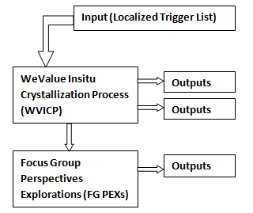
Figure 8: Research Design Flow Chart

3.2.1 Study site and Group Choice
The exploratory nature of this study permitted flexibility in the choice of sites. Both rural and more-urban sites were included in this study. The sites chosen had different ecosystem service contexts which might be reflected in the elicited shared values. The choice of groups eventually used in the study was based purely on availability and willingness to commit their time to participate in the workshops.
The study was carried out in three towns - Ufuma and Nanka, both of which are located in Orumba-North Local Government Area of Anambra State and Nsukka town located in Enugu State. The three towns are located in the southeastern part of Nigeria. While Ufuma town has 3 main communities with 9 villages, Nanka comprises 7 villages. The 2 communities possess a tropical climate with temperatures ranging between 25°C and 37°C and an annual rainfall ranging between 1500mm – 2700mm ^{[188]}. The area is characterized by 2 seasons – rainy season which lasts from April to October and dry season lasting from November to March ^{[189]}.
These communities are predominantly rural/semi-urban and are classified as agrarian as majority of the residents are subsistence farmers and traders who sell their farm produce in the weekly market called Afor/Afọ. The presence of fertile and arable lands in Ufuma has earned the community a pride of place as a renowned farming community with the king of the community referred to as ‘Diji’ – an agricultural term meaning a great farmer of yams. This has also attracted some World Bank interventions like the establishment of large portions of rice farms and fish farms. Ufuma is well-known for the cultivation of yams, cassava, maize and oil palm.
Nanka is renowned by the presence of a natural spring called ‘Isi atama’. This spring may well be considered the livewire of the community as a lot of activities revolve around it. Recently, the community granted permission to a company to start the production of bottled and sachet water for sale. The company employs a lot of the villagers to work and also carries out some corporate social responsibilities like road maintenance. Nanka is bedeviled by serious cases of gully erosion. History reports that the gully erosion has its origin in the slave trade where the foot paths of the slaves and traffickers were heavily flooded and led to the formation of gullies. In 2010, members of the community donated about 10,000 cashew seedlings to plant in the erosion site to aid the control of the gully which had led to frequent landslides. The gully sites are a serious concern to state, and national government and have been designated a disaster zone by the Nigerian Environmental Agency ^{[188]}.
Nsukka town is the headquarters of Nsukka Local Government Area. It is the boundary town that connects the south east to the north central part of Nigeria. It plays host to the University of Nigeria and has a tropical climate. It has an average temperature of between 22.3°C and 32.1°C and a mean yearly rainfall of 1695.4mm. Nsukka has a population of around 1.5 million. It is also a semi-urban town with the inhabitants being predominantly farmers, traders, civil servants and students. Nsukka is also an agricultural community and many inhabitants are engaged in subsistence agriculture planting crops like cassava, maize, oil palm, cowpea, cocoyam etc. Being host to the first indigenous university in Nigeria, it provides a hub for the convergence of people from different cultures. Flooding and erosion are the major environmental problems encountered in this town.

3.2.2 Preparation of Localized Wevalue Materials
The WeValue InSitu process is carried out in different stages or phases. Usually, before the commencement of the main phases of the WeValue InSitu process, there is need to prepare locally relevant materials that will be suitable for the intended audience. The standard procedure involves the localization of these materials; hence WeValue can be carried out anywhere because the materials can be readily adapted for local contexts. This localization phase involves the following:
- Conduct of key informant interviews
- Translation and/or transcription of the interview data
- Development of Local Trigger Lists
- Retranslation of the trigger lists into the local language (when English is not the language of use)

3.2.2.1 Key Informant Interviews
Key Informant interviews are non-deliberated informal interviews conducted by a researcher to get the understanding of the targeted community or audience. These interviews act as the researcher’s first line of contact with the locality. During this process, the identified people are asked about what is important, valuable and meaningful with respect to where they live.
Prior to the interview, the informed consent of interviewees was obtained. They were informed that the data would be used for research purposes and that every personal detail would be anonymized. This preliminary interview to ascertain the predominant themes of importance in the locality was carried out with 5 persons from the communities. In this study, the people chosen were asked several questions on the beliefs and ways of life of the community. The people chosen were individuals who had in-depth knowledge about the community and could give unbiased ideas about different aspects of community life. Questions asked were generic questions which provoked profound thoughts about the place where they live. The interview was recorded with an audio recorder using the Sony ICD-PX470 Digital Voice Recorder. Another mobile device was also used as a backup for recording the interviews. Given below are the questions that were used in this study:
A. What do you hold so dear about life in Ufuma that you wish is never forgotten?
B. What is Ufuma known for?
C. What reasons would you give someone to relocate to Ufuma?
D. If there is a need for you to go outside the community for sometime (holidays etc), what would you miss most about Ufuma?
E. What are the expectations of elders from the Youths?
F. What are your expectations from your children?
G. Are there any developmental projects that have been done in Ufuma, past or present?
H. Are there developmental activities in Ufuma linked to Agriculture?
I. If there is a situation to choose between developmental projects in Education or Health or Agriculture, which would you choose?
J. Is there anything about Ufuma that you can never trade for anything?
At the completion of the key informant interviews, the data obtained was collated for the next stage which involved translation and transcription of interview data.

3.2.2.2 Translation and/or Transcription of the Interview Data
The interviews were conducted in the Igbo language because that is the native language of the residents of these 3 communities. Since the researcher is also of Igbo origin, the data gotten from the interviews were then translated and transcribed from Igbo to English by the researcher. The transcription was carried out using word processing software – MS Word 2007 and stored in a safe and secure drive.

3.2.2.3 Development of Local Trigger Lists
Using the data generated from the key informant interviews, a trigger list was developed. The trigger list is a ‘Menu’ of values-statements that represent what is most worthwhile, valuable and meaningful to a group of participants. Trigger lists are usually generated from the local environment where the workshop is to take place. Although there exists a global trigger list which has been developed from series of past workshops and interviews and which can readily be adapted for different contexts, this study ensured that the localized list generated from the Key informant interviews were utilized.
The procedures involved in the development of the trigger lists are listed below (not in the exact order):
- Interviews
- Transcriptions
- Translations
- Statement Extractions
- List Creation
- Mapping to WV125
- Natural clustering
- Removing Duplicates
- Localising Trigger List
- Adapting Resources
- Translation
After the transcriptions and translation of the interviews, extraction of statements was carried out on the transcripts. This was done by reading through the transcripts and drawing out clips of sentences that are values-related. The clips that were chosen are sentences that express the values of the people in any way. The extracts were then recorded in a list. This process of statement extraction was also carried out by a second person to ensure validity. Afterwards, duplicates of similar statements were removed to produce a finalized list. The list was then clustered based on recurring themes. Afterwards, the clustered statements were mapped to the global list of 125 Statements. The purpose of this was to discover the themes that were missing in the local list and decide if it was necessary to add statements that would bridge the gap. The list of statements was also analyzed to be sure that they were disruptive enough to trigger discussions. At the conclusion of this process, a definitive list of localized trigger statements was produced which would be deployed for the WeValue workshops in the various communities.

3.3 Data Collection Methods
The data collection methods include all the methods that were utilized in eliciting and collecting the data useful for answering our research question of how to generate situated environmental and ESS-related values within the general values framework. In this study, 2 main methods were used in generating and collecting data – the WeValue InSitu Crystallization Process (WVICP) and the Focus Group Perspectives Explorations (FG PEXs). The methods are described in more details below.
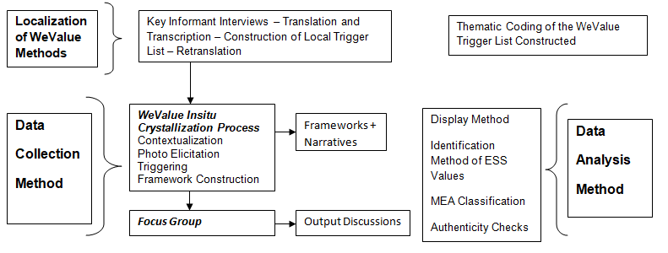
Figure 9: General Overview of the Data Collection and Analysis Methods

3.3.1 The Wevalue Insitu Crystallization Process (WVICP)
In this section, we describe the various activities that were carried out within the WeValue process. The WeValue InSitu process is an approach to eliciting values in a group context and connecting those values to concrete and specific actions, feelings or perceptions. It was developed and used as part of a European Union Seventh Framework Programme, called ESDinds, led by University of Brighton ^{[20]}. The WeValue approaches are deeply participatory and were co-developed through ongoing work with community groups, businesses, schools and Civil Society organizations ^{[20]}. It has been used in different studies to elicit shared values in different contexts such as in sustainable land remediation ^{[26]}, climate change ^{[24]}, education for sustainable development ^{[44]} etc.

In this study, WeValue workshops were carried out with 23 groups comprising village councilors, teachers and village committees for youth, women and health. Most of the workshops were carried out using the local Igbo language which is the major language spoken in the southeastern part of Nigeria. A few of the workshops were done in English, especially with the Teachers’ groups. The workshops were recorded with a Sony ICD-PX470 Digital Voice Recorder and another mobile device as a backup. Prior to the commencement of each workshop session, informed consent was obtained from the participants both orally and by filling out the informed consent forms. This was in line with the ethical approval guiding the conduct of this research which was gotten from the University of Brighton. In the sub-sections below, we explain the 4 stages of a WeValue workshop which were carried out in our study ^{[190]}.
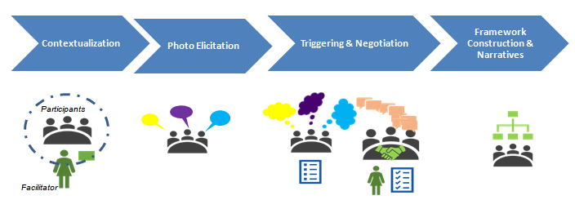
Figure 10: Steps in the WeValue InSitu Process.

3.3.1.1 Contextualization Stage
Each workshop session started with a period of introduction of the facilitator and the participants. The aims and responsibilities of the groups were also mentioned and other baseline questions were answered. Questions about the kind of relationships that exist between the group members, the challenges faced in the execution of their responsibilities and even how they plan to improve on their work are asked. The purpose of these baseline questions was to establish a basis for monitoring changes in perceptions and understanding during and after the workshops. It is also necessary for evaluating transformative outcomes and tracking organizational change.
The questions asked in this phase included such things as
- What do you do?
- How many people do work in your group?
- What kind of relationship do you have in your ward?
- Do you work separately or together?
- What challenges do you have in your ward?
- What would you want to improve?
- Is there something you are doing about erosion control or spring management or land management?
This stage sets the scene and atmosphere for the rest of the workshop and enabled the participants to relax and deeply engage with each other in the group context.

3.3.1.2 Photo Elicitation Stage
Following the contextualization stage, the participants then proceeded to the next stage of photo elicitation. The participants were invited to think about anything that was important, meaningful, worthwhile and valuable to them – whether things, places, ideas or practices. The photo elicitation stage makes use of pictures and images from everyday life for eliciting the tacit and dormant knowledge in the participants. Photo cards measuring 21cm by 15cm were displayed on tables and benches at the workshop venue and the participants were welcome to choose any picture that best reflected what was valuable, meaningful and worthwhile to them. The participants spent a couple of minutes to choose the pictures that were most suitable for them. They were also told at this stage that there were no predefined meanings attached to the pictures. After choosing their preferred pictures, the participants were then invited to talk on the pictures they had chosen one by one. They were asked to explain what the picture meant to them, why they chose it and what messages they felt the picture was helping them to pass across. During this exercise, the participants practiced deep listening as their colleague shared their perceptions and understanding of the chosen photo.

3.3.1.3 Triggering and Negotiating Meaning Stage
The triggering stage was conducted using the list of trigger statements generated from the key informant interviews. This is the standard practice for all WeValue InSitu work in new locations ^{[26,191]}. In this study, a list of 76 trigger statements was used. Participants were allowed to read the trigger lists and mark statements that most resonated with them. In cases where the workshops were carried out with an illiterate group, the researchers produced a “Bingo” sheet that contained the numbers 1 – 76. Then the trigger statements were read out to the participants and they marked the numbers that most resonated with them. After reading and marking the trigger list (or bingo sheet), the participants started discussing and negotiating the ideas generated from the list.
During the triggering, the facilitator was responsible for keeping the discussions focused and not distracted. The facilitator also helped in ensuring disentangling of ideas and the balance of power in discussion. After each round of discussion, the participants wrote down an agreed-upon statement that represented the general consensus of the group. These statements are considered as the shared values of the group because they were produced through deliberative and participatory mechanisms. These statements were bespoke articulations of the values of the people and are products of rigorous dialogues and conversations involving examples, counter examples and experiences. This process was repeated until the participants could produce no further statements.

3.3.1.4 Framework Construction and Narrative
This is the fourth and final stage of the WeValue InSitu process. At this point, the participants have thoroughly deliberated upon all the statements that were triggered. They were then invited to carefully arrange the list of Values statements produced in a coherent manner that portrayed how they want the statements to flow. Some of the groups arranged their statements linearly from bottom to top or vice versa as the case may be. This was also a period for further deliberations and they were told that they were free to adjust, add, remove or rewrite some of their value statements. This was to be sure that the final outcome was indeed a product accepted by all. The arrangements were commonly ordered on the basis of the vision of the group, their characteristics and how they work. When they were satisfied about the arrangement of the statements, they were invited to give a summary of the framework from the beginning to the end just as if they were explaining to a third party that wanted to know about them.
The framework construction and the accompanying narratives are the final products of the WeValue InSitu process. Immediately after the process, a focus group was carried out to test for authenticity of the statements. The details of the focus group are presented in the next section.

3.3.2 Focus Groups
In this study, 2 focus group discussions were held with the participants immediately after the workshop. The first focus group was designed to capture the extent to which the participants took ownership of the general statements and frameworks produced from the WeValue InSitu process while the second focus group was to specifically confirm the authenticity of the environmental and ESS-related statements produced during the WeValue session.

3.3.2.1 Focus Group 1 – Test for Authenticity
The first focus group interview that was held was designed to test the authenticity of the values statements which made up the envelopes.
The WeValue process is inherently designed to test for the authenticity of the statements produced from the deliberations. This is established by other studies which utilized the tool ^{[24,26]}. The validity of the process was usually tested at the end of the session when the facilitator asks the participants questions to confirm if the words used in the statements were theirs or that of the facilitator. In addition, they were also asked if there was anything missing from the frameworks and if the frameworks adequately represented them. This was done to ascertain whether the statements written down represented the authentic, genuine, unbiased views of the participants.

3.3.2.2 Focus Group 2 – Perspectives Explorations (PEXs) concerning the Environment
The second focus group interview was conducted just immediately after the conclusion of the WeValue InSitu process. This focus group session was conducted to explore the perspectives of the group concerning their environment. This was an exploratory ‘add-on’ to investigate the output of the groups after a session of participatory deliberations and possibly check for variations or similarities with environmental themes discussed during the WeValue process. However, the questions were more directly focused on environmental attributes of the communities including the natural resources present in the area.

3.4 Data Analysis Methods

3.4.1 Transcription and Translation of the Qualitative Dataset
The deliberative processes for this study were conducted in 2 languages – the Igbo language and English language. In some cases, there were mixes of the two especially when the participants wanted to better express themselves or refer to some items that the names were not readily known in the English language. The workshops were recorded using a Sony ICD-PX470 Digital Voice Recorder and a mobile device as a backup after informed consent was gotten from the participants. The recordings were then transferred to the computer system for storage and further analysis.
The workshop summaries were first translated by the researcher from the Igbo language to the English language. Afterwards, it was transcribed and produced as Microsoft office word documents.

3.4.2 Thematic Coding of the Qualitative Dataset
Thematic coding or analysis is a method for analyzing qualitative data and has been used in different fields like sports, psychology, health etc. ^{[192–194]}. It is a flexible method that allows for application across a range of theoretical and epistemological approaches. Thematic analysis is a method for identifying, analysing, and reporting patterns (themes) within data. It involves familiarizing yourself with your data, generating initial codes, searching for themes, reviewing themes, defining and naming themes and producing the report ^{[192]}
In this study, the values frameworks (statements) were specifically used for the coding analysis. The values frameworks from the workshops were coded inductively for mentions and references to the environment or any aspect of Mother Nature. These coded statements were then extracted as indicators of environmental values and ecosystem services. The extracted statements were then put forward for classification using the analytical framework.

3.4.3 Classification using the Analytical Framework (Millennium Ecosystem Assessment Framework)
The elicited ESS-related values which were extracted from the process of thematic analysis were afterwards classified using the framework of classification produced by the Millennium Ecosystem Assessment ^{[1]}. The framework classifies ecosystem services into three broad categories of provisioning, regulating and cultural services with the cultural services having 10 subcategories. In order to achieve a reliable classification, the ESS-related values statements together with the accompanying narratives were matched with the descriptions provided in the MEA framework. The narratives were included to ensure that the statements retained the meanings intended by the participants and not the interpretations offered by the researcher. The classifications were verified by 2 independent researchers. Table 3 gives the definition of the different categories of ecosystem services and the criteria for classification.
Table 4: Description of the basic categories of Ecosystem Services (According to ^{[1]})
ECOSYSTEM SERVICE TYPE | DESCRIPTION
PROVISION-ING (PRV) | These are the products obtained from ecosystems, including food, fiber, fuel, genetic resources, biochemicals, natural medicines, and pharmaceuticals, ornamental resources and fresh water.
REGULATING (RGL) | These are the benefits obtained from the regulation of ecosystem processes, including: air quality regulation, climate regulation, water regulation, erosion regulation, water purification and waste treatment, disease regulation, pest regulation, pollination and natural hazard regulation.
CULTURAL  (CLT) | These are the nonmaterial benefits people obtain from ecosystems through spiritual enrichment, cognitive development, reflection, recreation, and aesthetic experiences,

3.4.3.1 Cultural Ecosystem Services (CES)
As stated before, these are the intangible, immaterial benefits we derive from ecosystems. The Millennium Ecosystem Service Assessment proposes 10 kinds of these cultural services. They are explained here for greater clarity and to aid in correctly classifying the cultural ecosystem services identified in this study. It should be stated that although the definitions of these different classes of CES are distinct, they nonetheless overlap in real world classifications. Therefore, situations where an ecosystem service matched the descriptions of 2 or more cultural categories, they were indicated as belonging to the different categories and classified as hybrid values. This did not result in double-counting of ESS in the values frameworks of the groups but only took into consideration the occurrence, diversity and spread of the ESS categories in the frameworks.

The definitions and descriptions of the different classes of CES are presented below as illustrated by MEA and other supporting studies.

3.4.3.1.1 Spiritual and Religious (SPR)
Many religions attach spiritual and religious values to ecosystems or their components . When ecosystems fulfill people’s need for sacred, religious and spiritual fulfillment and satisfaction, they are said to have spiritual value. This is manifested in the designation of certain sites as places of spiritual value or the assigning of certain celebrations as having spiritual significance. For example, there are cases of “holy” forests, sacred rivers or streams, dedicated plants, animals and even landscape features like mountains. This attribution of spiritual worth is captured and portrayed by ecosystems.

3.4.3.1.2 Recreation and Ecotourism (RCR)
People often choose where to spend their leisure time based in part on the characteristics of the natural or cultivated landscapes in a particular area ^{[1]}. Rest, relaxation, refreshment and recreation are important needs of humans often derived from association with certain ecosystems. There exists a vast array of nature-based recreation such as walking, bird-watching, fishing, swimming etc. As people spend their leisure time in the appreciation and enjoyment of nature, they are partaking in recreational ecosystem services. This particular service has serious potentials for growth as affluence and demand continues to increase in the future.

3.4.3.1.3 Aesthetic (AES)
Many people find beauty or aesthetic value in various aspects of ecosystems, as reflected in the support for parks, scenic drives, and the selection of housing locations ^{[1]}. This is simply the appreciation for the beauty of natural environments. The pleasure derived from this is evidenced by the creation and demarcation of “scenic spots and routes”. Certain human behaviour such as using decorative plants in homes are also indications of this value.

3.4.3.1.4 Inspirational (INSP)
Ecosystems provide a rich source of inspiration for art, folklore, national symbols, architecture, and advertising ^{[1]}. Natural and cultivated systems influence and stimulate a vast array of cultural expressions in the form of arts, music, literature, architecture, fashion etc. The derivation of ideas from ecosystems is considered an inspirational service.

3.4.3.1.5 Sense of Place (SOP)
Many people value the “sense of place” that is associated with recognized features of their environment, including aspects of the ecosystem ^{[1]}. This refers to the perception and interpretation of the environment in an emotional spiritual and cognitive way. It is developed as a result of socio-cultural processes that take place while people interact with the physical environment ^{[86]}.

3.4.3.1.6 Cultural Heritage (CH)
Many societies place high value on the maintenance of either historically important landscapes (“cultural landscapes”) or culturally significant species ^{[1]}. Heritage is conceptualised as the ‘past received through objects and display, representations and engagements, spectacular locations and events, memories and commemorations, and the preparation of places for cultural purposes and consumption’ ^{[195]}. When certain ecosystems give us a sense of continuity and understanding of our place in the natural environment, cultural heritage is achieved.

3.4.3.1.7 Cultural diversity & Identity (CDI)
The diversity of ecosystems is one factor influencing the diversity of cultures ^{[1]}. The cultural linkage between people and their ecosystems and through which they derive and define their identity, personality and uniqueness. Usually these are ecosystems in which they live and on which they depend.

3.4.3.1.8 Knowledge systems (KS)
(Traditional and formal). Ecosystems influence the types of knowledge systems developed by different cultures ^{[1]}. According to UNESCO, this knowledge comprises understandings and philosophies developed through long histories of interaction with the natural environment. It is central to how a people utilize their resources, communicate, interact and practice their spirituality. It is not just about what is known but also about how it is known.

3.4.3.1.9 Social relations (SR)
Ecosystems influence the types of social relations that are established in particular cultures ^{[1]}. Among CES, “social relations” is regarded as the key to understanding the role of ecosystems in breaking down social barriers and bringing citizens together ^{[196]}. To clarify the definition of SR, we list five indicators based on previous studies.
- Ecosystems provide opportunities for people to meet each other
- Ecosystems provide opportunities for Knowledge and values sharing through a variety of interactions ^{[197]}.
- Ecosystems provide a context for sharing, exchanging, selling or buying products with others ^{[198]}.
- Ecosystems provide an avenue for people to participate in activities with others ^{[199–201]}.
- Ecosystems provide a basis for creation of bonds with people and generation of social capital ^{[202]}.
Using the guide provided by the MEA classifications, the values statements in the different envelopes were carefully analyzed to determine whether they fell within any of the MEA categories or sub-categories. During this process, the narratives which were derived from the workshop were used to give context to the statements. This was another way to ensure validity in the classification and to certify that the meanings intended by the participants were incorporated and not the meanings assumed by the researcher.
Subsequent to the classification of the values was the analysis of the results which involved drawing out trends, making comparisons, highlighting patterns and making generalizations.
In summary, this chapter describes the steps and processes that were involved in generating and analyzing the values frameworks of various groups. It also describes the Millennium Assessment framework and how it can guide in classifying values. In the next chapter, the results obtained from these steps will be presented.

CHAPTER FOUR

RESULTS

4.0 Overview
In the last chapter, we demonstrated how the use of a values-based deliberative approach known as the WeValue InSitu crystallization process was used in conjunction with an analytical framework (The Millennium Ecosystem Assessment) to elicit, identify and situate ecosystem services in an envelope of values. These envelopes of values contain statements of shared values of the group and shared values are what is important to people. In addition to the envelopes of values, a narrative was also developed. The narrative is the group’s description of how and why the value statements were chosen. It helps in understanding the reason and motivations for the values framework.
In this chapter we present the results of the WeValue InSitu crystallization process and the analysis that were carried out using the methods in the last chapter. It should be recalled that the aim of this study is to identify the shared values of different groups with regard to ecosystem services and to also demonstrate the situatedness of these ecosystem services and environmental values within the wider scope of other social values in the values envelopes of different groups. Additionally, the variations within sites and across groups are also investigated to check for patterns and trends.
Consequently, the results section of this thesis would contain a visual display of the values envelopes and narratives together with an in-depth presentation of the results of two groups of ward councilors in Ufuma and Nanka. This would be followed by a brief presentation of the results of other groups of ward councilor in the villages. Afterwards, the results of the village committees for the youth, health and women would be presented using the same format of a visual display of envelope and narrative plus an in-depth explanation of the results. The last group of results that would be presented would be that of the groups of teachers in Ufuma, Nanka and Nsukka. This will include a more in-depth presentation of some groups and a visual presentation of the values envelopes and narratives of some other groups.
Immediately following each section of result presentation (envelopes + narratives and in-depth explanation), we also present the results of an Ecosystem Analysis using the framework of the Millennium Ecosystem Assessment. The Ecosystem analysis shows the situatedness of the ecosystem services, the variations across groups, roles and sites, the specific ecosystem services elicited and the connection with the village contexts.
Using the data derived from the WeValue process and ecosystem analysis, we also compared results with reference to roles and sites for different groups of ward councilors, village committees and teachers. The results are presented below.

4.1 Situated Shared Values (Values Frameworks and Envelopes plus Narratives) of Village Councilors in Ufuma
Below I present results of two groups in some detail, to enable the reader to understand their nature and relationships to each other better. After that I present the results more briefly, but in terms of the sets of group types.

4.1.1 Village Councilor Group 8 (VC8)
This is a group of ward councilors. Their responsibility is to represent their constituency in matters of collective importance. They are the immediate governance structure for their village and mediate between individuals, families or groups to ensure general welfare, peace and progress. Additionally, they are entrusted with the responsibility of managing the collective resources of the community.
The diagram below is a structural representation of the values framework of VC8. It is an envelope of 8 statements produced by the group; hence it is referred to as a Values Envelope. The arrangement runs from a number 1through to number 8. The values framework of this group contains such themes as population growth, religion, farming, hard work, economic ability etc. Again, some of the values statements have diverse applications. For example, Statement 8 reads “We are empowered and can come together to discuss and agree on how to solve our challenges”. This statement contains the groups’ regard for empowerment, agreement and solving challenges together. This may be considered an example of value pluralism. The values envelope is presented below.
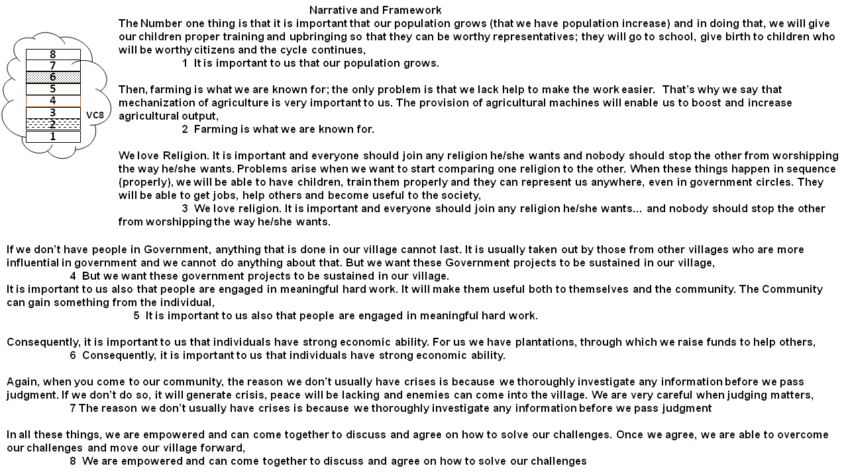
Figure 11. A visual display of the Values Statements and Narratives of Village Councilor Group VC8 in Ufuma
Village Councilors (VC) group 8 produced a set of 8 values statements linearly arranged. These statements were considered by the group as being important, worthwhile and valuable (meaningful) to them. The values framework of this group encompassed a range of ideas including desire for population growth, Farming, Religion, work, Livelihood and Unity. For example, the first statement in their framework reads, “it is important to us that our population grows”. This was probably viewed as a highly important value considering that it came first in the list of values. Again, the linear arrangement of the values statement can be regarded as an indication of the order of priority or scale of importance of the values listed. The values statement terminated with the aspiration that “we are empowered and can come together to discuss and agree on how to solve challenges”. This particular statement had several themes woven into it – empowerment, unity, good communication, agreement and solving challenges. This is indeed instructive in that although the values statements are concise and direct, they may have connotations for other themes that were not expressly mentioned. A complete list of the value statements is given below:

4.1.1.1 Value Statements of VC8
- It is important to us that our population grows.
- Farming is what we are known for.
- We love religion. It is important and everyone should join any religion he/she wants… and nobody should stop the other from worshipping the way he/she wants.
- But we want these government projects to be sustained in our village.
- It is important to us also that people are engaged in meaningful hard work.
- Consequently, it is important to us that individuals have strong economic ability.
- The reason we don’t usually have crises is because we thoroughly investigate any information before we pass judgment
- We are empowered and can come together to discuss and agree on how to solve our challenges

Furthermore, the statements produced were also accompanied by Narratives which explained or strengthened the meanings portrayed by the statements. The Narratives were attempts made by the participants to recap the value statements that they had chosen and why they chose them. It also showed the logical sequence of the statements – a kind of guide for assessing and interpreting the statements. The Narratives along with the values statements for Group VC8 are shown below.

4.1.1.2 Narratives and Values Statements for VC8
START OF NARRATIVE OF GROUP VC8:
“The Number one thing is that it is important that our population grows (that we have population increase) and in doing that, we will give our children proper training and upbringing so that they can be worthy representatives; they will go to school, give birth to children who will be worthy citizens and the cycle continues,
1 It is important to us that our population grows.
Then, farming is what we are known for; the only problem is that we lack help to make the work easier. That’s why we say that mechanization of agriculture is very important to us. The provision of agricultural machines will enable us to boost and increase agricultural output:
2 Farming is what we are known for.
We love Religion. It is important and everyone should join any religion he/she wants and nobody should stop the other from worshipping the way he/she wants. Problems arise when we want to start comparing one religion to the other. When these things happen in sequence (properly), we will be able to have children, train them properly and they can represent us anywhere, even in government circles. They will be able to get jobs, help others and become useful to the society.
3 We love religion. It is important and everyone should join any religion he/she wants… and nobody should stop the other from worshipping the way he/she wants.

If we don’t have people in Government, anything that is done in our village cannot last. It is usually taken out by those from other villages who are more influential in government and we cannot do anything about that. But we want these Government projects to be sustained in our village,
4 But we want these government projects to be sustained in our village.

It is important to us also that people are engaged in meaningful hard work. It will make them useful both to themselves and the community. The Community can gain something from the individual,
5 It is important to us also that people are engaged in meaningful hard work.

Consequently, it is important to us that individuals have strong economic ability. For us we have plantations, through which we raise funds to help others,
6 Consequently, it is important to us that individuals have strong economic ability.
Again, when you come to our community, the reason we don’t usually have crises is because we thoroughly investigate any information before we pass judgment. If we don’t do so, it will generate crisis, peace will be lacking and enemies can come into the village. We are very careful when judging matters,
7 The reason we don’t usually have crises is because we thoroughly investigate any information before we pass judgment

In all these things, we are empowered and can come together to discuss and agree on how to solve our challenges. Once we agree, we are able to overcome our challenges and move our village forward,
8 We are empowered and can come together to discuss and agree on how to solve our challenges
END OF NARRATIVE OF GROUP VC8.

The statements above together with the accompanying comments give a values portrait of the group. It shows an indication of the scale of preference that the group would adopt in any case of decision-making or situations where choices need to be made. We illustrate this further with the results from another group of ward councilors (VC9) shown below.

4.1.2 Village Councilor Group 9 (VC9)
The second group presented in detail for illustration is VC9, which plays similar roles as the first group, VC8. Their major responsibilities include mediation, management, governance and providing general leadership to their community. It should be noted that this group is composed primarily of men although it is not a written law that the group must be made up of the male gender. This may have its roots in some transcendental values which can be investigated in another study.

Village Councilors (VC) group 9 produced a total of seven value statements in their values envelope. The value statements were arranged in a cluster and not linearly. This is probably an indication that the values were considered equally important and hence, does not assume any particular order of priority. The seven values statements comprise values about family ties and social relations, excellence, youth, legacies and agriculture. The first statement reads “it is important to us that we ensure that family ties are maintained and that people are trained very well in the family”. This shows the centrality of the family structure in the values framework of this group. In fact, the statement also alludes that the basic discipline of training is to be carried out in the family. The second statement is closely linked to and builds on the first – “we value strong social relations and we support one another”. These two foundational values are reflections of the value of relationships in the functioning of the group and how it should be accommodated in their plans and actions.
The next 3 value statements are concerned with excellence, nurturing youths to take over legacies and hard work. This shows how they operate and conduct the affairs of the group. The values within this section indicate the actions that are taken by the group to prepare for the future. The last set of 2 values statements demonstrates the aspirations of the group. They speak about the desired future that they envisage. Statements about having improved varieties of economic trees and having equipments that can enable them engage in commercial agriculture speak of their long-term interests in agriculture. It definitely shows that they are primarily agrarian and their measure of success is defined by their advancement in agricultural practices and the attendant improved yields.

4.1.2.1 Value Statements of VC9
The list of values statements developed by VC9 is presented below:
- It is important to us that we ensure that family ties are maintained and that people are trained very well in the family
- We value strong social relations and we support one another
- It is important that we emulate excellence in all areas, in others.
- It is important to us that our youth are nurtured to take over from us and to follow our legacies
- It is important to us that everyone has something doing and is hardworking
- It is important to us that we have improved varieties of economic trees (example plantains)
- It is important to us that we have equipment and machines to engage in commercial agriculture
As is the practice, the statements were accompanied by a narrative to give contextual support to the framework. The narrative for VC9 is presented below and also shows where the statements fit into the picture and how they flow.

4.1.2.2 Narratives and Values Statements for VC9
The values statements and narratives for VC9 are presented below. We observe how the narratives help to bring out the obvious and intended meanings captured in the statements.

START OF NARRATIVE OF GROUP VC9:
It helps to ensure that everyone is well trained. Talking about family ties, for example when you come to the things we do, our hustles and our farm work, it means that when we wake up, and we want to go to work in the farm, we take our children along with us to the farm. If there is anything the family is doing, we ensure that our children join us. Even if they go to school, in the evening, after school hours, they still come to join us to work in the farm. We train them in these things,
1 It is important to us that we ensure that family ties are maintained and that people are trained very well in the family

As we work together in the farm, we interact a lot with each other because we meet each other in the farms. If there is anyone that has a problem or other emergency in the farm, we help them for example if they have problems with flooding in their farm lands, we help them. If someone planted certain crops and didn’t get a commensurate harvest, we help him by advising him on what to do. In some cases, we even help by giving him seedlings to replant and replace the spoilt ones. So we support one another,
2 We value strong social relations and we support one another
Thirdly it is important to us that we emulate excellence. Like in our farms, when we notice that someone’s crops were particularly very productive, we ask him and observe how he was able to achieve the results. And he will always advise us on the best way to approach planting that crop. He can tell us to plant certain crops only at certain times and when we do so, it produces the same result. As such when we see others having the same problem, we advise them in the same way so that they can also have the same output. That way, the excellence spreads,
3 It is important that we emulate excellence in all areas, in others.

It is important that our youth are nurtured and take over from us. Anyone who isn’t able to get a white-collar job should join us in the farm work and follow our precepts. Again, we value that everyone is hardworking, to have a means of livelihood in order to sustain oneself. If it isn’t farming, let the person learn another trade or craft, wherever his destiny leads him. The important thing is that everyone has a legitimate work is diligent in their work,
4 It is important to us that our youth are nurtured to take over from us and to follow our legacies
5 It is important to us that everyone has something doing and is hardworking

Being diligent in our work requires that we as farmers have need of improved varieties of seedlings (like plantain). Not just plantain but other economic trees and plants that will help us. Some of the seedlings we have can take up to 5-10 years to grow but if we can have access to the ones that can produce in 2-3 years, we will be happy because it will help us a lot,
6 It is important to us that we have improved varieties of economic trees (example plantains)

In our farm work, we usually depend on manual labour to do the work and it has serious limitations in terms of the size of land that can be cultivated. So we need mechanized agricultural equipment…
7 It is important to us that we have equipment and machines to engage in commercial agriculture
…so that we can cultivate in hectares. It will lead to large quantity of output which puts you on a commercial scale. As such you are not only cultivating to feed your family but you have excess to sell and meet up with all your financial challenges.

For this study, the final product of the WeValue process is the diagram of the structural framework of the group (values envelope) and an integrated narrative-plus-statements dataset. The visual display of the values envelope is shown below in figure 12:
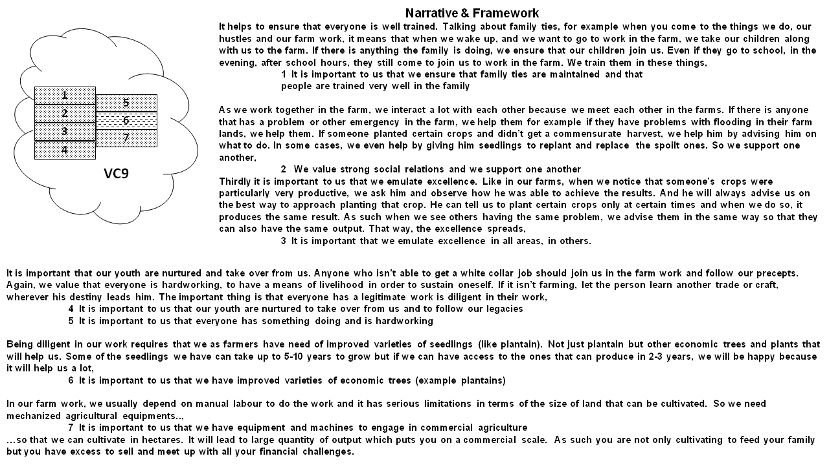
Figure 12: A visual display of the Values Statements and Narratives of Village Councilor Group VC9 in Ufuma

4.1.3 Visual Display of the Situated Shared Values of the remaining Groups of Village Councilors in Ufuma
The remaining groups of village councilors in Ufuma produced similar results. The groups had similar characteristics as the previously described groups of village councilors. They were basically groups of people chosen by the villagers to represent the village and make decisions on their behalf. The same procedure was carried out for the 9 groups of village councilors in Ufuma. The results of the WeValue workshops in the form of diagrams showing the values envelopes, statements and narratives of the remaining 7 groups of village councilors are presented below.

All the values statements were accompanied with corresponding narratives except for VC1, VC2 and VC3 where no narratives were given because the participants felt that their discussions which have been captured through recordings had everything they needed to say about the statements and did not see any further need for giving a narrative.

4.1.3.1 Village Councilor Group 1 (VC1)
Village Councilors (VC) group 1 produced a set of fourteen values statements.

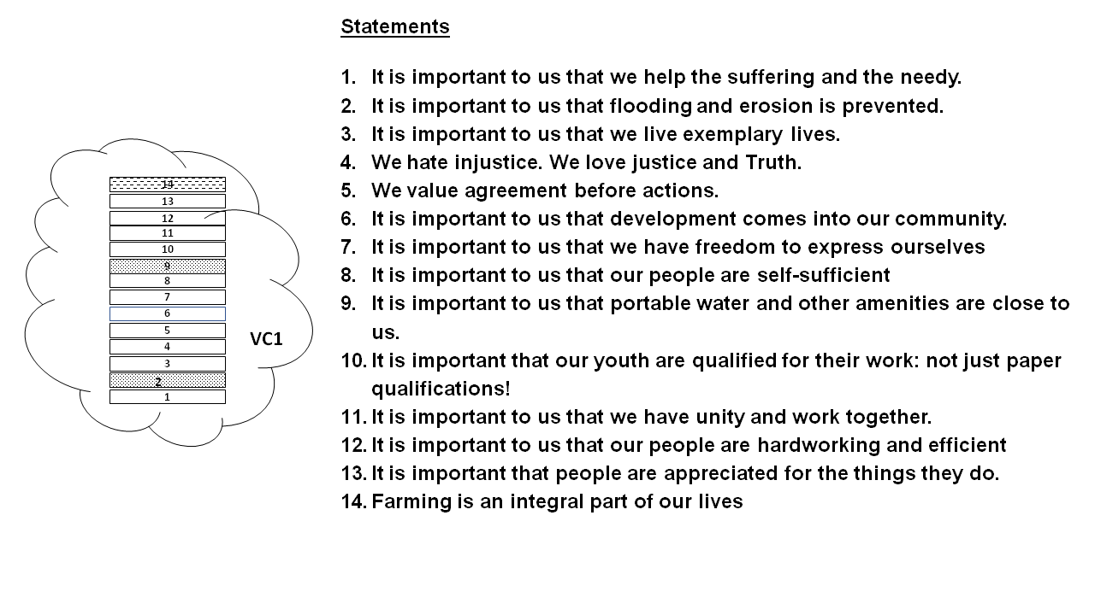
Figure 13: A visual display of the Values Statements of Village Councilor Group VC1 in Ufuma.

4.1.3.2 Village Councilor Group 2 (VC2)
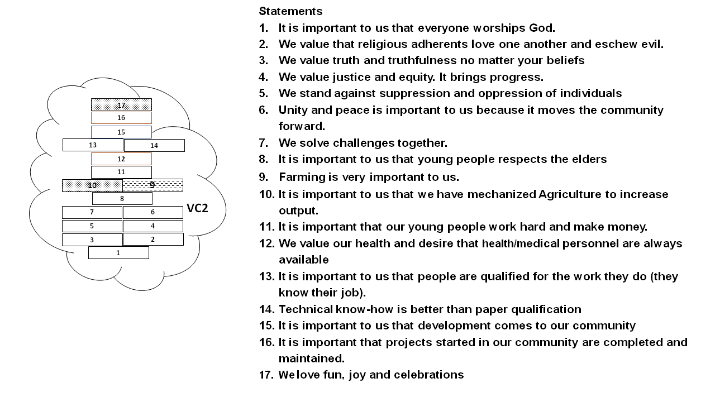
Figure 14: A visual display of the Values Statements of Village Councilor Group VC2 in Ufuma

4.1.3.3 Village Councilor Group 3 (VC3)
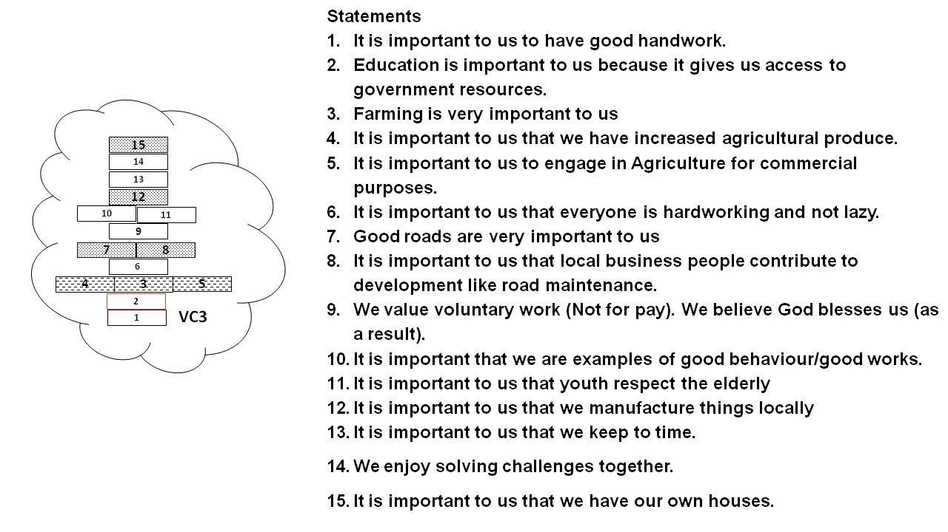
Figure 15: A visual display of the Values Statements of Village Councilor Group VC3 in Ufuma

4.1.3.4 Village Councilor Group 4 (VC4)

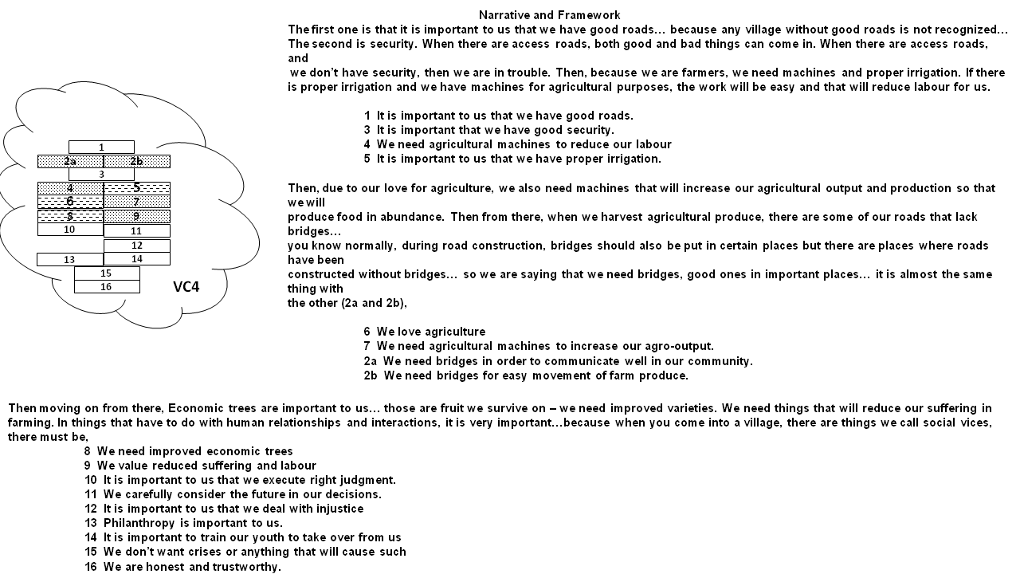
Figure 16: A visual display of the Values Statements and Narratives of Village Councilor Group VC4 in Ufuma

4.1.3.5 Village Councilor Group 5 (VC5)

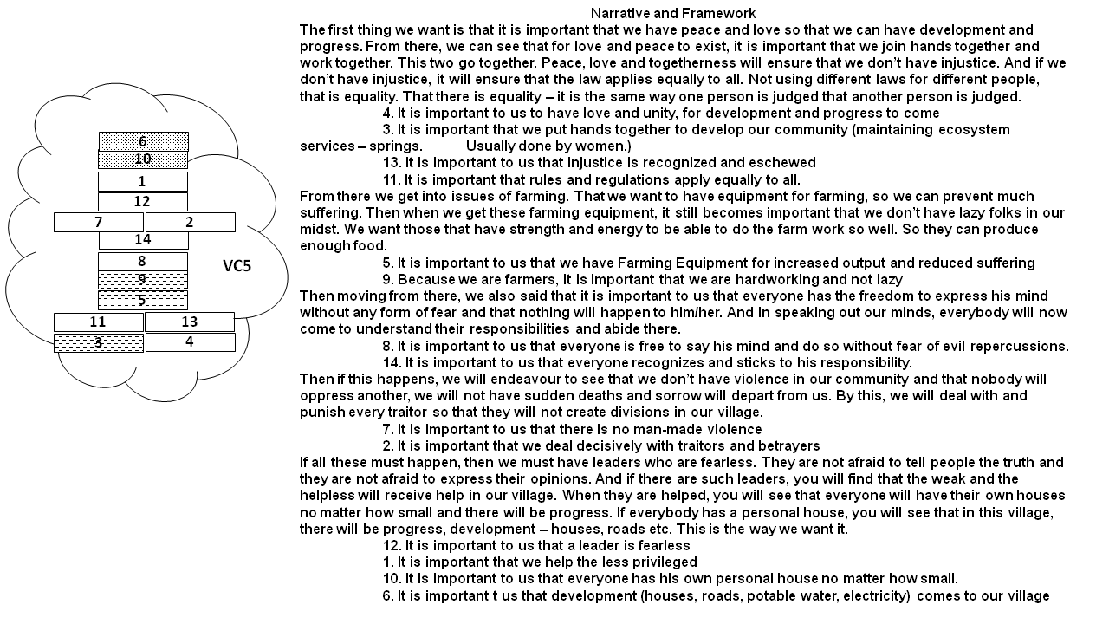
Figure 16: A visual display of the Values Statements and Narratives of Village Councilor Group VC5 in Ufuma
4.1.3.6 Village Councilor Group 6 (VC6)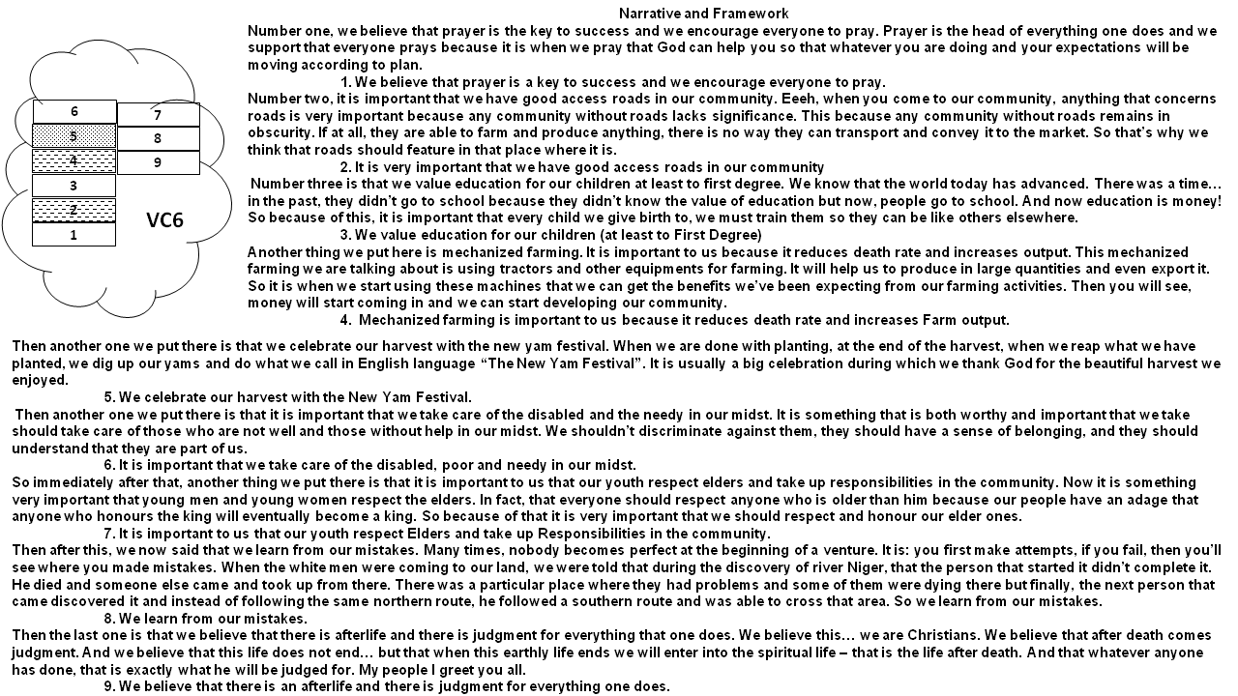
Figure 17: A visual display of the Values Statements and Narratives of Village Councilor Group VC6 in Ufuma

4.1.3.7 Village Councilor Group 7 (VC7)
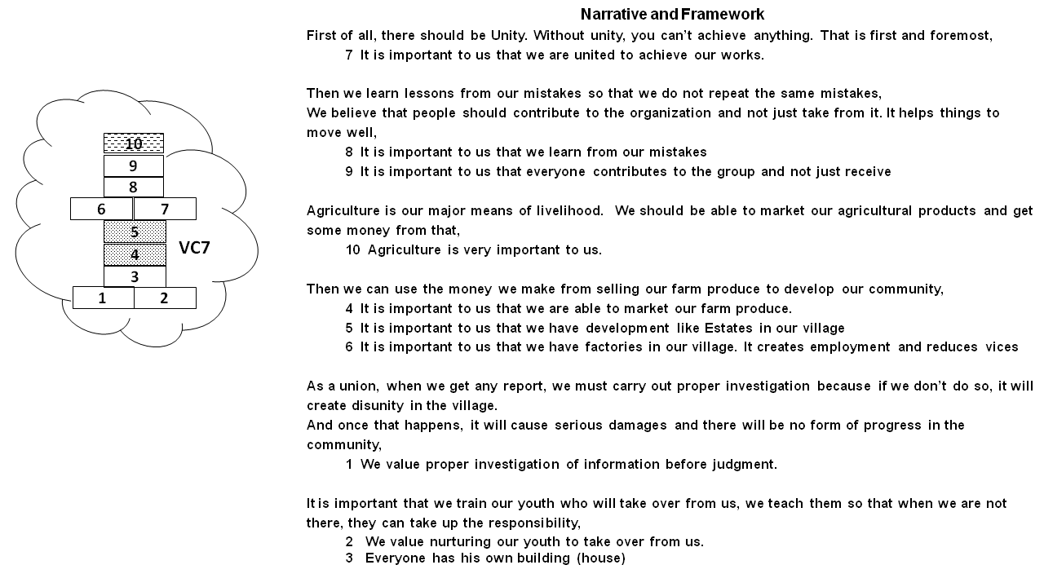
Figure 18: A visual display of the Values Statements and Narratives of Village Councilor Group VC7 in Ufuma

Ecosystem Analysis of the Village Councilor Groups in Ufuma
4.1.4.1 Situatedness –
An analysis of the values statements of the 9 groups of ward councilors in Ufuma reveals that Ecosystem services were embedded in the wider human values of the groups. All the groups had references to one or more ecosystem services and in many cases, these were considered vital in the functioning of the groups. Almost all the groups made reference to farming or agriculture as one of the things that are very important to them. This shows the centrality of the ecosystem goods and services connected with farming to the groups and by extension, the community. For example, groups VC 1 – VC 4 make specific reference on the importance of farming to them and their love for farming. Group 8 describes their attachment to farming thus, “Farming is what we are known for”. This is evidence that farming/agriculture, an environmental variable, is considered as a valid part of the lives and functioning of these groups.

      - Variation /not across these Groups – The groups were similar in that they consistently mentioned the importance of farming in their operations. However, farming and agriculture was approached from different angles by the groups. While all the groups mentioned farming because of its livelihood potentials and outputs, a few of the groups were careful to give details of the requirements for the farming process and what they needed to increase production. For example, groups VC 5 and VC 9 were specific about the need for farming equipments. VC 3 (It is important to us to engage in Agriculture for commercial purposes.) and VC 9 (It is important to us that we have equipment and machines to engage in commercial agriculture) also mentioned the need for involvement in agriculture for commercial purposes. Among all the groups, only group VC 1 had any mention of the need to control erosion and flooding (It is important to us that flooding and Erosion is prevented). The others are silent on this.

4.1.4.3 ESS Categories Elicited and Identified – In general, all the 3 categories of ecosystem services according to the Millennium Ecosystem Assessment (MEA) were identified in Ufuma. In all the groups (VC 1 – VC 9), provisioning services were clearly elicited and identified. This was so because the obvious result of farming and other agricultural activities are the products. Only one group (VC 1) was able to generate a regulating service while all the groups produced some amount of cultural ecosystem services. The cultural category of Knowledge Systems (KS) were the most abundant of cultural ecosystem services (CES) generated. This was closely followed by the Sense of Place (SOP). Social Relations (SR) and Cultural Diversity and Identity (CDI) were generated equally and are the third most abundant. Interestingly, 2 cultural categories – Aesthetics and Inspiration were not elicited in this study with ward councilors in Ufuma.

4.1.4.4 Connection with Ufuma context – The study site for these nine groups of village councilors is Ufuma – a rural community with a population of mostly subsistence farmers. It is therefore expected that their values should show some correlation with the community’s characteristics. Hence, farming which is the major occupation of the members featured prominently in the values statements. It is so deeply entrenched that group VC 1 describes it as “… an integral part of our lives” and VC 8 mentions it as a part of their identity (Farming is what we are known for). The values of mechanization and commercialization of their agricultural practices and products may be an indication of their desire for better and enhanced outputs.

The table below shows a list of values statements from the nine groups of village councilors in Ufuma which had references to ecosystem services and other environmental values. They were extracted from the wider framework of shared values produced by the different groups. It also shows the different categories of Ecosystem Services elicited from the groups.

TABLE 5: A summary of all those shared values statements produced by each of the 9 Village Councils of Ufuma which contained reference to ecosystem services, with the meaning contained coded as a proportion of any of the MEA ESS categories that seems applicable (Figures are rounded and presented as percentages).
LABEL | STATEMENTS | PRV | RGL | SPR | RCR | AES | INSP | EDU | SOP | CH | CDI | KS | SR
VC1 | 2. It is important to us that flooding and Erosion is prevented. |  | 100
VC1 | 9. It is important to us that portable water and other amenities are close to us. | 100
VC1 | 14. Farming is an integral part of our lives | 50 |  |  |  |  |  |  | 13 | 13 | 13 | 13
VC2 | 9. Farming is very important to us. | 50 |  |  |  |  |  |  | 13 | 13 | 13 | 13
VC2 | 10. It is important to us that we have mechanized Agriculture to increase output. | 100
VC2 | 15. It is important to us that development comes to our community
VC2 | 17. We love fun, joy and celebrations |  |  |  | 100
VC3 | 3. Farming is very important to us | 50 |  |  |  |  |  |  | 13 | 13 | 13 | 13
VC3 | 4. It is important to us that we have increased agricultural produce. | 75 |  |  |  |  |  |  |  |  | 25
VC3 | 5. It is important to us to engage in Agriculture for commercial purposes. | 75 |  |  |  |  |  |  |  |  | 25
VC3 | 7. Good roads are very important to us | 25
VC3 | 8. It is important to us that local business people contribute to development like road maintenance. |  |  |  |  |  |  |  |  |  |  | 25
VC3 | 12. It is important to us that we manufacture things locally | 50
VC3 | 15. It is important to us that we have our own houses. |  |  |  |  |  |  |  | 25 | 25 | 25 | 25
VC4 | 1. It is important to us that we have good roads.
VC4 | 2. We need bridges in order to communicate well in our community. We need bridges for easy movement of farm produce. | 50
VC4 | 4. We need agricultural machines to reduce our labour [because we are farmers] | 50
VC4 | 5. It is important to us that we have proper irrigation [because we are farmers]. | 75 |  |  |  |  |  |  |  |  |  | 25
VC4 | 6. We love agriculture [so we need agricultural machines to produce food in abundance] | 40 |  |  |  |  |  |  | 20 | 20 | 20
VC4 | 7. We need agricultural machines to increase our agro-output [Because we love Agriculture]. | 100
VC4 | 8. We need improved economic trees [we survive on them] | 75 |  |  |  |  |  |  |  |  |  | 25
VC4 | 9. We value reduced suffering and labour [in our farming] |  |  | 50
VC5 | 3. It is important that we put hands together to develop our community [take care | 50 |  |  |  |  |  |  |  |  |  |  | 50
VC5 | 5. It is important to us that we have Farming Equipment for increased output and reduced suffering. | 50 |  |  | 25 |  |  |  |  |  |  | 25
VC5 | 6. It is important to us that development (houses, roads, potable water, electricity) comes to our village |  |  |  |  |  |  |  | 50 |  |  | 25
VC5 | 9. Because we are farmers, it is important that we are hardworking and not lazy [to produce enough food]. | 20 |  |  |  |  |  |  |  |  | 40 | 40
VC5 | 10. It is important to us that everyone has his own personal house no matter how small. |  |  |  |  |  |  |  | 50 |  |  | 50
VC6 | 2. It is very important that we have good access roads in our community [so we can transport our farm produce to the market] [anything that concerns roads is very important because any community without roads lacks significance] | 50 |  |  |  |  |  |  | 25 |  |  | 25
VC6 | 4. Mechanized farming is important to us because it reduces death rate and increases Farm output. | 50 |  |  | 25 |  |  |  |  |  |  | 25
VC6 | 5. We celebrate our harvest with the New Yam Festival. |  |  | 40 | 30 |  |  |  |  | 30
VC7 | 3. It is important to us that everyone has his own building (house) |  |  |  |  |  |  |  | 50
VC7 | 4. It is important to us that we are able to market our farm produce. | 100
VC7 | 5. It is important to us that we have development like Estates in our village | 50
VC7 | 10. Agriculture is very important to us. | 50 |  |  |  |  |  |  |  | 25 | 25
VC8 | 2. Farming is what we are known for [enable us to boost and increase agricultural output]. | 40 |  |  |  |  |  |  |  | 20 | 20 | 20
VC8 | 6. Consequently, it is important to us that individuals have strong economic ability. [For us we have plantations, through which we raise funds to help others} | 100
VC9 | 1. It is important to us that we ensure that family ties are maintained and that people are trained very well in the family […by joining us in farm work and being trained in it] |  |  |  |  |  |  | 20 | 20 |  |  | 20 | 40
VC9 | 2. We value strong social relations and we support one another [working together & helping in the farm] |  |  |  |  |  |  |  |  |  |  |  | 100
VC9 | 3. It is important that we emulate excellence in all areas, in others. [especially in farm work] |  |  |  |  |  |  | 50 |  |  |  | 50
VC9 | 4. It is important to us that our youth are nurtured to take over from us and to follow our legacies [even in farm work] |  |  |  |  |  |  |  |  | 50
VC9 | 5. It is important to us that everyone has something doing and is hardworking |  |  |  |  |  |  |  |  |  |  | 50
VC9 | 6. It is important to us that we have improved varieties of economic trees (example plantains) | 75 |  |  |  |  |  |  |  |  |  | 25
VC9 | 7. It is important to us that we have equipment and machines to engage in commercial agriculture | 100

4.2 Situated shared values (Values Frameworks and envelopes plus Narratives) of other Village Committees (Youth; Women; Health) in Ufuma
In line with the objectives of the study to investigate the variations in the occurrence of ecosystem services and environmental values in the values frameworks of different groups, we conducted the study using a different type of group – village committees.
The study involved a different set of groups namely the village committees for the youth, women and Health. These groups were included to check for variations or consistencies across various group types. First, the results of the WeValue workshops for the different groups are presented and later, the implications of the data for ecosystem services are explored.

4.2.1 Village Youth Committee VY12
The group VY 12 is the representative of the village youth. They are responsible for organizing the youth, arranging meetings and mobilizing them for community engagements. The workshop with the youth executive committee produced a set of 11 Value statements in their values envelope. The youth group started with values about diligence in attending to meetings and commitments, information management and the need to invest in the village. It is noteworthy that statements 3 (It is important to us that people invest in our village), 4(It is important to us that local businesses contribute to village development and job creation) and 5A (It is important to us that people are hardworking, not lazy) have a lot to do with investments, job creation, and hard work which are values that have to do with economy/financial gains. This is a pointer to the areas of interest for the youth in this community. Furthermore, the Youth group provides a link between the presence or absence of these economic means (5A) and certain vices like hard drugs (5B). So, their values statements contain their perceived solution to certain societal ills. Statements about farming and erosion control are centrally placed and considered important such that references to job creation are linked to farming. In addition, erosion control is considered as a job for the youth and they have taken ownership of this responsibility. The later values statements of the youth group were focused on the future and rewards for deserving persons. It is part of their aspirations.

4.2.1.1 Narratives and Values Statements for VY12
The narratives and value statements of VY 12 are presented below:
START OF NARRATIVE OF GROUP VY12:
It is important that people are diligent in meeting commitments… Diligent in meeting commitments has to do with meetings, gatherings… You understand? People being committed and attending as and at when due… with the understanding that this thing is a meeting and there’s a time for it.
1. It is important to us that people are diligent to attend meetings or meet commitments

Then number 2, it is important to us that we don’t hide information without good reason… you know it’s not good to hide information. Before someone should hide information, you know that there must be a good reason for hiding it because there are some good information that may be revealed in the presence of someone who is not supposed to be there and it will hamper the outcome of whether an investigation or other thing…
2. It is important to us that we don’t hide information without good reason

Number 3, it is important to us that people invest in our village. Yeah, it is good that people should be investing in our village because it will attract development and will create jobs for the youth. You understand/ because this time around now, people no longer wait for white collar jobs or be waiting for government to create jobs. But our people who are industrious, who are in other places and are well to do, can come back home and make investments. And when they make investments in the community, then the job will be for the citizens of the community. Then development will come.
3. It is important to us that people invest in our village

Number 4, it is important to us that local businesses contribute to village development and job creation. It is like… the same thing with the other one. Once there is a good local business on ground, there comes development and job creation as well. Everybody will be happy.
4. It is important to us that local businesses contribute to village development and job creation

Now Number 5A, it is important that people are hardworking, not lazy. This is telling us that hard work is very good in the community as a youth. Because for anyone who is hardworking, it is difficult to find him complaining about the government or this thing…. Laziness isn’t good in a community because it will bring a lot of vices and bad habits.
5A. It is important to us that people are hardworking, not lazy

5b, It is important that our community doesn’t have scourge of hard drugs. Laziness goes with these hard drugs of a thing. Because when someone is hardworking, you will see that his mind will not dwell on anything that has to do with hard drugs.
5B. It is important to us that our community doesn’t have scourge of hard drugs

Number 6, it is important to us that we are close to farming. Farming is so important. Apart from the normal cultivation or farming, we also have poultry farming and other types of farming. It is good in the community and it is a way of creating jobs also.
6. It is important to us that we are close to farming

It is important to us that those that have strength regularly volunteer to help with the erosion or road maintenance work. Yes. This thing is very important and that’s why we the youth took it upon ourselves by telling our elders to remove their hands from anything that has to do with road maintenance work and even erosion control because the strength is still there in the youth. So we took it upon ourselves to make sure that this makes progress.
7. It is important to us that those that have strength regularly volunteer to help with the erosion or road maintenance work
It is important to us that we protect against oppression of others: that we are careful in our judgment. It is part of our duty as youths, that any oppression in our community, we don’t mind whether you are from this place or whether you are an outsider or stranger, all we want is that you do the right thing, keep your hands straight… we will not oppress you. Maybe, if you have problems with an indigene and he is at fault, we will not cover him up, we are not like that!
8. It is important to us that we protest oppression of others: that we are careful in our judgment
Then, it is important to us that we make good plan that consider the long term future. Why this is important is that whatever we do today will determine how our community will be in the future. And that is why it is important that any plans that we are making should be plans we are very careful with and make sure that our plans have future benefits.
9. It is important to us that we make good plan that consider the long-term future

Then the last, it is important to us that we give people credit for the things they do for others. If you look carefully, you will discover that there are some of our people that always come to our aid - both in the issue of roads, when we are creating virgin roads, when we have problems… he told you earlier how we had the problem of armored cable, so those people that contribute to do those things, it is important that we also make out time to appreciate them for what they have done. And when you appreciate someone who has done something, the person will be happy and also have a sense of belonging knowing that this people really accept what they have done.
10. It is important to us that we give people credit for the things they do for others

END OF NARRATIVE OF GROUP VY12:
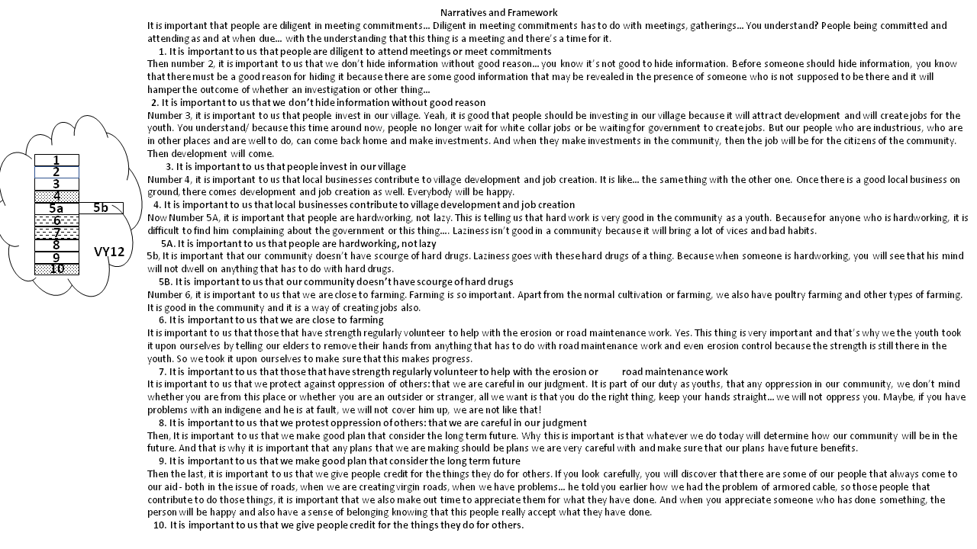
Figure 19: A visual display of the Values Statements and Narratives of the Village Youth Committee VY12 in Ufuma

4.2.2 Village Health Committee VH13
VH 13 is regarded in the village as the Health Committee. They are group of retired civil servants and practicing local health workers who are charged with the responsibility of promoting the health of the village by creating awareness on the need for immunization of children and providing the first and affordable access to health care and drugs to members of the community. They are saddled with the responsibility of running a mobile health post and liaising with local government authorities to procure health supplies for the community. They claim that their major challenge is the lack of financial resources to execute their responsibilities.

The workshop held with this group produced a set of 11 values statements in the values envelope. The framework begins with the foundational values of respect for elders and the fear of God and terminates with the need for enhanced agricultural productivity and improved processing and storage of the products. Improved agricultural productivity is linked to good weather, which in this case is described as the absence of drought and the existence of rain at the due season. They acknowledge that although it is beyond their control to control the weather, it is nonetheless important as a determinant of productivity. There are also values about strong family ties, hard work, development of potentials etc.

4.2.2.1 Narratives and Values Statements for VH13
The values statements and narratives of the health committee are presented below:
START OF NARRATIVE OF GROUP VH13:

Number one, we started from the elders. The elders, we must have to respect our elders and be God-fearing because of a truth, if we respect our elders and have the fear of God, God will guide us to …
2. It is important to us that we respect our elders and are God-fearing

Our families will be bound together. We desire to have strong family ties. There will be love in the family.
1. It is important to us that we have strong family ties
Then the other one is that it is important to us that our youth… from that one… if we are God-fearing and have a family that is knitted together, it will help our youths to develop their potentials and also those that are lazy will no longer be so. There must be hardworking people not lazy. Not only that, issues concerning unwanted pregnancy will not arise and we don’t want that in our village.
3. It is important to us that our people are not lazy but hardworking
4. It is important to us that our youth are helped to develop their potential
5. It is important that we do not have unwanted pregnancies

It is also important that our village doesn’t have conflicts, disagreements should not be there and once we are God-fearing, that (disagreements) will not be.
6. It is important to us that we do not have disagreements in the village

It is also important that every one of us contributes ideas in every occasion instead of saying… Join and contribute! Contribution is what helps us in the village. And when we are doing that in love, there will be progress.
7. It is important to us that everyone contributes ideas in the group

We also said that it is important to have local businesses that will contribute to our village. We have talked of how they can be of help in this village – roads, water and so on.
8. It is important to us that local businesses contribute to village development

It is important that we have good weather. That is very important because if we don’t have good weather, there is nothing that we cultivate that will be tangible… It will be only drought. In the bible times, there were times when they stayed for many years without any rainfall; It was only drought, ehee…. Or if you are coming out… (Male voice: but you cannot control the weather!), But it is important to us!
9. It is important to us that we have good weather

Then from there, if we have good weather, (we will be able to produce food) we will have agriculture…because we have lands… even processing it… In fact we have enough land that will sustain us in food production. Then if we produce food, we should process and store it. Right?
10. It is important to us that our land can give us enough to sustain us
11. It is important to us that agricultural products are well processed and stored
END OF NARRATIVE OF GROUP VH13:

The schematic representation of the framework of group VH 13 is shown in the figure below:
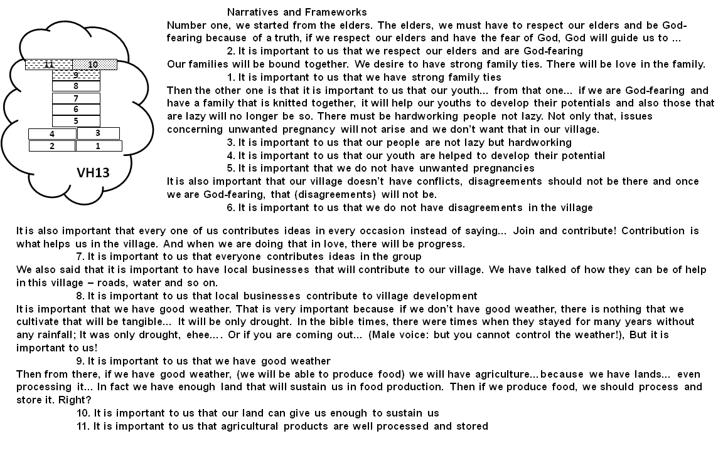
Figure 20: A visual display of the Values Statements and Narratives of the Village Health Committee VH13 in Ufuma

4.2.3 Village Women Committee VW 14
The group VW 14 is the executive committee of the women. They are mostly farmers and traders who sell some of their farm produce and other commodities in the weekly market. Most of them aren’t literate having not completed secondary education. All were mothers and grandmothers with mostly grown children (i.e. none was still breastfeeding nor still had toddlers). They represent the women in the community and help to organize different activities like collection of levies. In some situations, they are also responsible for enforcing disciplinary measures as it pertains to women in the community.

The workshop with the women group (VW 14) produced a set of 9 values statements in the values envelope. Interestingly, the framework started with statements such as “It is important that we have daily market”(Statement 1), “It is important that we have our own source of water” (Statement 2)and “It is important to us that erosion problems are controlled” (Statement 3). These are all indications of their value for the environment and resources that are obtained from it and how these should be managed. It may be regarded a bit surprising that the other life values of respect, peace and unity in the family are listed as the terminal values. Additionally, it is observed that the women group do not make a direct mention of farming although most of them were subsistence farmers. The possible reason for this may be the WeValue structure which emphasizes the discussion of the values of a group in the context of their shared experiences, vision and roles or functions. Hence, we see them discussing on the need for a ‘daily market’, probably because much of their interactions were carried out in the market context and not in the farmlands. Again, we see the women discuss their value for empowerment through education. Being a group composed of predominantly people with little exposure to education, this is quite instructive. This may be a statement not of shared vision, but of shared aspirations.
The structural framework of the women group (VW 14) is presented below along with a complete list of the values statements. There was no narrative in this framework because the women just read out the statements as it was written and did not offer any further explanations.
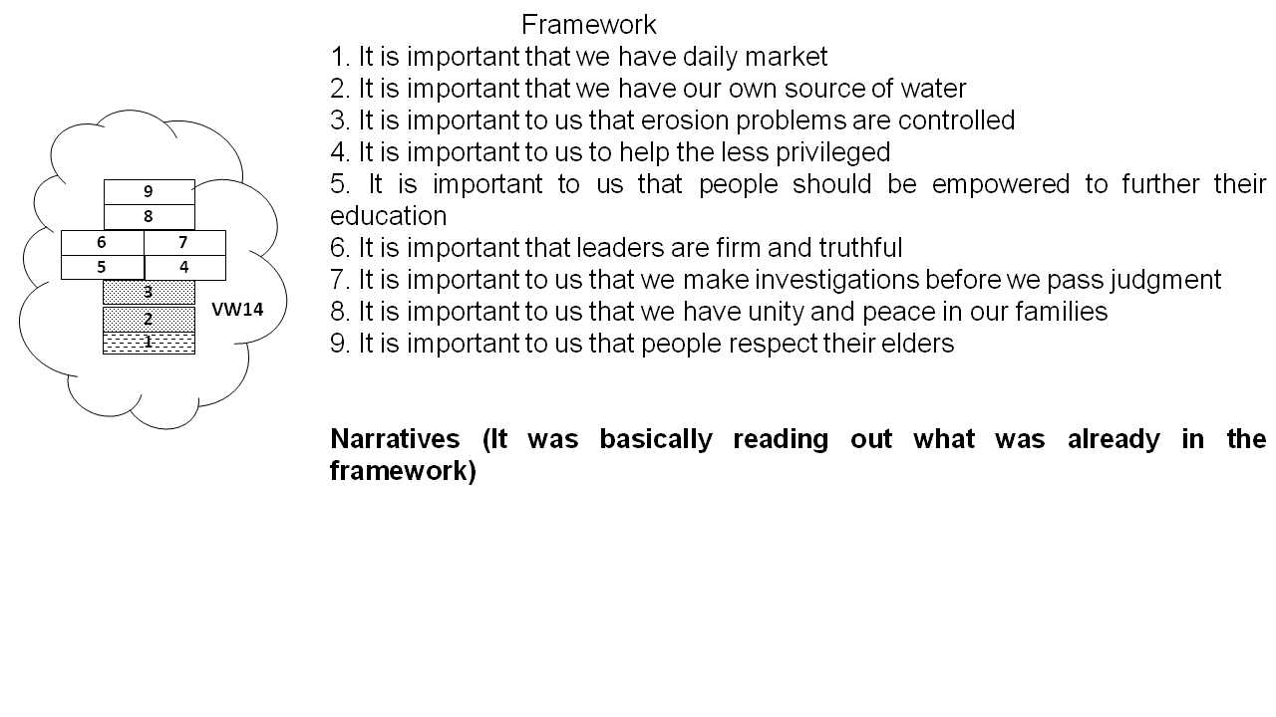
Figure 21: A visual display of the Values Statements of the Village Women Committee VW14 in Ufuma

4.2.4 Ecosystem Analysis of the Village Committees in Ufuma

4.2.4.1 Situatedness – An evaluation of the 3 different groups (Youth, Health and Women) reveal that ecosystem services are situated right within the shared social values of the groups. A close inspection of the values shows that there is no attempt by the groups to create any distinction between statements on ecosystem services and that on other domains of life. Group VY 12 generated ecosystem services explicitly linked to farming (Statement 6). For group VH 13, statements 9 (It is important to us that we have good weather), 10 (It is important to us that our land can give us enough to sustain us) and 11(It is important to us that agricultural products are well processed and stored) are values founded on the supply and regulation of ecosystem services. Also to be noted is that these values were elicited from a group as ‘specialized’ as the Health committee. The framework of Group VW 14 displays the central place of ecosystem services in the group’s structure. They mention the need for a source of water (Statement 2) and also the necessity for erosion to be controlled (Statement 3).

4.2.4.2 Variation /Not Across These 3 Groups – The three groups all produced value types consistent with their shared interactions. It is remarkable that the women do not mention farming as an ecosystem of interest in contrast to the other 2 groups. They however refer to the need for a source of water which is another provisioning service not mentioned by the youth and health groups. VY 12 produced the greatest number of cultural services (3) followed by VW 14 (2) and VH 13 (1) in that order. Apart from Cultural Diversity and Identity (CDI), Knowledge Systems (KS) and Social Relations (SR), all the other categories of CES were missing in the 3 groups.

4.2.4.3 Variation with Role, Including Comparison with 4.1 Results – Comparing the results of these 3 village committees (Youth, Health and Women) with the Village councilors, it was observed that the cultural category of knowledge systems (KS) was the most abundant amongst them. This may require further investigation in the future. Additionally, the study with village councilors produced more cultural categories than the village committees. This is probably due to the role of the village councilors who perform a wider range of oversight functions when compared with other groups who are more focused on a specific group. Again, in both classes of groups, Aesthetics and Inspiration CES are missing.

4.2.4.4 ESS categories elicited and identified – All the MEA ESS categories were elicited and identified across the 3 groups. Also, each of the 3 groups produced all the MEA categories of provisioning, regulating and cultural ecosystem services. As was the case with the ward councilors, the provisioning services elicited in the study were more than the other services. The cultural services were the second most abundant ecosystem service elicited with knowledge systems (KS) occurring in a higher frequency than the other cultural categories. Both the youth and women groups generated regulatory services that had to do with Flood and erosion control while the Health group produced the regulatory service of good weather which can also be referred to as a supporting service since it helps in the proper functioning of the provisioning services related to agriculture.

4.2.4.5 Connection with Ufuma context – The different roles of the groups under consideration may account for differences in the areas of ESS emphasis. The women (VW14) and the youth (VY12) made references to erosion control – an environmental issue of emerging concern. Likewise the health committee (VH13) and the youth group (VY12) discussed about farming which is the major occupation of the members of the community.

Table 6: A summary of all the shared values statements produced by each of the 3 Village Committees (Youth (VY12), Health (VH13) and Women (VW14)) in Ufuma which contained references to ecosystem services, with the meaning contained coded as a proportion of any of the MEA ESS categories that seems applicable (Figures are rounded and presented as percentages).

LABEL | STATEMENT | PRV | RGL | SPR | RCR | AES | INSP | EDU | SOP | CH | CDI | KS | SR
VY12 | 4. It is important to us that local businesses contribute to village development and job creation. [...we also have poultry farming and other types of farming. It is good in the community and it is a way of creating jobs also.] | 50
VY12 | 6. It is important to us that we are close to farming. [Apart from the normal cultivation or farming, we also have poultry farming and other types of farming. It is good in the community and it is a way of creating jobs also.] | 50 |  |  |  |  |  |  |  |  | 50
VY12 | 7. It is important to us that those that have strength regularly volunteer to help with the erosion or road maintenance work [...that’s why we the youth took it upon ourselves by telling our elders to remove their hands from anything that has to do with road maintenance work and even erosion control because the strength is still there in the youth]. |  | 50 |  |  |  |  |  |  |  |  | 50
VY12 | 10. It is important to us that we give people credit for the things they do for others. [...If you look carefully, you will discover that there are some of our people that always come to our aid - both in the issue of roads, when we are creating virgin roads, when we have problems…] |  |  |  |  |  |  |  |  |  |  | 75
VH13 | 9. It is important to us that we have good weather [...That is very important because if we don’t have good weather, there is nothing that we cultivate that will be tangible… ][Then from there, if we have good weather, (we will be able to produce food)] | 50 | 50
VH13 | 10. It is important to us that our land can give us enough to sustain us [...we will have agriculture…because we have lands…] [In fact we have enough land that will sustain us in food production] | 100
VH13 | 11. It is important to us that agricultural products are well processed and stored [Then if we produce food, we should process and store it. Right?] | 50 |  |  |  |  |  |  |  |  |  | 50
VW14 | 1. It is important that we have daily market | 25 |  |  |  |  |  |  |  |  |  | 25 | 50
VW14 | 2. It is important that we have our own source of water | 100
VW14 | 3. It is important to us that erosion problems are controlled |  | 100

4.3 Situated shared values (Values Frameworks and envelopes plus Narratives) of village councilors in Nanka
In order to make a case for authenticity and validity of the research, similar studies were conducted to obtain data from other sources apart from Ufuma. Hence, 2 other groups of councilors were investigated in another town called Nanka. The results of these other two groups are presented below with great insights into the impact of site-specific factors in the perception of ecosystem services by indigenes.
The Village Councilors in Nanka who participated in this study were responsible for directing, organizing and leading the members of the community in different community initiatives. They are also charged with the responsibility of maintaining law and order. They are elected by the community members to represent them and usually serve for 2- 4 year tenures. However, they can be re-elected. Nanka village suffers from a serious menace of gully erosions and there are a number of community initiatives and efforts aimed at controlling this. For example, every family compound is expected to construct local catchment pits for collection of run-off water. This is critical that at certain times of the year, especially before the start of the rainy season, an announcement is made for every family to clean out and open up clogged pits. The village usually mandates these groups of councilors to supervise this work and punish offenders. Hence, in the local parlance, the group is usually addressed by the locations of the catchment pits that they oversee. Additionally, Nanka has a source of spring water which is used by members of the community. The local authorities granted permission to a company to begin the production of bottled water. The company in turn employs members of the community and also carries out other corporate social responsibilities like road maintenance. This study was conducted with 2 groups of village councilors in Nanka - VC 10 and VC 11.

4.3.1 Village Councilors Group 10 (VC10)
The village councilors in group 10 were basically men who had been chosen to represent their people in different matter. They produced a total of 13 values statements with diverse themes ranging from human rights, family, hard work, law and order, farming, volunteering, erosion control etc. The framework of values described how they wanted their community to be run and the tenets by which everyone was expected to abide. The cross-shaped framework was the product of an intense time of deliberations and discussions after which everyone was satisfied with the outcome. The visual display of the framework, statements and narratives are presented below.
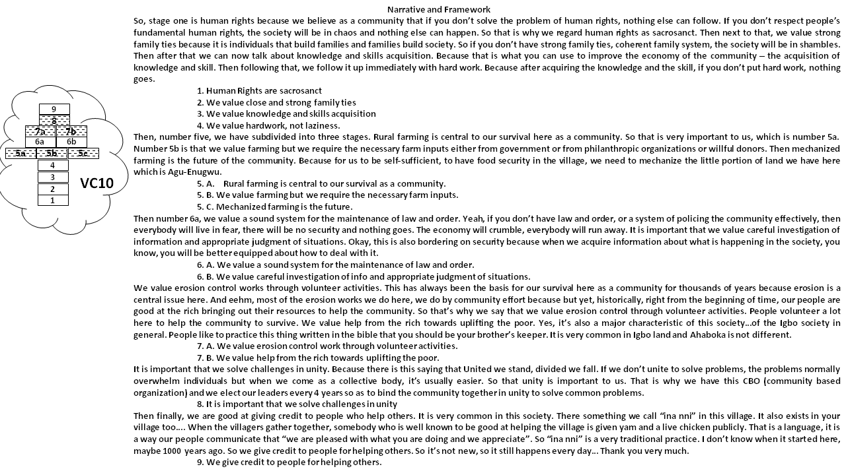
Figure 22: A visual display of the Values Statements and Narratives of Village Councilor Group VC 10 in Nanka

4.3.2 Village Councilors Group 11 (VC 11)
Village councilor Group VC11 was similar in composition and characteristics to VC10. They had basically the same responsibilities as the former and were a sister community to VC10. The group produced a total of 9 statements reflecting themes like respect, physical fitness, hardwork, unity, generational value transfer, environmental maintenance etc. The diagram below is a display of the values framework showing the statements and narratives.

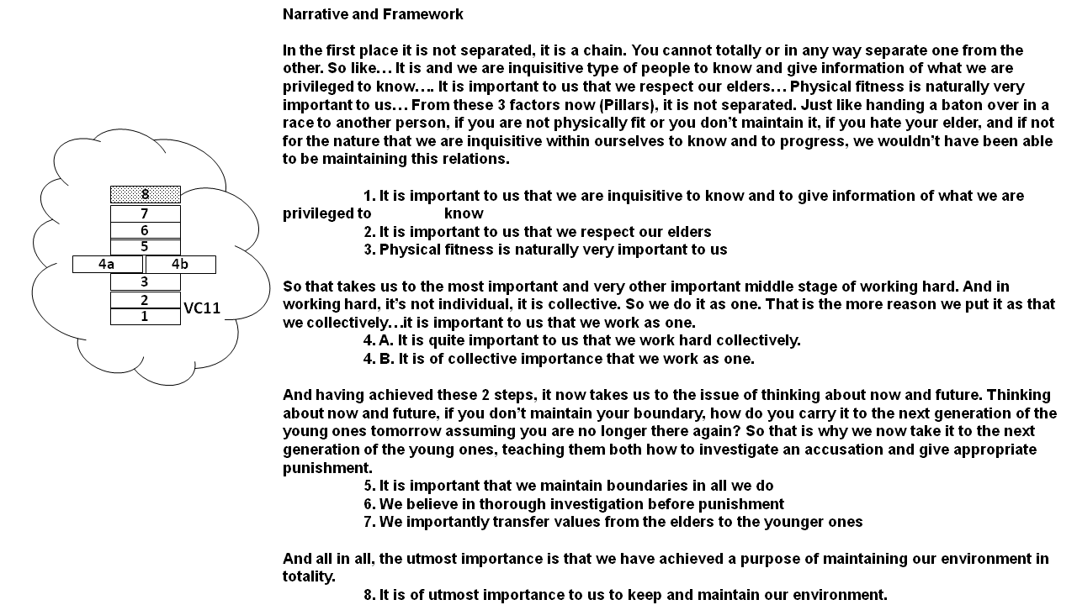
Figure 23: A visual display of the Values Statements and Narratives of Village Councilor Group VC 11 in Nanka

4.3.3 Ecosystem Analysis of Village Councilor groups in Nanka

4.3.3.1 Situatedness - As have been described in previous cases, the workshop produced several statements of shared values within which we find mentions of environmental values and ecosystem services. In fact, the group is even named after their environmental functions of ensuring the optimal functioning of the catchment pits. Of the 13 Values statements generated in VC 10, 6 had connections to ecosystem services while there was only one reference to ecosystem service in VC 11. The place of ecosystem services in the shared values framework of these groups is firmly established and confirmed by the linkage of the group’s activities to these services.

4.3.3.2 Variation across these 2 groups – VC 10 produced more connections to ecosystem services than VC 11. While VC 11 made reference only to the regulating-type ESS (8. It is of utmost importance to us to keep and maintain our environment), VC 10 made reference to provisioning-type ESS (5A. Rural farming is central to our survival as a community), regulating-type ESS (7A. We value erosion control work through volunteer activities) and cultural services-type ESS (8. It is important that we solve challenges in unity). In addition, VC 10 made reference to several different categories of cultural services while VC 11 produced none.

      - Variation with village (cf Ufuma) – While both Ufuma and Nanka communities are rural and agrarian, the results reveal that the village councilors in Nanka were able to generate more regulating services than the Ufuma councilors relatively. This could be attributed to the prevailing environmental situation.

4.3.3.4 Connection with Nanka context – The production of regulating services linked with erosion control by the 2 groups (VC 10 and VC 11) further confirms that local contexts seriously affect the perception of ecosystem services by different stakeholders. The gully erosion situation in Nanka undoubtedly affects all members of the community and this was reflected in their value statements. Surprisingly, in spite of the perceived importance of the spring source as deduced from the discussions and post-workshop interviews, none of the groups directly referred to it in the values statements. This may need further research on which types of shared experiences are generated in a group – shared pain (erosion control) or shared pleasure (spring source) – and why it is so.

4.3.3.5 Variation with roles, including comparison with 4.1, 4.2 results – The two village councilors in Nanka were similar to those in Ufuma in the types of values elicited. All ecosystem service types were represented. However, the Nanka groups did not produce CES categories of Spiritual, recreational, Aesthetics, Inspirational, Educational and Sense of Place. Furthermore, the 2 Nanka groups stressed the need for careful investigation of information and appropriate judgments probably due to their roles as enforcers of discipline. This is only found in VC 7 and VW 14 in the Ufuma groups.
Table 7 shows the ecosystem services elicited in the 2 groups of Village councilors in Nanka

TABLE 7: A summary of all the shared values statements produced by each of the 2 Village Councils of Nanka which contained references to ecosystem services, with the meaning contained coded as a proportion of any of the MEA ESS categories that seems applicable (Figures are rounded and presented as percentages).

LABEL | STATEMENT | PRV | RGL | SPR | RCR | AES | INSP | EDU | SOP | CH | CDI | KS | SR
VC10 | 5. A. Rural farming is central to our survival as a community. |  | 40 |  |  |  |  |  |  | 20 | 20 | 20
VC10 | B. We value farming but we require the necessary farm inputs. | 40 |  |  |  |  |  |  |  | 20 | 20 | 20
VC10 | C. Mechanized farming is the future [For self sufficiency and food security]. | 40 |  |  |  |  |  |  |  | 20 | 20 | 20
VC10 | 7. A. We value erosion control work through volunteer activities. [always been the basis for our survival here as a community for thousands of years because erosion is a central issue here] |  | 50 |  |  |  |  |  |  |  |  | 25 | 25
VC10 | B. We value help from the rich towards uplifting the poor. [most of the erosion works we do here, we do by community effort because but yet, historically, right from the beginning of time, our people are good at the rich bringing out their resources to help the community. So that’s why we say that we value erosion control through volunteer activities] |  | 25 |  |  |  |  |  |  |  | 25 |  | 25
VC10 | 8. It is important that we solve challenges in unity. [...That is why we have this CBO (community based organization) and we elect our leaders every 4 years so as to bind the community together in unity to solve common problems (like erosion control)] |  | 50 |  |  |  |  |  |  |  |  |  | 50
VC11 | 8. It is of utmost importance to us to keep and maintain our environment. |  | 100

4.4 Situated shared values (Values Frameworks and envelopes plus Narratives) of Secondary School Teachers in Nsukka and Ufuma
In this section, the results of the study conducted with groups of teachers are explored. Investigation into the perception of ecosystem services by different groups with different functions is captured here. The results reveal interesting insights into the disparities between the values elicited in the village councilors and that elicited by teachers. The results suggest that the functions and purpose of a group play important roles in the perception of the ecosystem services in their locality.
Nine groups of teachers were explored for this study in 2 sites – Ufuma and Nsukka. While Ufuma is a village involved predominantly in farming, Nsukka is a town that plays host to a University and has a convergence of people from different cultural backgrounds. 6 groups of teachers (T1 – T6) were studied in Nsukka while 3 groups (T7 – T9) were explored in Ufuma.
First, we present the results of 2 groups of teachers in Nsukka.

Groups of Teachers in Nsukka

4.4.1 Teachers Group 4 (T4)
The T4 teachers were a group of form teachers who were responsible for exercising oversight functions for students in their first year of senior secondary. The teachers’ responsibilities include ensuring attendance of students to school and classes by taking daily attendance records (once in the morning and once before dismissal), ensuring the neatness of the classes by supervising the creation of cleaning timetables for the class, ensuring the timely payment of school fees by the parents and wards of students and other functions as may be assigned by the school authorities. Although they are all subject teachers – specialized in different subjects, their context of interaction was as form teachers.
The T4 teachers participated in the WeValue workshop and produced a framework of values statements which were important and worthwhile to them. Their envelope of values comprised 8 value statements which were arranged linearly with 2 statements fixed in the middle to separate the upper values from the lower ones. They begin their narrative by referring to the values at the top (4 …we feel we can create something better as a group than on our own) and (1 …everyone respects boundaries in the team). This they consider as the first principles of their operations. The values in the middle are indications of how they want their relationships to be ordered – without discrimination and with special considerations for the disadvantaged (2 …regardless of differences, people should relate without discrimination, 5 …members of the minority or disadvantaged social groups are valued). The final set of values is indicative of their ambitions and expectations (6 …we are empowered to effect changes; 7 …we value creativity among our students). The figure below presents a structural framework of the values statements and the narratives to give further context.
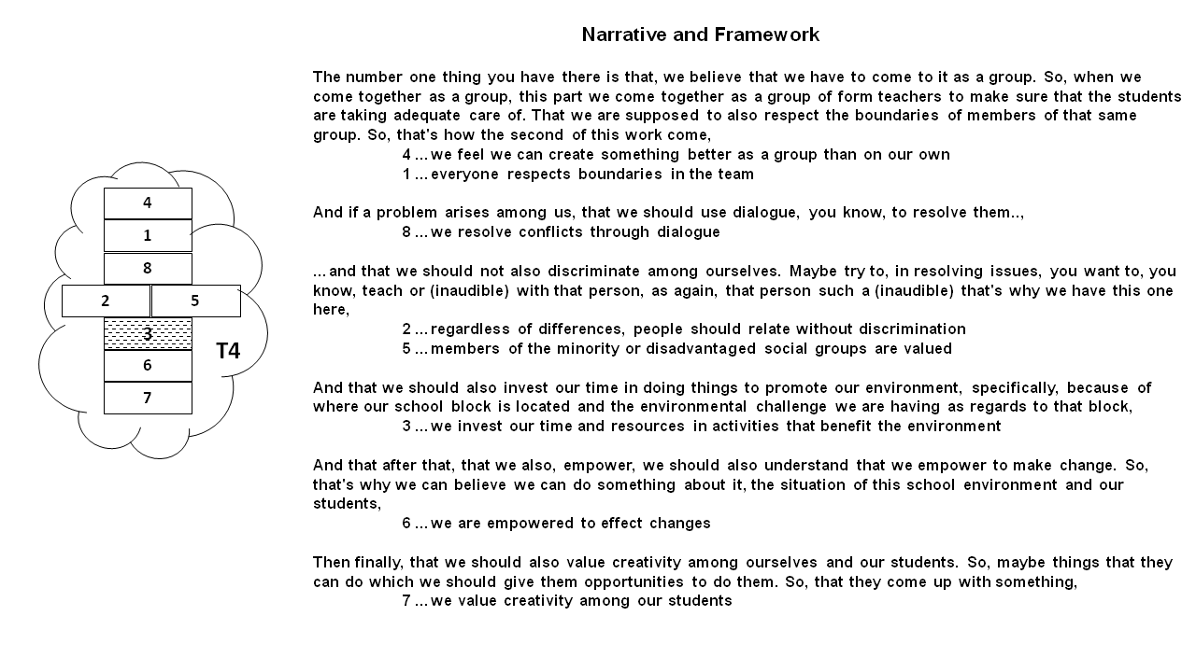
Figure 24: A visual display of the Values Statements and Narratives of Secondary School Teachers Group T4 in Nsukka

4.4.2 Teachers Group T5
Teachers Group T5 had similar characteristics with the previous group described above. They were responsible for taking care of students in their second year of senior secondary education. They produced a total of 10 values statements arranged linearly. The statements included values on teamwork, training, meeting commitments, consciousness of the environment etc.
A diagrammatic display of the values statement and the narratives is shown below.
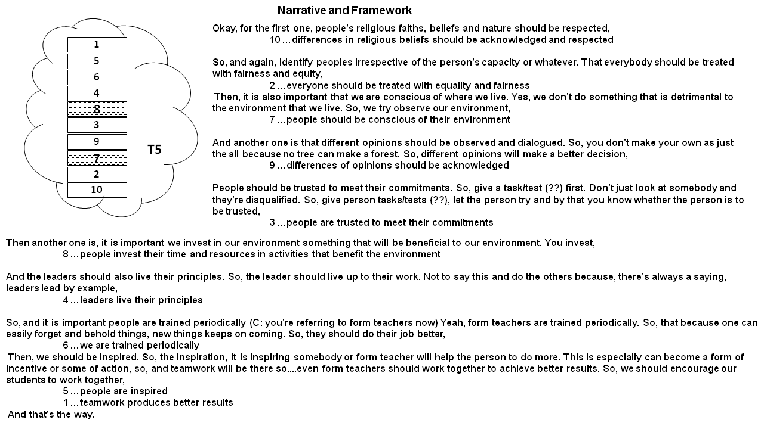
Figure 25: A visual display of the values statements and Narratives of Secondary School Teachers Group T5 in Nsukka

4.4.3 Visual Display of the Situated Shared Values of the remaining Groups of Teachers in Nsukka
Similar workshops were carried out with 4 other groups of teachers in Nsukka. The results including the frameworks and narratives of these groups are presented below.

4.4.3.1 Teachers Group T1
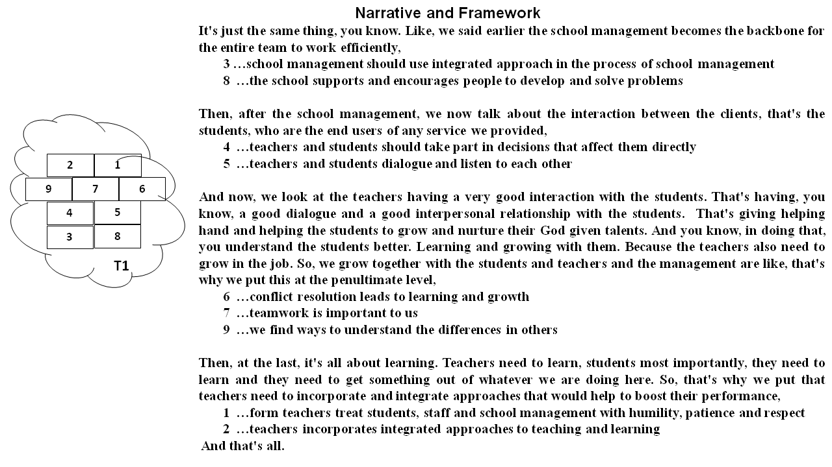
Figure 26: A visual display of the Values Statements and Narratives of Secondary School Teachers Group T1 in Nsukka

4.4.3.2 Teachers Group T2
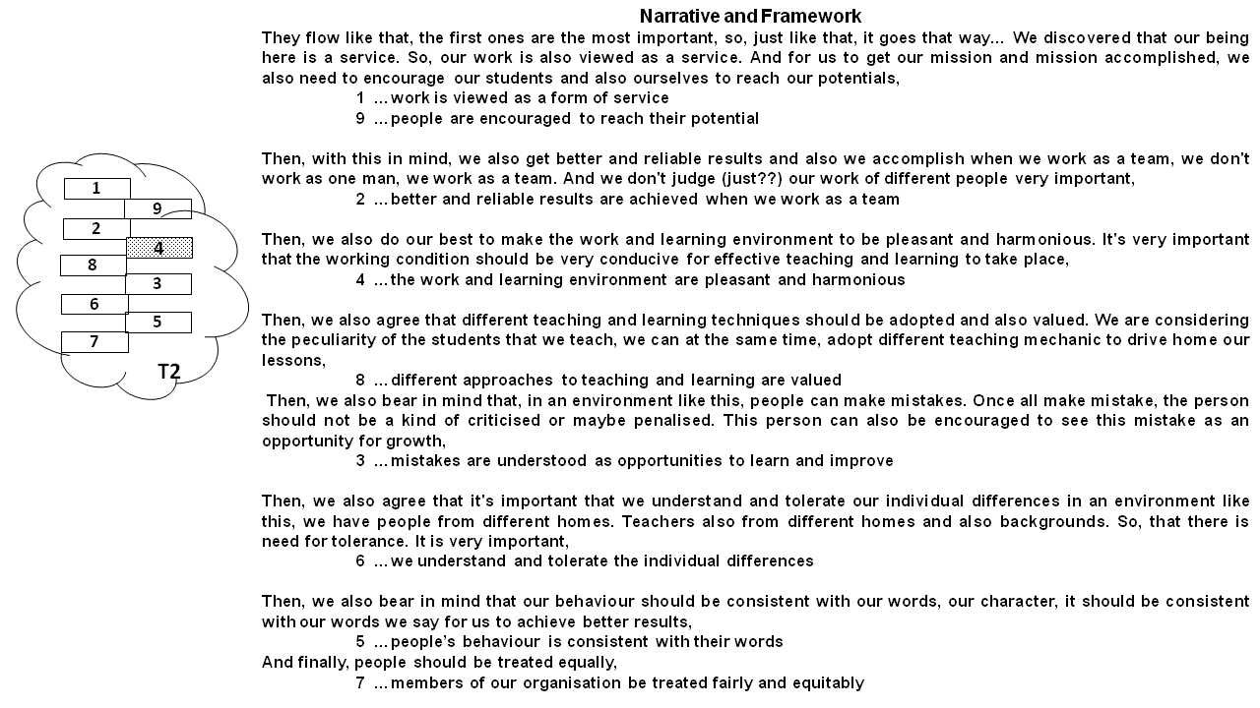

Figure 27: A visual display of the Values Statements and Narratives of Secondary School Teachers Group T2 in Nsukka

4.4.3.3 Teachers Group T3
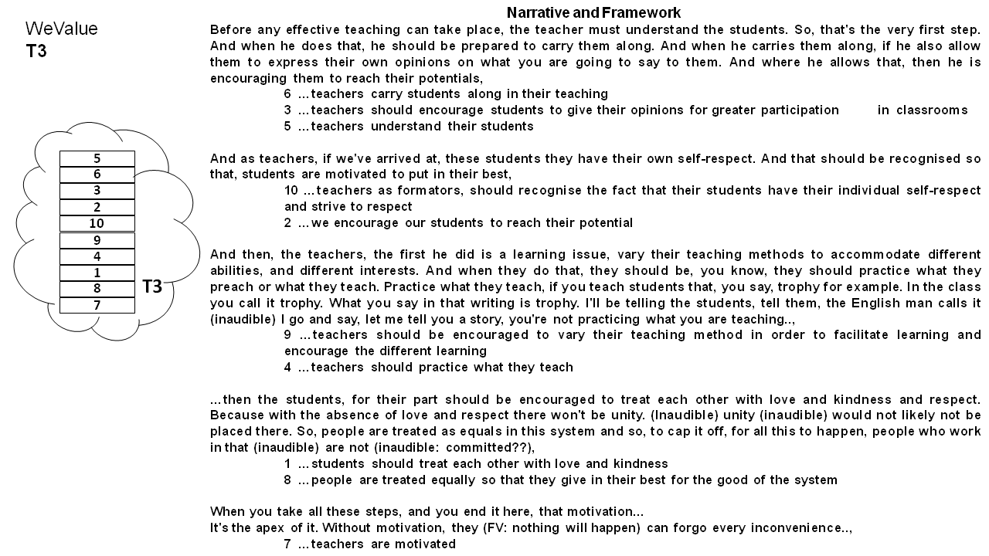
Figure 28: A visual display of the Values Statements and Narratives of Secondary School Teachers Group T3 in Nsukka

4.4.3.4 Teachers Group T6
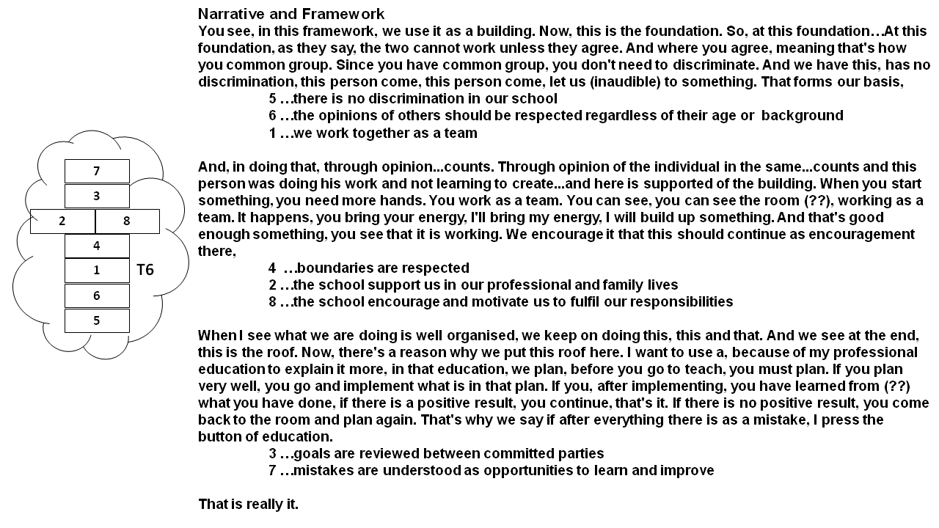
Figure 29: A visual display of the Values Statements and Narratives of Secondary School Teachers Group T6 in Nsukka

4.4.4 Groups of Teachers in Ufuma
Groups T7 to T9 were teacher groups based in Ufuma. The schools were located in a more rural environment and were not as organized as the first group of teachers. However, they agree that their shared responsibilities include teaching and impartation of knowledge, evaluation and assessment of students’ performance, enforcement of discipline among others. They also agree that they work together in fulfilling these responsibilities.

4.4.4.1 Teachers Group T7
The T7 teachers were a group of different subject teachers in a secondary school. The results of the WeValue workshop carried out with this group produced a set of 9 values statements in their values envelope. They employed a bottom-up approach in delivering the narrative of their frameworks. They consider teamwork as a value of vital importance, hence the placement at the base. The other values in the framework are statements of their ways of operation (5…we follow laid down rules and not cross boundaries), the qualities a teacher should possess (3…hard work is valued). The framework ends with the desire to contribute to environmental integrity by helping in the prevention and control of erosion (Statement 7).
The structural framework and narratives of T7 is presented below.
Similar workshops were carried out with 2 other groups of teachers in Ufuma. The results including the frameworks and narratives of these groups are displayed further below.

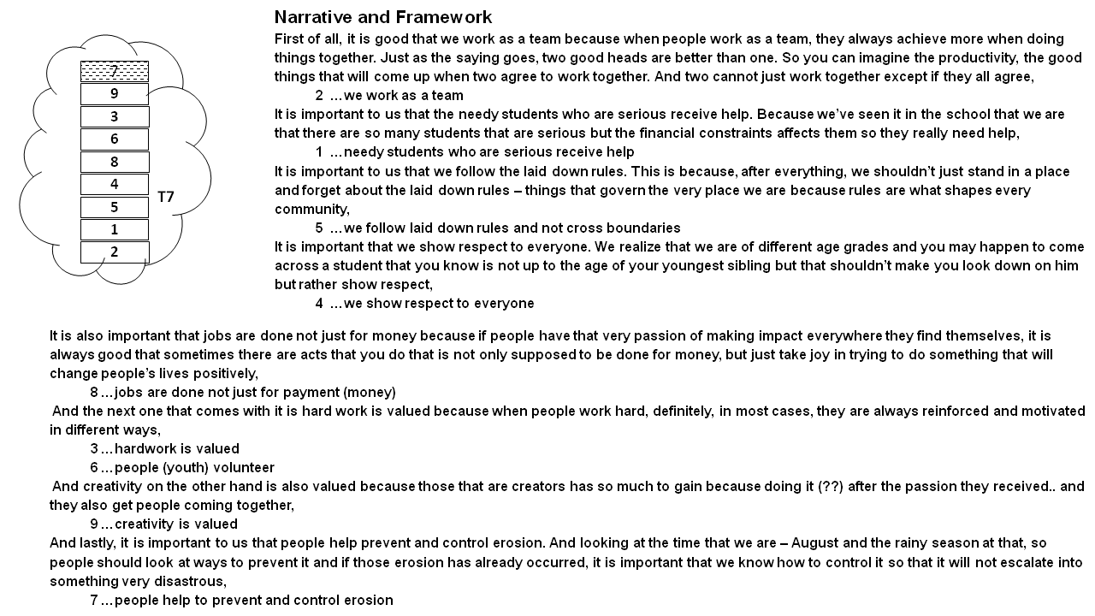
Figure 30: A visual display of the Values Statements and Narratives of Secondary School Teachers Group T7 in Ufuma

4.4.4.2 Teachers Group T8
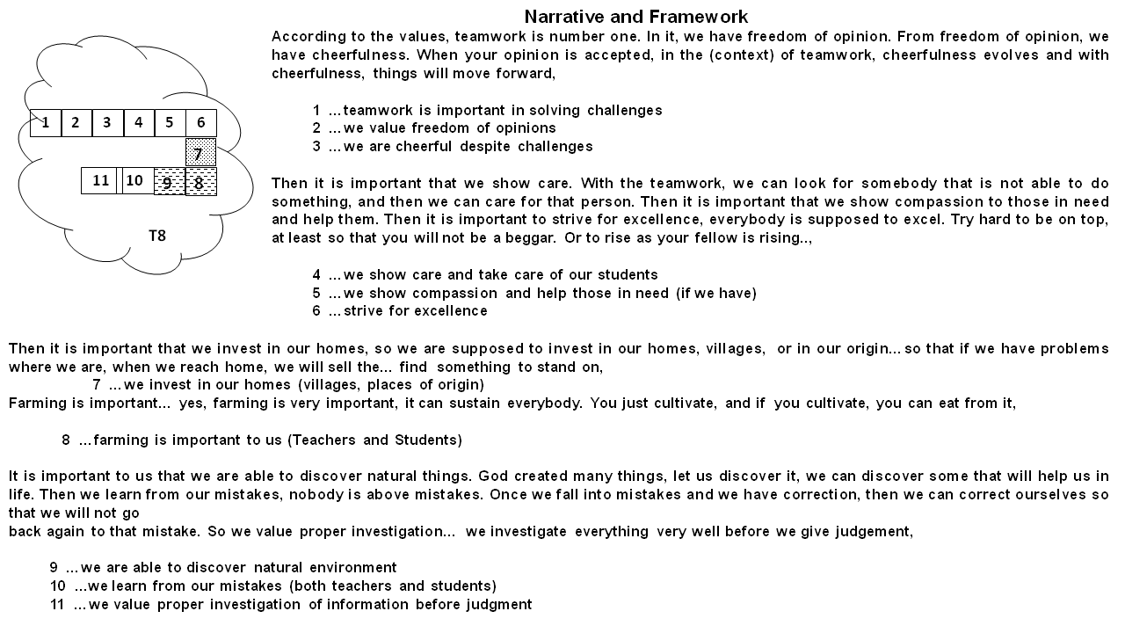

Figure 31: A visual display of the Values Statements and Narratives of Secondary School Teachers Group T8 in Ufuma

4.4.4.3 Teachers Group T9
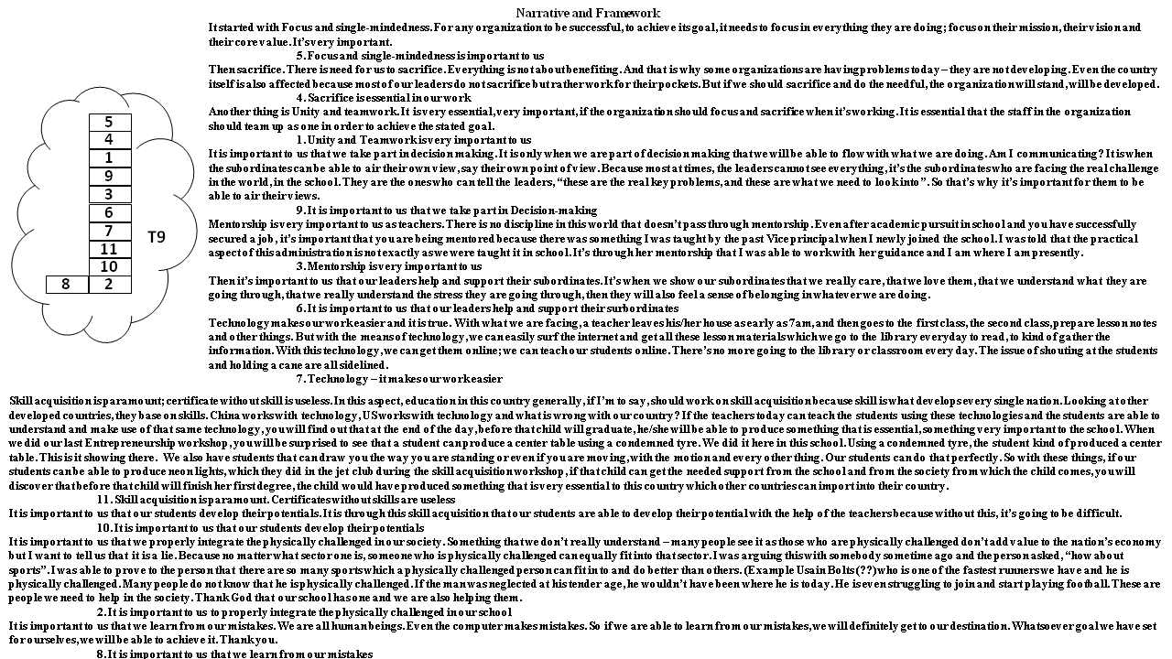

Figure 32: A visual display of the Values Statements and Narratives of Secondary School Teachers Group T9 in Ufuma

4.4.5 Ecosystem Analysis of Groups of Secondary School Teachers (T1 – T9)

4.4.5.1 Situatedness – Among the 9 teachers’ groups studied, ecosystem services were only elicited in 5 groups (T2, T4, T5, T7 & T8). Ecosystem values were absent in 4 other groups (T1, T3, T6 & T9). In other words, shared values of ecosystem services were elicited from teachers groups in both Nsukka and Ufuma. Despite the absence of any form of nudging before the workshops, these teachers groups were able to generate values that were linked to ecosystem services. This is evidence that ecosystem services are central to other human values and should not be discussed or valuated separately.

4.4.5.2 Variation /not across these 2 groups – The teachers’ groups in Nsukka produced regulating and cultural services only without any provisioning service. However, the Ufuma schools produced the complete MEA ESS types. None of the groups produced recreational and inspirational values in the cultural ecosystem service categories. In addition, the Nsukka schools did not generate any values related to spiritual (SPR), cultural heritage (CH), cultural diversity and Identity (CDI). However, the Ufuma schools produced all these but were lacking in values related to aesthetics (AES) and social relations (SR) both of which were elicited in the Nsukka groups.

      - Variation with site –
It was observed that the teachers in both sites produced values that were aligned with their responsibilities. For example, almost all the groups had reference to teamwork except T2, T3 and T4. However, on a general scale, the groups in Ufuma generated all the MEA categories (Provisioning, regulating and cultural) in contrast to the groups in Nsukka which produced only regulating and cultural services.
      - Connection with site ESS context
As earlier noted, the production of a provisioning service with particular reference to farming (T8 - …Farming is important to us) could be attributed to the socio-economic characteristics of the site since they are mostly farmers.
4.4.5.3 Variation with roles, including comparison with 4.1, 4.2, 4.3 results – It is noteworthy the types of CES categories generated among the teachers in both sites. The elicitation of educational and knowledge system values in the cultural category from the 2 sites indicates that the impact of group roles may persist across sites despite differing environmental or cultural contexts. .
Table 8: A summary of all the shared values statements produced by each of the 9 groups of teachers in Nsukka and Ufuma which contained references to ecosystem services, with the meaning contained coded as a proportion of any of the MEA ESS categories that seems applicable (Figures are rounded and presented as percentages).

LABEL | STATEMENT | PRV | RGL | SPR | RCR | AES | INSP | EDU | SOP | CH | CDI | KS | SR
T1 | …teachers and students dialogue and listen to each other
T2 | …the work and learning environment are pleasant and harmonious [It's very important that the working condition should be very conducive for effective teaching and learning to take place,] |  |  |  |  |  |  | 50 |  |  |  |  | 50
T3 | …teachers should encourage students to give their opinions for greater participation in classrooms
T4 | …we invest our time and resources in activities that benefit the environment [specifically, because of where our school block is located and the environmental challenge we are having as regards to that block] |  | 50 |  |  |  |  |  | 25 |  |  | 25
T5 | …people should be conscious of their environment [Yes, we don't do something that is detrimental to the environment that we live. So, we try observe our environment] |  | 50 |  |  |  |  |  | 25 |  |  | 25
T5 | …people invest their time and resources in activities that benefit the environment |  | 50 |  |  | 50
T5 | …differences of opinions should be acknowledged
T6 | …the opinions of others should be respected regardless of their age or background
T7 | …people help to prevent and control erosion [.. and the rainy season at that, so people should look at ways to prevent it and if those erosion has already occurred, it is important that we know how to control it so that it will not escalate into something very disastrous] |  | 80 |  |  |  |  |  |  |  |  | 20
T8 | 2. …we value freedom of opinions
T8 | 7. …we invest in our homes (villages, places of origin) |  |  |  |  |  |  |  | 50 |  |  | 50
T8 | 8. …farming is important to us (Teachers and Students) [yes, farming is very important, it can sustain everybody. You just cultivate, and if  you cultivate, you can eat from it] | 40 |  |  |  |  |  |  |  | 20 | 20 | 20
T8 | 9. …we are able to discover natural environment [God created many things, let us discover it, we can discover some that will help us in life.] | 50 |  | 30 |  |  |  | 20
T9 | It is important to us that we take part in Decision-making

  - Authenticity
Table 9: Examples of statements made which indicated perceived authenticity of the shared values Statements and Frameworks produced from the WeValue InSitu process

Grp | Transcribed dialogue
T3 | Facilitator: How do you feel about it? [POINTING TO THE FRAMEWORK ON THE TABLE] Just be sincere. Because this is your work. These are your words? Are these your words, ? Or my words?  MV: they are our words.  And, what we did today is only a reiteration of what we already know.  MV: It's only a reminder.)  Facilitator: it's a reminder…  MV: Reminds us of what we are able to do. It's like a refresher workshop to teach you, reminds you of what you already knew, not something really new.
T4 | MV: They are our words. They are the words of the researcher but we take…  Facilitator: …the words of the researcher?  MV: These are our statements. Actually, we chose them [FROM THE TRIGGER LISTS ] based on things that pertained to us. Although we were given kind of a run down…  Facilitator: a trigger list?  MV: yeah, so, from it, we chose those that are...  Facilitator: So, you are comfortable, if we bring out these statements tomorrow and show to the principal (of the school): that this is what the form teachers of SS1 agree: are you comfortable with these things? [POINTING TO THE FRAMEWORK ON THE TABLE]  FV: yes  MV: of course  Facilitator: You're very comfortable?  MV: yes
T5 | XX: That is our ideas.  MV: that's our ideas. It's not yours, no! (inaudible) (laughter)  Facilitator: So, they are yours. How do you feel about this?  MV: Good; great.
T6 | MV: …No, there's nothing (missing), we just captured everything that we need to say.  Facilitator: Okay, just sit down. I want to ask you a question. I want you to...how do you feel about this framework that you constructed? Are these really your words or are they my words?  MV: these are our own words.  Facilitator: These are your own words, … right?  MV: Yes, they are all our own. We picked everything, we wrote it down and we arranged it.  We feel that what we are doing is been captured, it's been represented. This [POINTING TO THE FRAMEWORK ON THE TABLE] shows what we do and what we act.  Facilitator: So, can we use this if there's a kind of assessment you do for teachers? Okay? For form teachers. Can we use this to assess your team? Do you feel confident that it can be related with your team?  (Participants say yes)

4.6 Summing up
The results of this study reveal that ecosystem services were clearly identified as situated within the framework of shared human values. These identified ecosystem services cut across the different divisions of ecosystem services as presented by the Millennium Ecosystem Assessment (MEA) framework. Furthermore, all the ecosystem services identified were effectively captured by this framework and there were no new categories identified. In addition to this, the study reveals that a recurring attribute of the ecosystem services identified in these studies is that they were mostly Hybrid values. In other words, most of the ecosystem services were either mixtures of provisioning/regulating and cultural services or even contained 2 or more dimensions of the cultural categories. For example, the statement in VC10.7: “We value erosion control work through volunteer activities. [always been the basis for our survival here as a community for thousands of years because erosion is a central issue here]” (The square brackets [ ] shows wording provided in the Narrative and are inserted to supplement the shorter statement). This statement clearly portrays a value for the regulating service of erosion control but also has a deep-seated appreciation for the place of social relations (a cultural category) in the fulfillment of this function. A majority of the ecosystem services identified in this study fell into the hybrid category while a fewer number retained their ‘pure’ status.

CHAPTER FIVE

DISCUSSION

5.0 Overview
In this study, the focus was to produce evidence of situated expressions of ecosystem services within the general shared values of different groups. In conducting this research, it was necessary to develop and utilize an unbiased approach that elicits and captures the shared values of ecosystems services at the group level. Furthermore, the classification system of the millennium ecosystem assessment ^{[1]} was adopted to examine the categories of ecosystem services valued by the groups. The authenticity of the data obtained from the process was validated using two focus group sessions.

In this chapter, the implications of the results are discussed with particular insights into contributions to integrated valuation studies, classification frameworks, group roles, contexts and other conversations in ecosystem services research.

5.1 Determining Values Shared at the Group Level
The work here has successfully shown that it can produce clear statements of group values – values held at the group level. Previous leading researchers have emphasized the need to examine values about ESS at a group level, rather than by individuals ^{[34,152,203]}. The reasoning was that such types of values are naturally occurring and held at the group level, not individual. The shared values of different groups were thus the centre of exploration in this study.

The methods for eliciting these shared values vary among researchers. However, the method used in this study involved the use of trigger lists and photos for the elicitation and crystallization of the values. The final product – ‘envelopes’ of group values (as illustrated in Figs 11, 12, 13 etc) – clearly provide evidence that the groups do indeed have shared values that occur as a group. These sets of values include many types of human values, (for example concerning prosperity, family life, morals) and that they also include ESS considerations. In summary, groups are found here to hold group-level values, and the WeValue InSitu crystallization process is confirmed to be effective in generating articulations of general sets of group values ^{[27]}.

The validity of considering ESS values as being held at the group level can be seen confirmed in the results here: the frequent reference to the provisioning service of farming by most of the groups in Ufuma suggests that it is a transcendental value which is firmly rooted in the culture of the community. This can be separately confirmed in anecdotal information such as by the connection of the title of their king to this all-important value (the title means “effective grower of yams”).
In a similar fashion, the various values elicited in different groups clearly fall within the framework of value types advocated in earlier studies ^{[34]}.

5.2 Insights Concerning Classifications of ESS Values
The data shows that every group has its own unique group-level values. The uniqueness of the different groups is in terms of having customized statements of shared human values unique to each group. This uniqueness persists despite the groups coming from the same town and playing the same roles. This supports the reports of several studies that the shared values of groups are context-dependent and culturally constructed ^{[40]} ^{[41,64,147]}.

There were also statements of human values that were seen across almost all the groups (except some few teachers’ groups). This may be an indication that there are values that are universally important to groups despite differing functions. For example, the provisioning service of food was a theme that was found to be recurring across groups and contexts. This provides further evidence that Ecosystem services are valued by the majority of people.

In this study, the results showed that provisioning and regulating services occurred at a higher frequency among the ESS categories in the different groups. However, a careful observation also reveals that around half of the ESS values elicited were cultural ESS values. This is indicative of the level of importance attached to cultural ecosystem services by people in relation to other values of what is most important to them. This further suggests that cultural ecosystem services deserve to be given more attention in valuation studies of ecosystem services. In addition, this shows the relative importance of cultural to provisioning/regulating ESSs – a result that has not been readily addressed in previous studies of value

The validity of the range of MEA categories produced in this study is further supported by the fact that almost the full range of MEA cultural subcategories was elicited. Most of the statements produced in the groups could not fit solely into a single category of CES suggesting that the item validity may need to be checked with the availability of more data. The data from this study did not generate any new category or classification of CES. Instead, we observed that several of the shared values statements were captured in both the cultural and non-cultural categories of the MEA framework. These groups of statements were classified as hybrids and holds special significance for ESS studies especially because the current classification puts a distinction between the material and non-material values ^{[39][172]}. This separation is reflective of the ontological roots of the ESS valuation mechanisms which are deeply embedded in market-based economics and which greatly limits the ability to effectively understand cultural value ^{[14,15]}, ^{[16]}) (like the value of housewives catering for their children etc).

5.3 Who Is Appropriate To Be Engaged To Contribute ESS Values Information?
The data shows that many different types of groups including teachers, councilors, youth and women were able to generate shared values statements that dealt with ecosystem services. This is pertinent in addressing the questions in certain literature of who should be asked and whose value included in ESS valuations ^{[64,65]} ^{[75]}. Some works have also advocated for the inclusion of local and indigenous knowledge in ecological studies ^{[204][107,205]}. The usual practice had been to involve environmental and developmental experts in such valuations ^{[206,207]}and accept their opinions at the expense of the opinions of the local people who were frequently thought not to have sufficiently adequate responses to expert questions. This has been debated and calls for the integration of local knowledge are now gaining momentum. ^{[151]}describe it as making ecological knowledge to be locally accountable by having attachments to and being valid for the local people.
Admittedly, there have been attempts at involving non-expert local people in the valuation processes. This is coupled with engaging with local participants using more participatory methods and the use of several tools to overcome barriers in communication. Nevertheless, there persists certain challenges. For example, a study on the use of photo-elicitation revealed inherent difficulties: the conceptual interpretations of the pictures given by the local people was different from that intended by the researchers ^{[151]} thereby raising questions of face validity ^{[208]}.
The method used in this study for eliciting the shared values of the groups exhibit no difficulty or problems when a range of local non-ESS-experts are involved in the study. The participants (teachers, health workers, women and youth) acknowledge that the shared value statements produced during the process represent their authentic shared values as is shown in Table 9.
^{[27]} suggests that this depth of engagement could be attributed to shared experiences and relevance of the topic being discussed. Earlier works by ^{[209]}and ^{[210]} rate the WeValue approach highly in being able to foster participation and produce outputs reflective of the local values.
The prospect of being able to choose any type of group of local participants rather than experts in valuation of ESS is innovative and holds a huge potential in ESS practice because it provides the platform for a more accountable and authentic framework of shared values including ESS values within a wider ‘envelope’. Additionally, since the final output from the process is a set of carefully articulated statements produced through a tacit-to-explicit translation, this process could be considered to facilitate the fusion of local and global knowledge ^{[107]}. The statements produced from these workshops can be made more concise if there exists more workshop time. This would add to the possibility of using these statements as indicators in decision-making for ESS valuations as has already been done for sustainable land use^{[26]}; environmental management ^{[208]}; environmental education ^{[181]}; and for local-national indices ^{[191]}.

5.4 Impact of Group Roles and Ecosystem Context
The effect of group roles on the value types and dimensions produced with our methodology was also considered in this study. There was clear evidence of variation in the types of values elicited across the groups. For example, a careful observation of the cultural services elicited across the groups reveal that the teachers produced more values related to education in contrast to the councilors who had more values related to cultural heritage, identity and social relations. This can be attributed to the different roles played by different groups. While this is evidence of the fact that shared values are bespoke statements tailored for specific groups, there is also a need to critically appraise the source of these variations.
It is also shown in the study that the contexts of the existent ecosystems also played some roles in the services that were emphasized. This is further emphasized in the results obtained from the teachers in Nsukka and Ufuma. At least one group of teachers in Ufuma mentioned their value for farming activities while this was not mentioned at all among the teachers’ groups in Nsukka. Ufuma being a more rural community where a greater population of the locals engages in subsistence agriculture may be a useful explanation for this. As a result, even when a study is carried out with similar groups or similar group characteristics in different locations, there is always the possibility that different ecosystem services would be emphasized.

5.5 Work Towards Situated, Integrated, ‘Translated’, Authentic Values
Situated ecosystem service values was the main objective of this research, and therefore a major contribution of this study is the production of situated ecosystem service values – that is ESS values that occur and are embedded within the envelope of other shared values held by the group. Such values are more clearly understood only within the context of the other shared values where it occurs. This corresponds to calls for ESS valuations to become situated practices that produce situated knowledge ^{[116]}. ^{[211]} proposed that certain landscape units be linked to specific ecosystem services – a cultural model which tried to measure landscape values of certain populations. This contrasts with the approach used in this study. Here, we have employed a wider platform for exploration of values; one which is devoid of any form of geographical, landscape or thematic restrictions. The group decides its own contexts at the beginning of the process and every other activity is aligned to it.

Essentially, the WeValue InSitu process assists a community of practice to identify, and articulate what is valuable, meaningful and worthwhile to them. The process is inherently designed to ensure a situated and integrated exercise that allows participants to point out and work out meanings around their shared practice. The ensuing articulations are developed InSitu and without external bias.

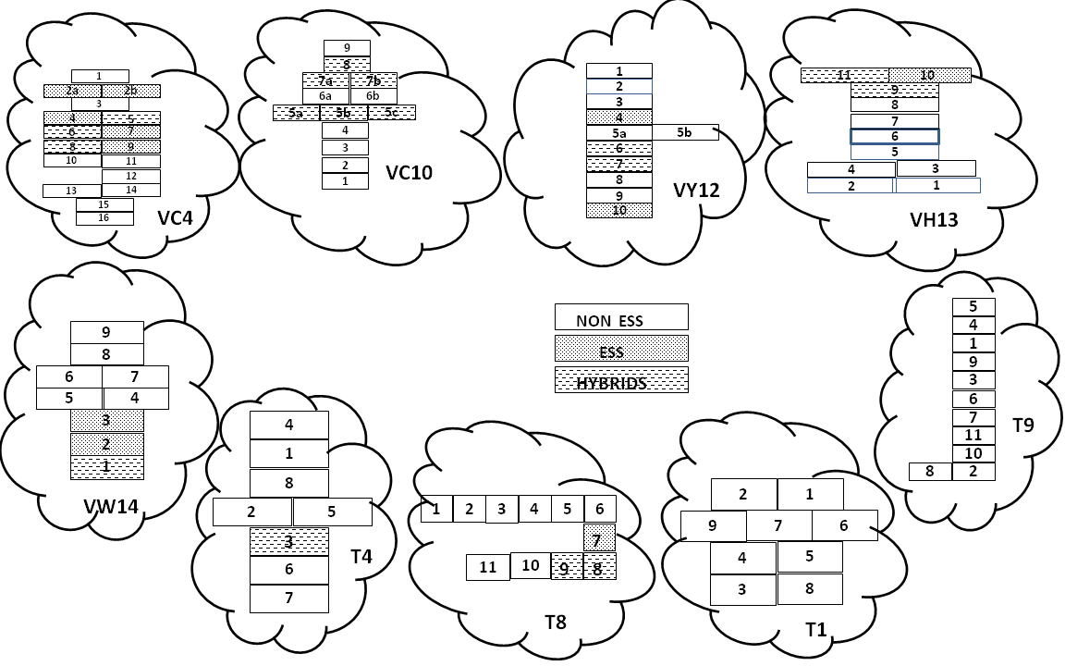
SITUATED ESS
Figure 33: Values envelopes of various groups, indicating the situatedness of ESS and which were purely ESS, NON-ESS and HYBRIDS
Unlike some other deliberative methods that modifies the existing social constructs of ESS values as reported by ^{[129]} and ^{[64]}, it is pertinent to note that the WeValue InSitu process does not aim to construct new meanings but to help to generate clear expressions of the hidden tacit values which are shared by members of the group. ^{[23]} has carried out an extensive analysis of the micro-processes involved in the WeValue InSitu process using the theory of tacit knowledge developed by Polanyi. The results show that the WeValue InSitu involves the continuous translation of tacit knowledge to explicit knowledge. The figure below gives a lucid illustration of the process.

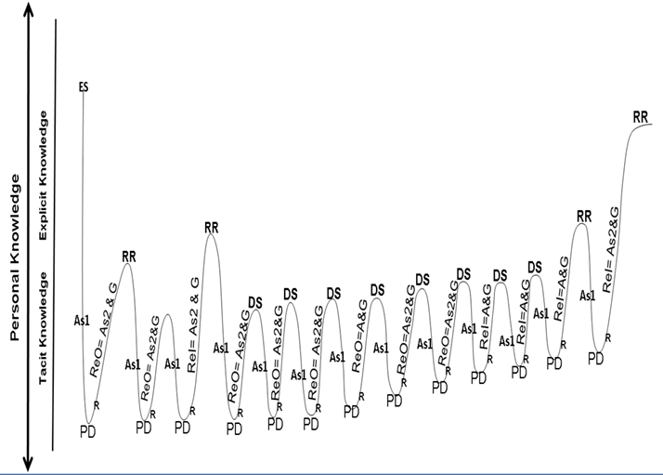
Figure 34: A schematic representation of the microprocesses found in line-by-line analysis of transcriptions of the main Crystallization Stage of a WeValue InSitu process (see Odii B. 2021 for details). They start with an External Stimulus (ES) provided by a list of Trigger Statements provided by the facilitator, and proceed via sub-processes of Polanyi’s tacit-to-explicit translation (TET). PD=Primary Denotation, ReO=ReOrganization, A= Assimilation, G=Groping, R=Reflection, DS=Designation, ReI=ReIntegration, RR= Read Result ^{[23]}.

5.6 Hybrid Values, Values Plurality and Pluralistic Valuations
Another important observation is that many of the values captured in this study did not fit into just one category of classification. Although the framework of the Millennium Ecosystem Assessment presents different distinct types of ecosystem services, the values were predominantly found to be a mix of different types of ecosystem services, hence the name Hybrid values. Thus, whereas the participants’ outputs agree with the broad divisions of the MEA framework, they were nonetheless difficult to be confined to one category. This agrees with the idea that ecosystem services should be viewed through the lenses of culture – a concept described as relational values in the IPBES framework (^{[41,42]}. The cultural interpretations by the groups are responsible for the specific framings of values. Therefore, this study seems to suggest that the various global frameworks for classifying ecosystem services should be considered as just a guiding template for ecosystem studies and never as a definitive system of classification especially at the local level.
Several studies by other researchers are advocating for integrated and plural valuations. For example, ^{[41]} carried out a detailed work on the IPBES approach to valuing nature’s contributions to people which involves integrated and pluralistic valuation. Their study contrasts a one-dimensional approach to multiple or pluralistic approaches where diverse valuations targeting the different domains of biophysical, socio-cultural, health and economic values are assessed and afterwards the results of the different valuations are collated and produced ^{[41]}. The major difference is that the IPBES approach encourages that several different methods of valuations are used for the different domains and afterwards an integration of different value foci across domains are carried out usually resulting in value trade-offs. In contrast, the WeValue InSitu method is an inherently integrated holistic process that captures the whole range of dimensions of human values as produced in the group context. These value types produced are inclusive of all domains of value – all captured in the envelope of what is most important to the group – and often without the need for trade-offs. It is considered comprehensive and representative of the group and is highly integrated.

5.7 Culture and ESS Valuation
The results indicate that slightly different perspectives and ways of looking at ESSs could be found in different groups. This appears to be a manifestation of cultural dynamics operationalized at different levels - societal, organizational etc.
In this study there were small and frequent variations in perspectives interpretations or definitions offered by different groups concerning the same ecosystem service. These variations were culturally induced. As a result, studies that are concerned with cultural perceptions of the values of ecosystem services are expected to be largely different for different groups. This is perhaps what makes studies on cultural ecosystem services a bit complicated for people from different fields especially the economists.
Thus it appears that our approach opens the door for naturally varying results from different groups to emerge, containing their authentic perspectives, whereas more-standard or traditional approaches which use fixed formats might have to use a multitude of those in order to elicit the same range of localized results. If researchers try to see these slight variations which are culturally-originated from traditional methods, they may not be seen or might appear to be contradictory.
This has serious implications for ecosystem service practitioners. First, it means that different approaches are needed for different scenarios. This means that each case must be approached on its own merit and without pre-existing bias from previous studies. This may pose a bit of trouble for planners and policy makers who would now need to constantly monitor for variations. Even in cases where study methods are replicated, there must be enough room for flexibility. Secondly, it implies that there is really no generally accepted metric for measuring these cultural values. This is perhaps the most difficult of the objections posed by economists. These values are difficult to measure, difficult to monetize and difficult to standardize ^{[212,213][162]}.

5.8 Cultural Ecosystem Services – Implications for Group Voice
The nature of cultural ecosystem services and the shared values studied in this work promotes the recognition of group voice. Since the values generated from this study have been validated as the authentic idea of the group, it is proper to state that the process delivers a good platform for ensuring environmental justice ^{[89]}. It therefore addresses the core of ethical considerations in ecosystem services by answering the question of who’s voice and opinion should be considered and for what purpose ^{[214,215]}. Recent studies on ecosystem services are increasingly adopting methodologies that empower the voices of aboriginal people ^{[216]}; ^{[217,218]}.

5.9 The WVICP and its Usefulness in Valuation Frameworks
It is clear that the use of WeValue InSitu in this study provided a scaffolding process for the crystallization of the shared values of the group. It was also useful in helping the groups to gel different values concepts and domains of life together. Thus the WeValue InSitu crystallization process was useful in navigating the perceived dichotomies between natural and cultural aspects of the ecosystem. This is similar to the role played by the IPBES relational values which posits that culture permeates through and across all categories of Nature’s contributions to people. Therefore, we propose that the integration of culture in the valuation of material, non-material and regulating NCPs in the IPBES framework is perceived in this work as a role well executed by the WeValue InSitu. We suggest that the WVICP could be a used as a bolt-on process in other valuation frameworks for cultural ecosystem services. Further studies may be needed to validate this.

5.10 Authenticity of Values Elicited (Issues on Authenticity)
A fundamental requirement for works done in the assessment of ecosystem services is the confirmation of authenticity or validity of the values elicited and the process used. This is supported by several studies on validity ^{[219,220]}. This study utilized the WeValue process which has been established to have a transparent audit trail from the negotiating and meaning-making stage right to the final outcome ^{[23]}.
The high authenticity value of the WeValue InSitu process is reported by ^{[27]} and ^{[26]} and confirms the process as a useful scaffolding process that provides space for participants to collectively explore their dormant hidden knowledge about shared experiences. This procedure is carried out without any nudging to any particular theme or any interference of the facilitator. The values statements so produced are entirely owned by the participants and not the facilitator, hence the name InSitu. This further corroborates the reports of face validity as reflected in Table 9.
The action of linking the shared values statements that are produced from the process to the shared tacit knowledge of the group ensures that the values statements are accountable, well situated and well blended with the group’s norms and ideals.

5.11 Implications for Sustainability
Sustainability science advocates for the inclusion of all pillars of sustainable development – economic, environmental and social, in valuations and ecosystem service decision-making. This connotes the consideration of diverse factors before any intervention is carried out. Many studies have focused on the environmental and economic contexts of decision-making in ecosystem service research. This study takes into consideration the role of the social and cultural aspect in any project. It is evident from the results that even the presence of a provisioning service as basic as food had far reaching implications in terms of being significant for the spiritual lives and social relations of certain groups. This must always be taken into account in environmental impact assessments and other assessments by governments and decision makers.

5.12 Indicators for Cultural Valuations
Although it was not the intention in this study to produce indicators for cultural values of ecosystem services, the results are pointers to the possibility of developing cultural indicators for ecosystem services. The values framework can act as a feedback mechanism for group preferences in a local context. This is well reported in studies using biocultural approaches for constructing wellbeing indicators ^{[148]}.

5.13 Environmental Responsibility
This study further provides insights into issues of environmental responsibility. Who is responsible for the environment and to what extent? Most of the works done on environmental responsibility and accountability are linked to the role of corporate organizations, small and medium enterprises (SMEs) and multinationals in adopting the environment as part of their Corporate Social Responsibility ^{[221]}. However, this study opens new prospects on the need for shared responsibility towards the environment by other non-business groups. For example, we observe that the youth group (VY12) considers matters of erosion prevention and control as one of vital importance and for which they should be accountable and answerable for. Also, we observe similar scenario for VC5 where they explain that their women are responsible for maintaining the spring. The 2 cases mentioned above show that different local groups can be assigned to take care of different aspects of the environmental – a situation that may lead to a form of decentralized environmental governance. This is supported by reports on the emergence of new policies that advocate inter-territorial, intersectorial and intergenerational co-responsibility towards environmental problems ^{[105]}. This also extends to more gender-specific inclusions ^{[222]}.

5.14 Limitations
This study was conducted with basically 3 group types. A wider range of group types would be necessary to capture more information about the variations that arise with different groups. The study was also limited in cases where the participants were not able to read the trigger lists even in the local language. During such occasions, the researcher had to read out the contents of the trigger list while the participants chose their preferred statements by ticking the corresponding number on a bingo sheet.
Finally, it may be difficult to state precisely if the outbreak of the pandemic had any specific effect on the level of engagement of the participants. This can only be confirmed after series of other fieldworks to check the level of engagement post-pandemic.

5.15 Future work

5.15.1 Investigating the Impact of Group Roles
It was observed that there were variations in the ESS categories produced across groups. Although it is too early to generalize, it is nonetheless evident that the councilor groups produced more shared values aligned to the provisioning and regulating services while the teachers produced values that were more focused on learning and relationships. So, there is a clear alignment of values produced with group roles. This is a new observation in studies involving the WeValue crystallization process and would influence group selection in subsequent studies on ESS.

5.15.2 The Impact of a Second Session Of The WVICP
Secondly, future studies can look at the likelihood of conducting a second session of the WeValue crystallization InSitu process with participants. It is known that each session lasting about 3 – 4 hours only produces a framework of the topmost issues of importance. It has been frequently observed that participants naturally stop producing statements at some time during the session. It is thought that participants may build on earlier results if a second session is conducted, during which they may produce another list of lesser important values but which may contain more values of ESS not previously mentioned.
The findings in this study present some options of actions to be taken. The first is to continue with the development of methods that disclose or crystallize the authentic values of the people and afterwards, to separate them into the already established categories based on economics. Another option would be to begin the process of forming a new normative economics that recognizes and incorporates different domains of ecological and financial accounting but with the added advantage of acknowledging and absorbing the importance of intrinsic human values. This would obviously require more data about people’s own ideas of what is important, meaningful and worthwhile based on their knowledge systems. This holds much promise to generating a practical, reasonable approach to valuation in ESS and other domains of sustainability assessments. In order to generalize this option, there is need for the rigorous work of linking indigenous knowledge with accepted universal concepts and this could become the foundation of what could be referred to as Group-Level Universal Values-based Economics (GLUVE).

CHAPTER SIX

CONSIDERATION OF A WIDER RANGE OF CASES (INDONESIA AND SENEGAL)

6.0 Overview
The purpose of this chapter is to generalize the findings of this study by presenting the results of similar studies conducted with different groups across 2 countries – Indonesia and Senegal. The same methodology designed for this study (See Chapter 3) was applied to the 2 sites. The WeValue insitu crystallization process was first conducted with 9 groups in Indonesia and 11 groups in Senegal. In this chapter, the results of the study conducted in these 2 sites are presented and analyzed for ecosystem service outputs.

6.1 Situated Shared Values (Frameworks) of Groups in Indonesia
Indonesia is a country located in southeast Asia. It is the world’s largest archipelagic state with around 17500 islands and an estimated population of 270 million people ^{[223]}. As at 2019, it was considered the largest economy in southeast Asia and contains an extremely varied climate, topography and geography ^{[224]}. This study was conducted in East Lombok – one of the lesser islands in the country.
The study was conducted with 9 groups comprising mothers (M1 – M6), fathers (F1) and teachers (T1 – T2). As stated earlier, the methodology for this thesis was applied including the preprocess of localization of WeValue materials, the WeValue insitu Crystallization process (WVICP), the focus groups perspectives explorations and the thematic analysis and classification using the Millennium Ecosystem Assessment framework.
The diferent groups generated different types of shared values on different themes such as respect, learning, sacrifice, family, religion and spirituality etc.
An analysis of the results reveal similar interesting details as the previous studies in Nigeria. The results show that out of 9 groups examined in this study, only 4 groups were found to have generated ESS-related values. This consisted of M2, M3, M6 and T2 groups. Further analyses of the results are presented below.
6.1.1 Situatedness – The results show that ecosystem services were embedded within the values frameworks of some of the groups. The generation of these ESS values as part of the list of most important things confirms that ESS values should not be assessed seperately from other values.
6.1.2 Variation /Not Across These Groups – Incidentally, all the mothers group produced the same types of ESS value – cultural ecosystem service. Specifically, they all had references to nature using such statements as these: 14 …we have a beautiful natural environment that is still natural - It's nice to see clean and tidy yards (M2); 2 …East Lombok has many places of natural beauty for recreation (M3); 9 …we have Nature: a tree represents peace and calm in life (M6). From the example statements above, it is clear that the mothers had a strong value for recreation provided by nature. The teachers’ group (T2) on the other hand also had references to nature but were not restricted to recreation. Their appreciation for nature expanded to include values for learning, education and knowledge systems. The example statements below illustrate this further: 9 …we introduce nature to children at an early age (knowledge system); 5 …children learn about the growing of rice so they can be closer to nature (education). They also produced statements connected to regulating services like 4 …we actively preserve the environment. The statement about agriculture being a way of living was considered a hybrid supplying the usual provisioning service and also the cultural service of identity.
6.1.3 ESS Categories Elicited and Identified – In the Indonesian study, all the MEA classification of values were produced but not at the same frequency. The most frequently occuring ecosystem service elicited from this study was the cultural ecosystem services. The 3 mothers’ groups that generated ESS values produced only cultural ecosystem services while the teachers’ group 2 produced al the categories with one of the value statements being a hybrid, that is a combination of provisioning and cultural services.
The figure below is a visual representation of the situatedness of ecosystem services within the envelopes of shared values of the various groups in Indonesia.
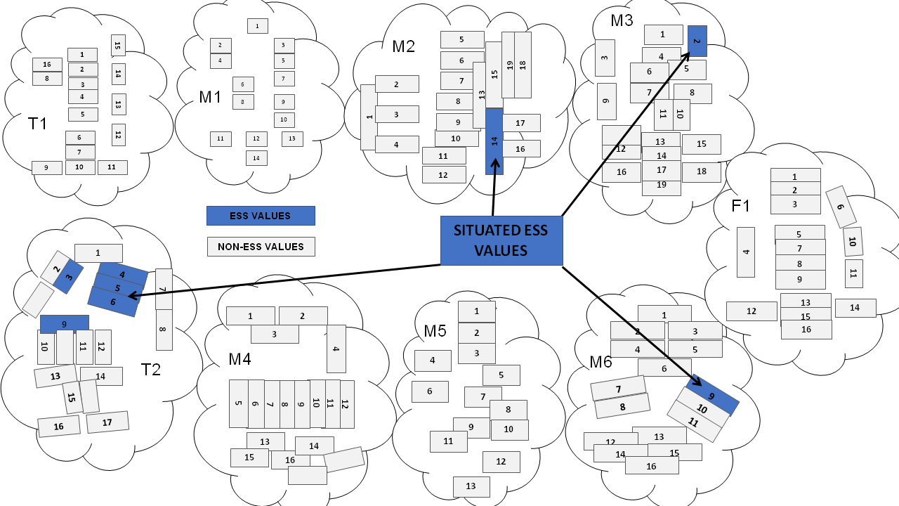
Figure 35: Values envelopes of various groups in Indonesia indicating the situatedness of ESS

6.2 Situated Shared Values (Frameworks) of Groups in Senegal
Senegal is a country in the Western part of Africa with the capital in Dakar. The country has a population of 16.74 million people. It is bordered by Mauritania, Mali and Guinea and enjoys a tropical climate.
The research for the exploration of ecosystem services within the shared values of groups was conducted in Kaffrine – an agricultural town renowned for growing peanuts, millets and maize. The study was conducted with 11 groups comprising mothers, fathers, health workers, farmers, market traders and administrators. The major language of use in this locality is Wolof which is the national language of Senegal. Due to this language restriction, local researchers were trained to carry out the WeValue insitu crystallization process with the guidance and supervision of the facilitator. The sessions were recorded and later transcribed and translated into French and English.
Furthermore, the difficulty in communication between the original faciliatator and the participants necessitated the slight variation of the wevalue insitu crystallization process by making use of clip art images rather than live photos for the photo-elicitation process. Just like a typical session, several values were generated from the partcipants corresponding to 3 major themes – their aspirations (most important to achieve), the qualities (needed to meet aspirations) and Interactions (to foster aspirations). The deliberations and values statements produced stressed on such themes as religion, family, food, livelihoods etc. An analysis of the results are presented below
6.2.1 Situatedness – The results of the study show that 4 groups namely the grandmothers (GM1), farmers (FM1), market traders (MT1) and mothers group 2 (M2) produced ESS-related values. Thus, it was observed that ecosystem services were situated within other shared values of the groups.
6.2.2 Variation /Not Across These Groups – There were some variations across groups in the ESS values elicited. First, some groups produced more ESS values than others. For example the farmers (FM1) generated more ESS values (4) than the the rest. They were followed by the grandmothers (GM1) who produced 2 ESS-related values. Both market traders (MT1) and mothers group 2 (M2) produced 1 ESS-related value each. The implications will be discussed later. Another important factor of is in the types of ESS values generated. There was basically not much difference in the category of ecosystem services generated by the groups. It was observed that all the ESS-generating groups produced only provisioning services with the exception of the grandmother group that also produced a regulating service of secure environments.
6.2.3 ESS Categories Elicited and Identified: As earlier stated, mostly provisioning services were produced by the groups with the exception of the 1 regulating service produced by group GM1. Most of the provisioning services mentioned access to resources like water and food. An example statement is provided by the farmers’ group: 1 ...To have good quality seeds. The regulating service produced by the grandmothers was depicted by the statement, “... To have secured environment”.
The diagram below shows the values frameworks of the different groups in Senegal and the occurrence of ecosystem services within the values frameworks. The implications of the results are briefly discussed afterwards.

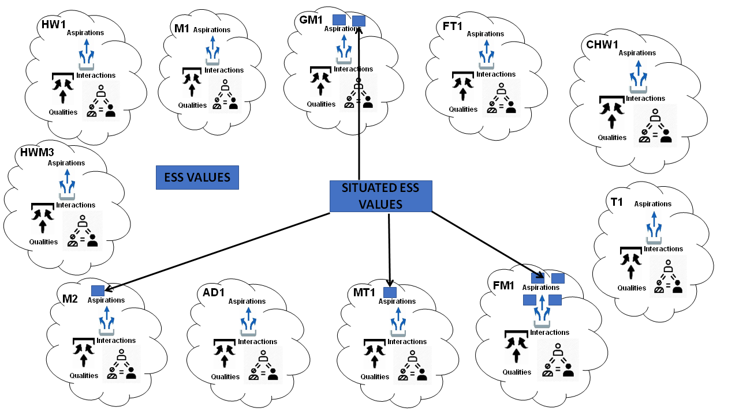
Figure 36: Values envelopes of various groups in Senegal indicating the situatedness of ESS

6.3 Discussion
This chapter is intended to demonstrate the applicability of this study to a wider range of cases and contexts. So far, the results obtained from this chapter correlate with the earlier results obtained from this study (See Chapter 4). The occurrence of ecosystem services within the context of other social, cultural and human values is indicative that ESS values are situated in the values framework of groups and should rightly be studied from that background.
The variations in values produced across groups in Indonesia is further evidence that group roles are important factors in the type of values elicited – ESS values inclusive. While it is not exactly the case in Senegal, we may argue that societal context had more influence in the deliberations of the Senegal groups than group roles. This may need to be studied further to ascertain the exact factors that influence the ESS values produced per time.
We also observe that even with the slight variation in the WeValue process, similar results were produced. However, it is clear that there is need for proper and sufficient training of local researchers to carry out effective facilitation of the process in cases of language or cultural hindrances. This is supported by studies which indicate that the limitation of the WeValue insitu crystallization process is the need for specialist facilitators ^{[44]}. The process for the development of a manual for training is underway and soon to be completed.
From the foregoing, the ideas about generalization seem to be trending correctly. Therefore, this approach is considered fit and beneficial and it is suggested that ESS valuations incorporate this technique in future studies of cultural ecosystem services. It is also proposed that other researchers can take this forward rigorously.

CHAPTER SEVEN

CONCLUSIONS AND RECOMMENDATIONS

7.0 Overview
The main objective of this study was to produce evidence of situated values about ecosystem services, (i.e. situated within the wider shared values of the group). Thus, this study was useful in exploring the situatedness of ESS values within the framework of other human values using a values-based participatory approach as a bolt-on to the MEA classification framework. The results obtained in this study reveal that ESS values are found embedded and situated within the group’s framework of shared social values. The ecosystem services elicited contained the 3 main MEA categories of provisioning, regulating and cultural services with cultural services forming about half of the total ESS values elicited. This situatedness of ESS values within the wider shared values of the group is in agreement with previous studies that shared values research should be context-dependent and culturally constructed (^{[147]}, ^{[40]}. It also fulfils the need to treat ESS research as a situated practice ^{[64]} – one which is locally accountable to the people.

Furthermore, this research was useful in developing a systematic non-biased methodology for the elicitation of cultural values of Ecosystem Services. Cultural ecosystem services are by nature intangible and non-physical. They are considered to be difficult to measure in conventional market-based economic valuations. Using a bolt-on of our values-based approach (WeValue insitu crystallization process) to the classification framework of the Millennium Ecosystem Assessment, the cultural values of ecosystem services were extracted from the general shared values of the group. The process was considered non-biased because it did not involve any form of nudging techniques and ensured that all the values statements were the original ideas of the participants and not that of the facilitator or environmental experts.

This study was also able to conveniently apply the WeValue insitu crystallization process trends and variations in the cultural values of ecosystem services of different types of groups. The groups involved in this research included village councilors, teachers and members of village committees in Southeast Nigeria. The results clearly demonstrated that there were variations in the types of ESS values elicited across the groups with the village councilors expressing more values for provisioning services than the teachers. The study also displayed slight variations in values across local and geographical contexts of the groups. These results are clear indications that group roles or functions and local contexts play a pivotal role in the types of ESS values elicited.

In addition, this study successfully demonstrated the authenticity of the shared values about ESS elicited through the process. Aside the already established auditability of the WeValue insitu crystallization process reported in previous studies ^{[26,27]}, this study also demonstrated that the ESS-values generated from this process were authentic. This was achieved using focus group perspectives explorations to produce representative statements that demonstrated ownership of and accountability to the statements. The participants were able to declare their acceptance of the values frameworks as being genuine representations of their shared values.

The final objective of this study was to demonstrate the specific usefulness of the standard WeValue deliberation process to making local shared values of ESS explicit. The process was very helpful in eliciting and crystallizing previously tacit ESS values to explicit. The ability of the WVICP to carry out these tacit-to-explicit conversions has been reported in previous studies ^{[23]} and is evidenced by the clear articulations of their values statements.

In fulfilling the objectives of the research mentioned in the preceding paragraphs, this thesis was able to answer the following research questions:

- Do ESS values exist within the values envelopes of non-environmental groups?
- Can this ESS values be successfully elicited without nudging?
- Do the elicited ESS values effectively fit into the classification categories of the Millennium Ecosystem Assessment?
- Are the elicited values authentic and can their authenticity be proven?
- Is the WeValue Insitu process effective in integrated valuation of ecosystem services?

In the next session, the specific contributions of this thesis are presented with particular emphasis on the implications for ecosystem service research, shared values studies, environmental management and sustainability indicators.

7.1 Contributions of this Thesis
With some degree of certainty obtained by the depth and breadth of this study, this work has made important contributions to theory and practice. This work has made significant contributions in 4 major areas and they are explained below.

7.1.1 Contributions to Ecosystem Services
This study has deepened our understanding on the relative placement of ecosystem services and associated environmental values on the general envelope of human values of a group. Therefore, this thesis demonstrates a new way of investigating cultural ecosystem services – one that is rooted in the cultural perspectives of the locals. It confirms the need to carry out ESS research as situated practices ^{[151]}. It further demonstrates that relevant information about ecosystem services can be obtained not only from expert groups, but also from the local people. Thus, it expands currently available ‘human repositories’ from where ESS data may be obtained. Moreover, the seamless integration of indigenous knowledge with available local knowledge is commendable. The bolting-on of the WeValue insitu crystallization process to the classification cum analytical framework of the Millennium Ecosystem Assessment is considered a methodological contribution to ESS research.

7.1.2 Contributions to shared values studies
This thesis also made notable contributions to shared values studies. The simplified and direct way of visually presenting the shared values data is noteworthy. It obviously improves the data visualization methods employed in shared values studies by enabling a quick understanding of the values framework of groups. So far, the study presented values at the group scale. However, the assemblage of the values frameworks of several groups in the locality (See Fig 33) can begin to reveal probable shared values at the communal or societal scale.

7.1.3 Contributions to Environmental Management
This thesis also made remarkable contributions to environmental management. The values frameworks of the people give a clear picture of their environmental concerns and priorities. The frameworks further reveal the reveal aspects of a group’s environmental responsibility. Hence this study presents a way of involving groups in environmental governance. It is suggested that since the values are authentic values of the participants, environmental tasks and/or responsibilities could be handled sustainably. This could be a strategy that would enable policy makers and community leaders to determine whom and what groups to involve in environmental decision making and policy executions. Thus, this study could aid in building governance structures for better environmental regimes.
7.1.4 Contributions to Sustainability Indicators
This study is obviously a remarkable contribution to the field of sustainable development in helping to supply the often neglected social indicators of sustainability. Previous studies report that the WeValue insitu crystallization process is successful in generating localized social indicators for use in sustainability assessment and decision-making ^{[26]}. Similarly, it is suggested that this thesis could be a very useful contribution in the development of cultural indicators for ecosystem services. Majority of current indicators in use in ecosystem service research rely on quantitative and economic indices. This work could further create options for the inclusion and utilization of qualitative and cultural indicators.

7.2 Further Research Suggested
This study was conducted in the context of the African and Asian culture. Hence the results are not representative but indicative. It would be useful to conduct this study in other contexts – European, American etc. Since studies of this nature are contextual and culturally specific, more studies in other contexts may evoke more interesting results. Closely aligned with this is the need to conduct the study with more educated than illiterate groups and more group types in order to observe for variations.
Additionally, there may be need to study the effect of conducting another session of the WeValue crystallization process with the groups and the outcome in terms of the values statements and the ESS values produced. It is necessary to discover if there were time-specific factors that affected the results of the study and to observe if there would be changes in the frameworks and what dimension of changes that would be.

Moreover, it is needful to critically study the other non-ESS values present in the values envelopes of the various groups. What types of values they are and what relationships they have with human well-being are questions that can be answered in future studies. Further studies can also highlight the patterns of ecosystem bundles and synergies that occur across groups in the same context. Finally it is necessary to investigate why some groups did not produce ESS values as similar groups located in the same geographical context.

7.3 Limitations
As earlier stated (see section 1.10), conducting this study with one classification framework may generate arguments about whether the study is all-inclusive. This can be developed in future studies. Time constraints may also be considered as another limiting factor as most of the groups were not willing to stay beyond the minimum 2 hours due to other engagements. The use of vernacular during some WVICP sessions, while helpful for the local participants, may also have veiled some important meanings.

REFERENCES
[1] 佚名. Millennium Ecosystem Assessment[M/OL]//Ecosystems and Human Wellbeing: A Framework for Assessment. Island Press, 2005. https://www.millenniumassessment.org/documents/document.356.aspx.pdf.
[2] COSTANZA R, D’ARGE R, DE GROOT R等. The value of the world’s ecosystem services and natural capital[J]. Nature, 1997, 387(6630): 253–260. DOI:10.1038/387253a0.
[3] BRAUMAN K, DAILY G C. Ecosystem Services[J]. 2017(April 2019). . DOI:10.1016/B978-0-12-409548-9.09453-7.
[4] KUMAR P. The Economics of Ecosystems and Biodiversity[M/OL]. KUMAR P, 编. Routledge, 2012. 10.1080/19390459.2013.763324.
[5] DÍAZ S, DEMISSEW S, CARABIAS J等. The IPBES Conceptual Framework - connecting nature and people[J]. Current Opinion in Environmental Sustainability, 2015, 14: 1–16. DOI:10.1016/j.cosust.2014.11.002.
[6] HAINES-YOUNG R, POTSCHIN M. Common International Clasification of Ecosystem Services CICES V5. 1. Guidance on the Application of the Revised Structure[J/OL]. Fabis Consulting, 2018(January): 53. www.cices.eu.
[7] SABINA ALKIRE. Dimensions of Human Development[J]. World Development, 2002, 30(2): 181–205.
[8] DASGUPTA P. Human Wellbeing and The Natural Environment[M]. Oxford University Press, 2001.
[9] JAX K, HEINK U. Human Well-Being[J]. 2016, 1: 1–6. .
[10] VEMURI A W, COSTANZA R. The role of human, social, built, and natural capital in explaining life satisfaction at the country level: Toward a National Well-Being Index (NWI)[J]. Ecological Economics, 2006, 58(1): 119–133. DOI:10.1016/j.ecolecon.2005.02.008.
[11] SUMMERS J K, SMITH L M, CASE J L等. A review of the elements of human well-being with an emphasis on the contribution of ecosystem services[J]. Ambio, 2012, 41(4): 327–340. DOI:10.1007/s13280-012-0256-7.
[12] JACOBS S, DENDONCKER N, MARTÍN-LÓPEZ B等. A new valuation school: Integrating diverse values of nature in resource and land use decisions[J]. Ecosystem Services, 2016, 22(November): 213–220. DOI:10.1016/j.ecoser.2016.11.007.
[13] KELEMEN E, GARCÍA-LLORENTE M, PATAKI G等. Non-monetary techniques for the valuation of ecosystem services[J]. OpenNESS Reference Book., 2014: 1–4.
[14] FARLEY J. Ecosystem services: The economics debate[J/OL]. Ecosystem Services, 2012, 1(1): 40–49. http://dx.doi.org/10.1016/j.ecoser.2012.07.002. DOI:10.1016/j.ecoser.2012.07.002.
[15] HIRONS M, COMBERTI C, DUNFORD R. Valuing Cultural Ecosystem Services[J]. 2016. . DOI:10.1146/annurev-environ-110615-085831.
[16] HAHN T, MCDERMOTT C, ITUARTE-LIMA C等. Purposes and degrees of commodification: Economic instruments for biodiversity and ecosystem services need not rely on markets or monetary valuation[J/OL]. Ecosystem Services, 2015, 16(October 2010): 74–82. http://dx.doi.org/10.1016/j.ecoser.2015.10.012. DOI:10.1016/j.ecoser.2015.10.012.
[17] HUGÉ J, ROCHETTE A J, DE BÉTHUNE S等. Ecosystem services assessment tools for African Biosphere Reserves: A review and user-informed classification[J/OL]. Ecosystem Services, 2020, 42(January): 101079. https://doi.org/10.1016/j.ecoser.2020.101079. DOI:10.1016/j.ecoser.2020.101079.
[18] BURFORD G, VELASCO I, JANOUŠKOVÁ S等. Field trials of a novel toolkit for evaluating 《intangible》 values-related dimensions of projects[J]. Evaluation and Program Planning, 2013, 36(1): 1–14. DOI:10.1016/j.evalprogplan.2012.04.005.
[19] BALZAN M V., PINHEIRO A M, MASCARENHAS A等. Improving ecosystem assessments in Mediterranean social-ecological systems: a DPSIR analysis[J]. Ecosystems and People, 2019, 15(1): 136–155. DOI:10.1080/26395916.2019.1598499.
[20] PODGER D, PIGGOT G, ZAHRADNIK M等. The Earth Charter and the ESDinds Initiative[J]. Journal of Education for Sustainable Development, 2010, 4(2): 297–305. DOI:10.1177/097340821000400219.
[21] PODGER D, VELASCO I, LUNA C A等. Can values be measured? Significant contributions from a small civil society organization through action research[J]. Action Research, 2013, 11(1): 8–30. DOI:10.1177/1476750312467833.
[22] HARDER M K, BURFORD G. Measuring Intangible Values: Rethinking How to Evaluate Socially Beneficial Actions.[M/OL]. Routledge, 2018. https://research.brighton.ac.uk/en/publications/measuring-intangible-values-rethinking-how-to-evaluate-socially-b.
[23] ODII B C, HUANG Y, BOUVRIE N des等. Cycles of meaning-making crystallization in the WeValue InSitu process as clear contributions towards transformative learning[J/OL]. Journal of Cleaner Production, 2021, 304: 127024. https://doi.org/10.1016/j.jclepro.2021.127024. DOI:10.1016/j.jclepro.2021.127024.
[24] SETHAMO O A, KARLSSON-VINKHUYZEN S, HARDER M K. Role clarification for local institutions: a missing link in multi-level adaptation planning? Insights from a multiple case study in Botswana[J/OL]. Climate and Development, 2021, 0(0): 1–13. https://doi.org/10.1080/17565529.2021.1924109. DOI:10.1080/17565529.2021.1924109.
[25] ODII E C, EBIDO C C, HARDER M K. A values-based approach for generating localized social indicators for use in sustainability assessment and decision-making: Test case of brownfield soft reuse in Nigeria[J/OL]. Science of the Total Environment, 2020, 711: 135045. https://doi.org/10.1016/j.scitotenv.2019.135045. DOI:10.1016/j.scitotenv.2019.135045.
[26] ODII E C, EBIDO C C, HARDER M K. A values-based approach for generating localized social indicators for use in sustainability assessment and decision-making: Test case of brownfield soft reuse in Nigeria[J]. Science of the Total Environment, 2020, 711. DOI:10.1016/j.scitotenv.2019.135045.
[27] SETHAMO O A, MASIKA R J, HARDER M K. Understanding the role of crystallizing local shared values in fostering effective community engagement in adaptation planning in Botswana[J/OL]. Climate and Development, 2019, 12(5): 448–456. https://doi.org/10.1080/17565529.2019.1639488. DOI:10.1080/17565529.2019.1639488.
[28] LAYKE C, MAPENDEMBE A, BROWN C等. Indicators from the global and sub-global Millennium Ecosystem Assessments: An analysis and next steps[J/OL]. Ecological Indicators, 2012, 17: 77–87. http://dx.doi.org/10.1016/j.ecolind.2011.04.025. DOI:10.1016/j.ecolind.2011.04.025.
[29] ZHONGMIN X, GUODONG C, ZHIQIANG Z等. Applying contingent valuation in China to measure the total economic value of restoring ecosystem services in Ejina region[J]. Ecological Economics, 2003, 44(2–3): 345–358. DOI:10.1016/S0921-8009(02)00280-X.
[30] WYNER Y, BLATT E. Connecting ecology to daily life : how students and teachers relate food webs to the food they eat[J/OL]. Journal of Biological Education, 2018, 9266: 1–22. http://doi.org/10.1080/00219266.2018.1447005. DOI:10.1080/00219266.2018.1447005.
[31] JOSHI G, NEGI G C S. Quantification and valuation of forest ecosystem services in the western Himalayan region of India[J]. International Journal of Biodiversity Science, Ecosystem Services and Management, 2011, 7(1): 2–11. DOI:10.1080/21513732.2011.598134.
[32] CUNI-SANCHEZ A, IMANI G, BULONVU F等. Social Perceptions of Forest Ecosystem Services in the Democratic Republic of Congo[J]. Human Ecology, 2019, 47(6): 839–853. DOI:10.1007/s10745-019-00115-6.
[33] PIGMANS K, ALDEWERELD H, DIGNUM V等. The Role of Value Deliberation to Improve Stakeholder Participation in Issues of Water Governance[J]. Water Resources Management, 2019, 33(12): 4067–4085. DOI:10.1007/s11269-019-02316-6.
[34] KENTER J O, O’BRIEN L, HOCKLEY N等. What are shared and social values of ecosystems?[J/OL]. Ecological Economics, 2015, 111: 86–99. http://dx.doi.org/10.1016/j.ecolecon.2015.01.006. DOI:10.1016/j.ecolecon.2015.01.006.
[35] HUNTER C E, LAUER M. Ecosystems services research in action: Reflexively valuing environments in the south pacific[J]. Ecology and Society, 2021, 26(2). DOI:10.5751/ES-12253-260224.
[36] GÓMEZ-BAGGETHUN E, RUIZ-PÉREZ M. Economic valuation and the commodification of ecosystem services[J]. Progress in Physical Geography, 2011, 35(5): 613–628. DOI:10.1177/0309133311421708.
[37] WEGNER G, PASCUAL U. Cost-benefit analysis in the context of ecosystem services for human well-being: A multidisciplinary critique[J/OL]. Global Environmental Change, 2011, 21(2): 492–504. http://dx.doi.org/10.1016/j.gloenvcha.2010.12.008. DOI:10.1016/j.gloenvcha.2010.12.008.
[38] HERNÁNDEZ-MORCILLO M, PLIENINGER T, BIELING C. An empirical review of cultural ecosystem service indicators[J/OL]. Ecological Indicators, 2013, 29: 434–444. http://dx.doi.org/10.1016/j.ecolind.2013.01.013. DOI:10.1016/j.ecolind.2013.01.013.
[39] CHAN K M A, BALVANERA P, BENESSAIAH K等. Why protect nature? Rethinking values and the environment[J]. Proceedings of the National Academy of Sciences of the United States of America, 2016, 113(6): 1462–1465. DOI:10.1073/pnas.1525002113.
[40] KLAIN S C, OLMSTED P, CHAN K M A等. Relational values resonate broadly and differently than instrinsic or instrumental values or the NEP[J/OL]. PLoS ONE, 2017, 12(8)(e0183962): A1–A7. https://doi.org/10.1016/j.cosust.2018.11.003.
[41] PASCUAL U, BALVANERA P, DÍAZ S等. Valuing nature’s contributions to people: the IPBES approach[J]. Current Opinion in Environmental Sustainability, 2017, 26–27: 7–16. DOI:10.1016/j.cosust.2016.12.006.
[42] DÍAZ S, PASCUAL U, STENSEKE M等. Assessing nature’s contributions to people: Recognizing culture, and diverse sources of knowledge, can improve assessments[J]. Science, 2018, 359(6373): 270–272. DOI:10.1126/science.aap8826.
[43] MAES J, BURKHARD B, GENELETTI D. Ecosystem services are inclusive and deliver multiple values. A comment on the concept of nature’s contributions to people[J]. One Ecosystem, 2018, 3. DOI:10.3897/oneeco.3.e24720.
[44] HARDER M K, DIKE F O, FIROOZMAND F等. Are those really transformative learning outcomes? Validating the relevance of a reliable process[J/OL]. Journal of Cleaner Production, 2021, 285: 125343. https://doi.org/10.1016/j.jclepro.2020.125343. DOI:10.1016/j.jclepro.2020.125343.
[45] 佚名. UK National Ecosystem Assessment Synthesis of the Key Findings[R]. .
[46] MASON J. Qualitative Researching[M]. Second Edi 版. London: SAGE Publications, 2002. DOI:10.2307/591613.
[47] CRESWELL J W. Research design: Qualitative, quantitative, and mixed methods approaches[M]. Third Edit 版. SAGE Publications, 2009.
[48] ANDERSON C. Presenting and evaluating qualitative research[J]. American Journal of Pharmaceutical Education, 2010, 74(8). DOI:10.5688/aj7408141.
[49] BEATON D E, CLARK J P. Qualitative research: A review of methods with use of examples from the total knee replacement literature[J]. Journal of Bone and Joint Surgery - Series A, 2009, 91(SUPPL. 3): 107–112. DOI:10.2106/JBJS.H.01631.
[50] PROSEK E A, GIBSON D M. Promoting Rigorous Research by Examining Lived Experiences: A Review of Four Qualitative Traditions[J]. Journal of Counseling and Development, 2021, 99(2): 167–177. DOI:10.1002/jcad.12364.
[51] BABBIE E. The Practice of Social Research[M]. MITCHELL E, ALBERT N, CHELL J, 编. 13 版. WADSWORTH CENGAGE Learning, 2013.
[52] DIETZ T, FITZGERALD A, SHWOM R. Environmental values[J]. Annual Review of Environment and Resources, 2005, 30: 335–372. DOI:10.1146/annurev.energy.30.050504.144444.
[53] KAREIVA P, TALLIS H, RICKETTS T H等. Natural Capital Theory & Practice of Mapping Ecosystem Services[M]. New York: Oxford University Press, 2011.
[54] COSTELLO. Encyclopedia ofCritical Psychology[M]. TEO T, 编. New York: Springer Science+Business, 2014. DOI:10.1007/978-1-4614-5583-7.
[55] R. AUDLEY S, STEIN N R. Creating an environmental resiliency framework: changing children’s personal and cultural narratives to build environmental resiliency[J/OL]. Journal of Environmental Studies and Sciences, 2017, 7(2): 205–215. http://dx.doi.org/10.1007/s13412-016-0385-6. DOI:10.1007/s13412-016-0385-6.
[56] NARRATIVE INITIATIVE. Toward New Gravity: Charting a Course for the Narrative Initiative[J/OL]. 2017. . https://narrativeinitiative.org/resource/toward-new-gravity/.
[57] RIEDY C. Discursive entrepreneurship: ethical meaning-making as a transformative practice for sustainable futures[J/OL]. Sustainability Science, 2021(0123456789). https://doi.org/10.1007/s11625-021-00978-z. DOI:10.1007/s11625-021-00978-z.
[58] ALEXANDROVA A. Well-being as an object of science[J]. Philosophy of Science, 2012, 79(5): 678–689. DOI:10.1086/667870.
[59] COSTANZA R, DE GROOT R, BRAAT L等. Twenty years of ecosystem services: How far have we come and how far do we still need to go?[J/OL]. Ecosystem Services, 2017, 28: 1–16. https://doi.org/10.1016/j.ecoser.2017.09.008. DOI:10.1016/j.ecoser.2017.09.008.
[60] HAINES-YOUNG R, POTSCHIN M. Common International Classification of Ecosystem Services (CICES): Consultation on Version 4[R]//Notes and Queries. . DOI:10.1093/nq/s3-XII.307.392-a.
[61] CZÚCZ B, ARANY I, POTSCHIN-YOUNG M等. Where concepts meet the real world: A systematic review of ecosystem service indicators and their classification using CICES[J]. Ecosystem Services, 2018, 29: 145–157. DOI:10.1016/j.ecoser.2017.11.018.
[62] BOYD J, BANZHAF S. What are ecosystem services? The need for standardized environmental accounting units: Ecological Economics of Coastal Disasters - Coastal Disasters Special Section[J]. Ecological Economics, 2006, 63(January): 616-626 ST-What are ecosystem services? The nee.
[63] LATOUR B. We Have Never Been Modern (translated by Catherine Porter)[M]//Noûs. .
[64] ALLEN K E, CASTELLANO C, PESSAGNO S. Using dialogue to contextualize culture, ecosystem services, and cultural ecosystem services[J]. Ecology and Society, 2021, 26(2). DOI:https://doi.org/10.5751/ES-12187-260207.
[65] SMALL N, MUNDAY M, DURANCE I. The challenge of valuing ecosystem services that have no material benefits[J/OL]. Global Environmental Change, 2017, 44: 57–67. http://dx.doi.org/10.1016/j.gloenvcha.2017.03.005. DOI:10.1016/j.gloenvcha.2017.03.005.
[66] JACOBS S, DENDONCKER N, MARTÍN-LÓPEZ B等. A new valuation school : Integrating diverse values of nature in resource and land use decisions[J/OL]. Ecosystem Services, 2016, 22(December): 213–220. http://dx.doi.org/10.1016/j.ecoser.2016.11.007. DOI:10.1016/j.ecoser.2016.11.007.
[67] HÄYHÄ T, FRANZESE P P. Ecosystem services assessment: A review under an ecological-economic and systems perspective[J/OL]. Ecological Modelling, 2014, 289: 124–132. http://dx.doi.org/10.1016/j.ecolmodel.2014.07.002. DOI:10.1016/j.ecolmodel.2014.07.002.
[68] SATTERFIELD T, GREGORY R, KLAIN S等. Culture, Intangibles and metrics in environmental management[J]. Journal of Environmental Management, 2013, 117: 103–114. DOI:10.1016/j.jenvman.2012.11.033.
[69] STEPHENSON J. The Cultural Values Model: An integrated approach to values in landscapes[J]. Landscape and Urban Planning, 2008, 84(2): 127–139. DOI:10.1016/j.landurbplan.2007.07.003.
[70] DICKINSON D C, HOBBS R J. Cultural ecosystem services: Characteristics, challenges and lessons for urban green space research[J/OL]. Ecosystem Services, 2017, 25: 179–194. http://dx.doi.org/10.1016/j.ecoser.2017.04.014. DOI:10.1016/j.ecoser.2017.04.014.
[71] DAILY G C. Management objectives for the protection of ecosystem services[J]. Environmental Science and Policy, 2000, 3(6): 333–339. DOI:10.1016/S1462-9011(00)00102-7.
[72] DE GROOT R S, WILSON M A, BOUMANS R M J. A typology for the classification, description and valuation of ecosystem functions, goods and services[J]. Ecological Economics, 2002, 41(3): 393–408. DOI:10.1016/S0921-8009(02)00089-7.
[73] WALLACE K J. Classification of ecosystem services: Problems and solutions[J]. Biological Conservation, 2007, 139(3–4): 235–246. DOI:10.1016/j.biocon.2007.07.015.
[74] CHURCH A, FISH R, HAINES-YOUNG R等. Cultural Ecosystem Services and Indicators. In UK National Ecosystem Assessment Follow-on.[R]. .
[75] CHAN K M A, SATTERFIELD T, GOLDSTEIN J. Rethinking ecosystem services to better address and navigate cultural values[J]. Ecological Economics, 2012, 74: 8–18. DOI:10.1016/j.ecolecon.2011.11.011.
[76] LIENHOOP N, BARTKOWSKI B, HANSJÜRGENS B. Informing biodiversity policy: The role of economic valuation, deliberative institutions and deliberative monetary valuation[J]. Environmental Science and Policy, 2015, 54: 522–532. DOI:10.1016/j.envsci.2015.01.007.
[77] REYERS B, BIGGS R, CUMMING G S等. Getting the measure of ecosystem services: A social-ecological approach[J]. Frontiers in Ecology and the Environment, 2013, 11(5): 268–273. DOI:10.1890/120144.
[78] BUCHEL S, FRANTZESKAKI N. Citizens’ voice: A case study about perceived ecosystem services by urban park users in Rotterdam, the Netherlands[J/OL]. Ecosystem Services, 2015, 12: 169–177. http://dx.doi.org/10.1016/j.ecoser.2014.11.014. DOI:10.1016/j.ecoser.2014.11.014.
[79] FISH R, CHURCH A, WILLIS C等. Making space for cultural ecosystem services: Insights from a study of the UK nature improvement initiative[J/OL]. Ecosystem Services, 2016, 21(September): 329–343. http://dx.doi.org/10.1016/j.ecoser.2016.09.017. DOI:10.1016/j.ecoser.2016.09.017.
[80] QUEIROZ C, MEACHAM M, RICHTER K等. Mapping bundles of ecosystem services reveals distinct types of multifunctionality within a Swedish landscape[J]. Ambio, 2015, 44(1): 89–101. DOI:10.1007/s13280-014-0601-0.
[81] GOULD R K, KLAIN S C, ARDOIN N M等. A Protocol for eliciting nonmaterial values through a cultural ecosystem services frame[J]. 2015, 29(2): 575–586. . DOI:10.1111/cobi.12407.
[82] BROWN G, HAUSNER V H, GRODZIŃSKA-JURCZAK M等. Cross-cultural values and management preferences in protected areas of Norway and Poland[J]. Journal for Nature Conservation, 2015, 28: 89–104. DOI:10.1016/j.jnc.2015.09.006.
[83] SCHOLTE S S K, TEEFFELEN A J A Van, VERBURG P H. Integrating socio-cultural perspectives into ecosystem service valuation : A review of concepts and methods[J/OL]. Ecological Economics, 2015, 114: 67–78. http://dx.doi.org/10.1016/j.ecolecon.2015.03.007. DOI:10.1016/j.ecolecon.2015.03.007.
[84] PRÖPPER M, HAUPTS F. The culturality of ecosystem services. Emphasizing process and transformation[J/OL]. Ecological Economics, 2014, 108: 28–35. http://dx.doi.org/10.1016/j.ecolecon.2014.09.023. DOI:10.1016/j.ecolecon.2014.09.023.
[85] SEPPELT R, DORMANN C F, EPPINK F V.等. A quantitative review of ecosystem service studies: Approaches, shortcomings and the road ahead[J]. Journal of Applied Ecology, 2011, 48(3): 630–636. DOI:10.1111/j.1365-2664.2010.01952.x.
[86] RUSSELL R, GUERRY A D, BALVANERA P等. Humans and nature: How knowing and experiencing nature affect well-being[M]//Annual Review of Environment and Resources. . DOI:10.1146/annurev-environ-012312-110838.
[87] DANIEL T C, MUHAR A, ARNBERGER A等. Contributions of cultural services to the ecosystem services agenda[J]. Proceedings of the National Academy of Sciences of the United States of America, 2012, 109(23): 8812–8819. DOI:10.1073/pnas.1114773109.
[88] PATTERSON O. Making sense of culture[J]. Annual Review of Sociology, 2014, 40: 1–30. DOI:10.1146/annurev-soc-071913-043123.
[89] JAX K, BARTON D N, CHAN K M A等. Ecosystem services and ethics[J/OL]. Ecological Economics, 2013, 93(May 2011): 260–268. http://dx.doi.org/10.1016/j.ecolecon.2013.06.008. DOI:10.1016/j.ecolecon.2013.06.008.
[90] CARPENTER S R, MOONEY H A, AGARD J等. Science for managing ecosystem services: Beyond the Millennium Ecosystem Assessment[J]. Proceedings of the National Academy of Sciences of the United States of America, 2009, 106(5): 1305–1312. DOI:10.1073/pnas.0808772106.
[91] RAUDSEPP-HEARNE C, PETERSON G D, BENNETT E M. Ecosystem service bundles for analyzing tradeoffs in diverse landscapes[J]. Proceedings of the National Academy of Sciences of the United States of America, 2010, 107(11): 5242–5247. DOI:10.1073/pnas.0907284107.
[92] BREYNE J, DUFRÊNE M, MARÉCHAL K. How integrating 《socio-cultural values》 into ecosystem services evaluations can give meaning to value indicators[J]. Ecosystem Services, 2021, 49(May): 1–13. DOI:10.1016/j.ecoser.2021.101278.
[93] SHACKLETON R T, ADRIAENS T, BRUNDU G等. Stakeholder engagement in the study and management of invasive alien species[J]. Journal of Environmental Management, 2019, 229: 88–101. DOI:10.1016/j.jenvman.2018.04.044.
[94] KUEFFER C. Transdisciplinary research is needed to predict plant invasions in an era of global change[J]. Trends in Ecology and Evolution, 2010, 25(11): 619–620. DOI:10.1016/j.tree.2010.08.001.
[95] KEELER B L, CHAPLIN-KRAMER R, GUERRY A D等. Society is ready for a new kind of scienceis academia?[J]. BioScience, 2017, 67(7): 591–592. DOI:10.1093/biosci/bix051.
[96] RODRÍGUEZ-MORALES B, ROCES-DÍAZ J V., KELEMEN E等. Perception of ecosystem services and disservices on a peri-urban communal forest: Are landowners’ and visitors’ perspectives dissimilar?[J/OL]. Ecosystem Services, 2020, 43(January): 101089. https://doi.org/10.1016/j.ecoser.2020.101089. DOI:10.1016/j.ecoser.2020.101089.
[97] FAGERHOLM N, KÄYHKÖ N, NDUMBARO F等. Community stakeholders’ knowledge in landscape assessments - Mapping indicators for landscape services[J/OL]. Ecological Indicators, 2012, 18: 421–433. http://dx.doi.org/10.1016/j.ecolind.2011.12.004. DOI:10.1016/j.ecolind.2011.12.004.
[98] PEREIRA E, QUEIROZ C, PEREIRA H M等. Ecosystem services and human well-being: A participatory study in a mountain community in Portugal[J]. Ecology and Society, 2005, 10(2). DOI:10.5751/ES-01353-100214.
[99] BARBIER EB, HACKER SD, KENNEDY C等. The value of estuarine and coastal ecosystem services[J]. Ecological Monographs, 2011, 81(2)(2): 169–193.
[100] BRAAT L C, DE GROOT R. The ecosystem services agenda:bridging the worlds of natural science and economics, conservation and development, and public and private policy[J/OL]. Ecosystem Services, 2012, 1(1): 4–15. http://dx.doi.org/10.1016/j.ecoser.2012.07.011. DOI:10.1016/j.ecoser.2012.07.011.
[101] LOPES R, VIDEIRA N. Bringing stakeholders together to articulate multiple value dimensions of ecosystem services[J/OL]. Ocean and Coastal Management, 2018, 165(May 2017): 215–224. https://doi.org/10.1016/j.ocecoaman.2018.08.026. DOI:10.1016/j.ocecoaman.2018.08.026.
[102] HARGROVE W L, HEYMAN, JOSIAH M. A Comprehensive Process for Stakeholder Water Resources Problems[J]. Land, 2020, 9(119): 21.
[103] DEGELING C, CARTER S M, RYCHETNIK L. Social Science & Medicine Which public and why deliberate ? e A scoping review of public deliberation in public health and health policy research[J/OL]. Social Science & Medicine, 2015, 131: 114–121. http://dx.doi.org/10.1016/j.socscimed.2015.03.009. DOI:10.1016/j.socscimed.2015.03.009.
[104] ORCHARD-WEBB J, KENTER J O, BRYCE R等. Deliberative Democratic Monetary Valuation to implement the Ecosystem Approach[J/OL]. Ecosystem Services, 2016, 21(December): 308–318. http://dx.doi.org/10.1016/j.ecoser.2016.09.005. DOI:10.1016/j.ecoser.2016.09.005.
[105] DENIS S. Environmental governance[J/OL]. S.A.P.I.EN.S, 2011, 4(1): 1–7. http://journals.openedition.org/sapiens/ 1092. DOI:10.4324/9780203155677.
[106] REED M S. Stakeholder participation for environmental management : A literature review[J]. 2008, 1. . DOI:10.1016/j.biocon.2008.07.014.
[107] LAUER M, MATERA J. Who Detects Ecological Change After Catastrophic Events ? Indigenous Knowledge , Social Networks , and Situated Practices[J]. Human Ecology, 2016, 44: 33–46. DOI:10.1007/s10745-016-9811-3.
[108] MERCER J, DOMINEY-HOWES D, KELMAN I等. The potential for combining indigenous and western knowledge in reducing vulnerability to environmental hazards in small island developing states[J]. Environmental Hazards, 2007, 7(4): 245–256. DOI:10.1016/j.envhaz.2006.11.001.
[109] BERKES F, COLDING J, FOLKE C. REDISCOVERY OF TRADITIONAL ECOLOGICAL KNOWLEDGE AS ADAPTIVE MANAGEMENT[J]. Ecological Applications, 2000, 10(5): 1251–1262.
[110] CAROTHERS C, MORITZ M, ZARGER R. Introduction : conceptual , methodological , practical , and ethical challenges[J]. 2014, 19(4): 3–5. .
[111] BRIGGS J. Indigenous knowledge: A false dawn for development theory and practice?[J]. Progress in Development Studies, 2013. DOI:10.1177/1464993413486549.
[112] LAUER M. Oral Traditions or Situated Practices? Understanding How Indigenous Communities Respond to Environmental Disasters[J]. 2012, 71(2). .
[113] BRIGGS J, MOYO B. The resilience of indigenous knowledge in small-scale African agriculture: key drivers[J]. 2012(June): 1–17. .
[114] MELLEGÅRD V, BOONSTRA W J. Craftsmanship as a Carrier of Indigenous and Local Ecological Knowledge: Photographic Insights from Sámi Duodji and Archipelago Fishing[J/OL]. Society and Natural Resources, 2020, 33(10): 1252–1272. https://doi.org/10.1080/08941920.2020.1729911. DOI:10.1080/08941920.2020.1729911.
[115] HE J. Situated Payments for Ecosystem Services : Local Agencies in the Implementation of the Sloping Land Conversion Programme in Southwest China[J]. 2019, 0(0): 1–21. . DOI:10.1111/dech.12539.
[116] LAUER M, ASWANI S. Indigenous Ecological Knowledge as Situated[J]. 2009, 111(3): 317–329. . DOI:10.1111/j.1548-1433.2009.01135.x.
[117] FEARON J D. Deliberation as Discussion[J]. Deliberative Democracy, 1998: 44–68. DOI:10.1017/cbo9781139175005.004.
[118] KENTER J O, REED M S, FAZEY I. The Deliberative Value Formation model[J/OL]. Ecosystem Services, 2016, 21(September): 194–207. http://dx.doi.org/10.1016/j.ecoser.2016.09.015. DOI:10.1016/j.ecoser.2016.09.015.
[119] REED M S, EVELY A C, CUNDILL G等. What is social learning?[J]. Ecology and Society, 2010, 15(4). DOI:10.5751/ES-03564-1504r01.
[120] ISON R, BLACKMORE C, IAQUINTO B L. Towards systemic and adaptive governance: Exploring the revealing and concealing aspects of contemporary social-learning metaphors[J/OL]. Ecological Economics, 2013, 87: 34–42. http://dx.doi.org/10.1016/j.ecolecon.2012.12.016. DOI:10.1016/j.ecolecon.2012.12.016.
[121] RODELA R. Advancing the deliberative turn in natural resource management: An analysis of discourses on the use of local resources[J/OL]. Journal of Environmental Management, 2012, 96(1): 26–34. http://dx.doi.org/10.1016/j.jenvman.2011.10.013. DOI:10.1016/j.jenvman.2011.10.013.
[122] MCCRUM G, BLACKSTOCK K, MATTHEWS K等. Adapting to climate change in land management: The role of deliberative workshops in enhancing social learning[J]. Environmental Policy and Governance, 2009, 19(6): 413–426. DOI:10.1002/eet.525.
[123] FAZEY I, KESBY M, EVELY A等. A three-tiered approach to participatory vulnerability assessment in the Solomon Islands[J/OL]. Global Environmental Change, 2010, 20(4): 713–728. http://dx.doi.org/10.1016/j.gloenvcha.2010.04.011. DOI:10.1016/j.gloenvcha.2010.04.011.
[124] JOHNSON K A, DANA G, JORDAN N R等. Using participatory scenarios to stimulate social learning for collaborative sustainable development[J]. Ecology and Society, 2012, 17(2). DOI:10.5751/ES-04780-170209.
[125] STEYAERT P, BARZMAN M, BILLAUD J P等. The role of knowledge and research in facilitating social learning among stakeholders in natural resources management in the French Atlantic coastal wetlands[J]. Environmental Science and Policy, 2007, 10(6): 537–550. DOI:10.1016/j.envsci.2007.01.012.
[126] BARDI A, GOODWIN R. The dual route to value change: Individual processes and cultural moderators[J]. Journal of Cross-Cultural Psychology, 2011, 42(2): 271–287. DOI:10.1177/0022022110396916.
[127] GASTIL J, BLACK L, MOSCOVITZ K. Ideology, attitude change, and deliberation in small face-to-face groups[J]. Political Communication, 2008, 25(1): 23–46. DOI:10.1080/10584600701807836.
[128] VÖLKER M, LIENHOOP N. Exploring group dynamics in deliberative choice experiments[J/OL]. Ecological Economics, 2016, 123: 57–67. http://dx.doi.org/10.1016/j.ecolecon.2016.01.006. DOI:10.1016/j.ecolecon.2016.01.006.
[129] KENTER J O, HYDE T, CHRISTIE M等. The importance of deliberation in valuing ecosystem services in developing countries — Evidence from the Solomon Islands[J/OL]. Global Environmental Change, 2011, 21(2): 505–521. http://dx.doi.org/10.1016/j.gloenvcha.2011.01.001. DOI:10.1016/j.gloenvcha.2011.01.001.
[130] BROUWER R, LANGFORD I H, BATEMAN I J等. A meta-analysis of Wetland Contingent valuation studies[R]//The Stated Preference Approach to Environmental Valuation: Volume III: Applications: Benefit-Cost Analysis and Natural Resource Damage Assessment. . DOI:10.1007/s101130050007.
[131] NEWIG J, FRITSCH O. More Input - Better Output: Does Citizen Involvement Improve Environmental Governance?[J]. In Search of Legitimacy: Policy Making in Europe and the Challenge of Complexity, 2009(Heinelt 2002): 205–224.
[132] WRIGHT G, ROWE G. Group-based judgmental forecasting: An integration of extant knowledge and the development of priorities for a new research agenda[J/OL]. International Journal of Forecasting, 2011, 27(1): 1–13. http://dx.doi.org/10.1016/j.ijforecast.2010.05.012. DOI:10.1016/j.ijforecast.2010.05.012.
[133] CUPPEN E. Diversity and constructive conflict in stakeholder dialogue: Considerations for design and methods[J]. Policy Sciences, 2012, 45(1): 23–46. DOI:10.1007/s11077-011-9141-7.
[134] BOHMAN J. Public Deliberation[M]. The MIT Press, 1996.
[135] LEHOUX P, DAUDELIN G, DEMERS-PAYETTE O等. Fostering deliberations about health innovation: What do we want to know from publics?[J/OL]. Social Science and Medicine, 2009, 68(11): 2002–2009. http://dx.doi.org/10.1016/j.socscimed.2009.03.017. DOI:10.1016/j.socscimed.2009.03.017.
[136] KENTER J O, JOBSTVOGT N, WATSON V等. The impact of information, value-deliberation and group-based decision-making on values for ecosystem services: Integrating deliberative monetary valuation and storytelling[J/OL]. Ecosystem Services, 2016, 21: 270–290. https://linkinghub.elsevier.com/retrieve/pii/S2212041616301279. DOI:10.1016/j.ecoser.2016.06.006.
[137] FAZEY I, EVELY A C, REED M S等. Knowledge exchange: A review and research agenda for environmental management[J]. Environmental Conservation, 2013, 40(1): 19–36. DOI:10.1017/S037689291200029X.
[138] RANGER S, KENTER J O, BRYCE R等. Forming shared values in conservation management: An interpretive-deliberative-democratic approach to including community voices[J/OL]. Ecosystem Services, 2016, 21(December 2015): 344–357. http://dx.doi.org/10.1016/j.ecoser.2016.09.016. DOI:10.1016/j.ecoser.2016.09.016.
[139] HOLMES T, SCOONES I. Participatory environmental policy processes: experiences from North and South[R]//IDS Working Paper No 113. . DOI:10.1007/978-1-349-13469-4_2.
[140] KELEMEN E, GÓMEZ-BEGGETHUM E. Participatory Methods for Valuing Ecosystem Services[J]. THEMES Summer School, Lisbon, 2008, 26(05): 1–21.
[141] ROWE G, FREWER L J. Public participation methods: A framework for evaluation[J]. Science Technology and Human Values, 2000, 25(1): 3–29. DOI:10.1177/016224390002500101.
[142] LYNAM T, DE JONG W, SHEIL D等. Research, part of a Special Feature on Navigating Trade-offs: Working for Conservation and Development Outcomes A Review of Tools for Incorporating Community Knowledge, Preferences, and Values into Decision Making in Natural Resources Management[J/OL]. Ecology and So, 2007, 12(1). https://s3.amazonaws.com/academia.edu.documents/6102466/8566.pdf?response-content-disposition=inline%253B filename%253DA_review_of_tools_for_incorporating_comm.pdf&X-Amz-Algorithm=AWS4-HMAC-SHA256&X-Amz-Credential=AKIAIWOWYYGZ2Y53UL3A%252F20190711%252Fus-.
[143] ABELSON J, FOREST P G, EYLES J等. Deliberations about deliberative methods: Issues in the design and evaluation of public participation processes[J]. Social Science and Medicine, 2003, 57(2): 239–251. DOI:10.1016/S0277-9536(02)00343-X.
[144] VATN A. An institutional analysis of methods for environmental appraisal[J/OL]. Ecological Economics, 2009, 68(8–9): 2207–2215. http://dx.doi.org/10.1016/j.ecolecon.2009.04.005. DOI:10.1016/j.ecolecon.2009.04.005.
[145] RAYMOND C M, KENTER J O. Transcendental values and the valuation and management of ecosystem services[J/OL]. Ecosystem Services, 2016, 21(December 2015): 241–257. http://dx.doi.org/10.1016/j.ecoser.2016.07.018. DOI:10.1016/j.ecoser.2016.07.018.
[146] KENTER J O. Integrating deliberative monetary valuation, systems modelling and participatory mapping to assess shared values of ecosystem services[J/OL]. Ecosystem Services, 2016, 21(December 2015): 291–307. http://dx.doi.org/10.1016/j.ecoser.2016.06.010. DOI:10.1016/j.ecoser.2016.06.010.
[147] CHAN K M A, BALVANERA P, BENESSAIAH K等. Why protect nature ? Rethinking values and the environment[J]. 2016, 113(6): 1462–1465. . DOI:10.1073/pnas.1525002113.
[148] MCCARTER J, STERLING E J, JUPITER S D等. Biocultural approaches to developing well-being indicators in Solomon Islands[J]. 2018, 23(1). .
[149] STANIK N, AALDERS I, MILLER D. Towards an indicator-based assessment of cultural heritage as a cultural ecosystem service – A case study of Scottish landscapes[J/OL]. Ecological Indicators, 2018, 95(December 2017): 288–297. https://doi.org/10.1016/j.ecolind.2018.07.042. DOI:10.1016/j.ecolind.2018.07.042.
[150] KENTER J O, RAYMOND C M, VAN RIPER C J等. Loving the mess: navigating diversity and conflict in social values for sustainability[J/OL]. Sustainability Science, 2019, 14(5): 1439–1461. https://doi.org/10.1007/s11625-019-00726-4. DOI:10.1007/s11625-019-00726-4.
[151] HUNTER C, LAUER M. Ecosystems services research in action : reflexively valuing environments in the South Pacific[J]. Ecology and Society, 2021, 26(2). DOI:https://doi.org/10.5751/ES-12253-260224.
[152] KENTER J O, BRYCE R, CHRISTIE M等. Shared values and deliberative valuation: Future directions[J/OL]. Ecosystem Services, 2016, 21(October): 358–371. http://dx.doi.org/10.1016/j.ecoser.2016.10.006. DOI:10.1016/j.ecoser.2016.10.006.
[153] TURNER R K, MORSE-JONES S, FISHER B. Ecosystem valuation: A sequential decision support system and quality assessment issues[J]. Annals of the New York Academy of Sciences, 2010, 1185: 79–101. DOI:10.1111/j.1749-6632.2009.05280.x.
[154] KENTER J O, REED M S, FAZEY I. The Deliberative Value Formation model[J/OL]. Ecosystem Services, 2016, 21(December 2015): 194–207. http://dx.doi.org/10.1016/j.ecoser.2016.09.015. DOI:10.1016/j.ecoser.2016.09.015.
[155] SCHWARTZ S H, BILSKY W. Toward A Universal Psychological Structure of Human Values[J]. 1987(3): 550–562. .
[156] HICKS C C, CINNER J E, STOECKL N等. Linking ecosystem services and human-values theory[J]. Conservation Biology, 2015, 29(5): 1471–1480. DOI:10.1111/cobi.12550.
[157] ABSON D J, TERMANSEN M. Valuing Ecosystem Services in Terms of Ecological Risks and Returns[J]. Conservation Biology, 2010: no-no. DOI:10.1111/j.1523-1739.2010.01623.x.
[158] VAN RIPER C J, KYLE G T. Capturing multiple values of ecosystem services shaped by environmental worldviews: A spatial analysis[J/OL]. Journal of Environmental Management, 2014, 145: 374–384. http://dx.doi.org/10.1016/j.jenvman.2014.06.014. DOI:10.1016/j.jenvman.2014.06.014.
[159] WALLACE K J. Values: Drivers for planning biodiversity management[J/OL]. Environmental Science and Policy, 2012, 17: 1–11. http://dx.doi.org/10.1016/j.envsci.2011.12.001. DOI:10.1016/j.envsci.2011.12.001.
[160] FISCHER A, EASTWOOD A. Coproduction of ecosystem services as human-nature interactions-An analytical framework[J]. Land Use Policy, 2016, 52: 41–50. DOI:10.1016/j.landusepol.2015.12.004.
[161] POTSCHIN M B, HAINES-YOUNG R H. Ecosystem services: Exploring a geographical perspective[J]. Progress in Physical Geography, 2011, 35(5): 575–594. DOI:10.1177/0309133311423172.
[162] IVES C D, KENDAL D. The role of social values in the management of ecological systems[J/OL]. Journal of Environmental Management, 2014, 144: 67–72. http://dx.doi.org/10.1016/j.jenvman.2014.05.013. DOI:10.1016/j.jenvman.2014.05.013.
[163] HEJNOWICZ A P, RUDD M A. The value landscape in ecosystem services: Value, value wherefore art thou value?[J]. Sustainability (Switzerland), 2017, 9(5): 1–34. DOI:10.3390/su9050850.
[164] SPANGENBERG J H, SETTELE J. Value pluralism and economic valuation – defendable if well done[J/OL]. Ecosystem Services, 2016, 18: 100–109. http://dx.doi.org/10.1016/j.ecoser.2016.02.008. DOI:10.1016/j.ecoser.2016.02.008.
[165] KENTER J O. Editorial : Shared , plural and cultural values[J/OL]. Ecosystem Services, 2016(xxxx). http://dx.doi.org/10.1016/j.ecoser.2016.10.010. DOI:10.1016/j.ecoser.2016.10.010.
[166] IRVINE K N, O’BRIEN L, RAVENSCROFT N等. Ecosystem services and the idea of shared values . White Rose Research Online URL for this paper : Article : Ecosystem services and the idea of shared values[J]. 2016. .
[167] SELIVANOV E, HLAVÁČKOVÁ P. Methods for monetary valuation of ecosystem services: A scoping review[J]. Journal of Forest Science, 2021, 67(11): 499–511. DOI:10.17221/96/2021-JFS.
[168] ACHARYA R P, MARASENI T N, COCKFIELD G. Local users and other stakeholders’ perceptions of the identification and prioritization of ecosystem services in fragile mountains: A case study of Chure region of Nepal[J]. Forests, 2019, 10(5): 1–20. DOI:10.3390/f10050421.
[169] ZHENG H X, TU Q. Analysis on willingness to pay for environmental services and its impacts in Jinhua river[J]. 2009 International Conference on Management Science and Engineering - 16th Annual Conference Proceedings, ICMSE 2009, 2009: 752–758. DOI:10.1109/ICMSE.2009.5318220.
[170] KOUNDOURI P, KER RAULT P, PERGAMALIS V等. Development of an integrated methodology for the sustainable environmental and socio-economic management of river ecosystems[J/OL]. Science of the Total Environment, 2016, 540: 90–100[2021–06–01]. http://dx.doi.org/10.1016/j.scitotenv.2015.07.082. DOI:10.1016/j.scitotenv.2015.07.082.
[171] STÅLHAMMAR S, THORÉN H. Three perspectives on relational values of nature[J/OL]. Sustainability Science, 2019, 14(5): 1201–1212. https://doi.org/10.1007/s11625-019-00718-4. DOI:10.1007/s11625-019-00718-4.
[172] TALLIS H, LUBCHENCO J. A Call for Inclusive Conservation[J]. Nature, 2014, 515: 27–28.
[173] LIPPERT I, KRAUSE F, HARTMANN N K等. Environmental management as situated practice[J/OL]. Geoforum, 2015, 66: 107–114. http://dx.doi.org/10.1016/j.geoforum.2015.09.006. DOI:10.1016/j.geoforum.2015.09.006.
[174] HARAWAY D. SITUATED KNOWLEDGES : THE SCIENCE QUESTION IN FEMINISM OF PARTIAL AND THE PRIVILEGE[J]. Feminist Studies, 1988, 14(3): 575–599.
[175] LITTIG B, GRIESSLER E. Social sustainability: A catchword between political pragmatism and social theory[J]. International Journal of Sustainable Development, 2005, 8(1–2): 65–79. DOI:10.1504/ijsd.2005.007375.
[176] DAHL A L. Achievements and gaps in indicators for sustainability[J/OL]. Ecological Indicators, 2012, 17: 14–19. http://dx.doi.org/10.1016/j.ecolind.2011.04.032. DOI:10.1016/j.ecolind.2011.04.032.
[177] HAYASHI N, BOCCARDI G, AL HASSAN N. Culture In The New International Development Paradigm[J/OL]. Culture in the Post-2015 Sustainable Development Agenda: Why is Culture Key to Sustainable Development?, 2013(September 2012): 1–10. http://lali-iniciativa.org/descargas/foros/4-UNESCOHangzhouCongress2013/FinalENG_Background_paper_HangzhouCongress.pdf.
[178] DE LEO J M. Quality Education for Sustainable Development[M/OL]. Adelaide, SA: UNESCO APNIEVE, 2012. http://ceeindia.org/esdg/PB_28_E_imp.pdf.
[179] WOODLEY E, CROWLEY E, PRYCK J D De等. Cultural indicators of Indigenous Peoples ’ food and agro-ecological systems[J]. 2006(February): 104. .
[180] NURSE K. Culture as the Fourth Pillar of Sustainable Development[J]. 2006(June): 28–40. . DOI:10.14217/smalst-2007-3-en.
[181] BURFORD G, HOOVER E, VELASCO I等. Bringing the 《Missing Pillar》 into sustainable development goals: Towards intersubjective values-based indicators[J]. Sustainability (Switzerland), 2013, 5(7): 3035–3059. DOI:10.3390/su5073035.
[182] MENGIST W, SOROMESSA T, LEGESE G. Ecosystem services research in mountainous regions: A systematic literature review on current knowledge and research gaps[J/OL]. Science of the Total Environment, 2020, 702: 134581. https://doi.org/10.1016/j.scitotenv.2019.134581. DOI:10.1016/j.scitotenv.2019.134581.
[183] WEITZMAN J. Applying the ecosystem services concept to aquaculture: A review of approaches, definitions, and uses[J/OL]. Ecosystem Services, 2019, 35(June 2018): 194–206. https://doi.org/10.1016/j.ecoser.2018.12.009. DOI:10.1016/j.ecoser.2018.12.009.
[184] LIQUETE C, PIRODDI C, DRAKOU E G等. Current Status and Future Prospects for the Assessment of Marine and Coastal Ecosystem Services: A Systematic Review[J]. PLoS ONE, 2013, 8(7). DOI:10.1371/journal.pone.0067737.
[185] MENGIST W, SOROMESSA T. Assessment of forest ecosystem service research trends and methodological approaches at global level: a meta-analysis[J/OL]. Environmental Systems Research, 2019, 8(1). https://doi.org/10.1186/s40068-019-0150-4. DOI:10.1186/s40068-019-0150-4.
[186] TALBOT C J, BENNETT E M, CASSELL K等. The impact of flooding on aquatic ecosystem services[J/OL]. Biogeochemistry, 2018, 141(3): 439–461. https://doi.org/10.1007/s10533-018-0449-7. DOI:10.1007/s10533-018-0449-7.
[187] PONELIS S R. Using interpretive qualitative case studies for exploratory research in doctoral studies: A case of information systems research in small and medium enterprises[J]. International Journal of Doctoral Studies, 2015, 10: 535–550. DOI:10.28945/2339.
[188] IGWE O. The Mechanisms of Enlargement and Hydrogeological Characteristics of Nanka Gully, Southeast Nigeria[J]. Journal of the Geological Society of India, 2018, 92(2): 227–234. DOI:10.1007/s12594-018-0985-8.
[189] OBI, N.I AND OKEKEOGBU C . EROSION PROBLEMS AND THEIR IMPACTS IN ANAMBRA STATE OF NIGERIA: (A CASE OF NANKA COMMUNITY) Arc. Nich. I. Obi and Arc. C.J. Okekeogbu. Department of Architecture, University of Nigeria. Enugu Campus .[J]. ternational Journal of Environment and Pollution Research, 2017, 5(1): 24–37.
[190] MORENO J M, SANYAL K A, FIROOZMAND F等. Reflective Practices in Community Development: a Grounded Analysis[J]. Systemic Practice and Action Research, 2020, 33(5): 501–525. DOI:10.1007/s11213-019-09496-7.
[191] PODGER D, HOOVER E, BURFORD G等. Revealing values in a complex environmental program: a scaling up of values-based indicators[J/OL]. Journal of Cleaner Production, 2016, 134: 225–238. http://dx.doi.org/10.1016/j.jclepro.2015.08.034. DOI:10.1016/j.jclepro.2015.08.034.
[192] BRAUN V, CLARKE V. Using thematic analysis in psychology[J]. Qualitative Research in Psychology, 2006, 3(2): 77–101. DOI:10.1191/1478088706qp063oa.
[193] ROBERTS K, DOWELL A, NIE J B. Attempting rigour and replicability in thematic analysis of qualitative research data; A case study of codebook development[J]. BMC Medical Research Methodology, 2019, 19(1): 1–8. DOI:10.1186/s12874-019-0707-y.
[194] FEREDAY J, MUIR-COCHRANE E. Demonstrating Rigor Using Thematic Analysis: A Hybrid Approach of Inductive and Deductive Coding and Theme Development[J]. International Journal of Qualitative Methods, 2006, 5(1): 80–92. DOI:10.1177/160940690600500107.
[195] WATERTON E, WATSON S. Heritage as a focus of research: Past, present and new directions[J]. The Palgrave Handbook of Contemporary Heritage Research, 2015: 1–17. DOI:10.1057/9781137293565.0005.
[196] PETIT-BOIX A, APUL D. From cascade to bottom-up ecosystem services model: How does social cohesion emerge from urban agriculture?[J]. Sustainability (Switzerland), 2018, 10(4). DOI:10.3390/su10040998.
[197] PAULIN D, SUNESON K. Knowledge transfer, knowledge sharing and knowledge barriers-three blurry terms in KM[J]. Electronic Journal of Knowledge Management, 2012, 10(1): 81–91.
[198] MADDEN D J. Revisiting the end of public space: Assembling the public in an Urban park[J]. City and Community, 2010, 9(2): 187–207. DOI:10.1111/j.1540-6040.2010.01321.x.
[199] GRAHN P, STIGSDOTTER U A. Grahn, P. & Stigsdotter, U., 2003[J]. Urban Forestry & Urban Greening, 2003, 2(1): 1–18.
[200] BOWLER D E, BUYUNG-ALI L M, KNIGHT T M等. A systematic review of evidence for the added benefits to health of exposure to natural environments[J]. BMC Public Health, 2010, 10(May 2014). DOI:10.1186/1471-2458-10-456.
[201] CHEN Y, LIU T, XIE X等. What attracts people to visit community open spaces? A case study of the overseas chinese town community in Shenzhen, China[J]. International Journal of Environmental Research and Public Health, 2016, 13(7). DOI:10.3390/ijerph13070644.
[202] LI P P. Social tie, social capital, and social behavior: Toward an integrative model of informal exchange[J]. Asia Pacific Journal of Management, 2007, 24(2): 227–246. DOI:10.1007/s10490-006-9031-2.
[203] CHAN K M, GOULD R K, PASCUAL U. Editorial overview: Relational values: what are they, and what’s the fuss about?[J/OL]. Current Opinion in Environmental Sustainability, 2018, 35: A1–A7. https://doi.org/10.1016/j.cosust.2018.11.003. DOI:10.1016/j.cosust.2018.11.003.
[204] CAMERON M, ROSE D, PHILLIP S. From the other side of the knowledge frontier : Indigenous knowledge , social – ecological relationships and new perspectives[J]. 2010: 259–265. .
[205] REID J, ROUT M. Series : Environmental Insights and Sustainable Guardianship Can Sustainability Auditing Be Indigenized ?[J]. 2018, 35: 283–294. .
[206] PANDEYA B, BUYTAERT W, ZULKAFLI Z等. A comparative analysis of ecosystem services valuation approaches for application at the local scale and in data scarce regions[J]. Ecosystem Services, 2016, 22(October): 250–259. DOI:10.1016/j.ecoser.2016.10.015.
[207] NAVRUD S, STRAND J. Valuing Global Ecosystem Services: What Do European Experts Say? Applying the Delphi Method to Contingent Valuation of the Amazon Rainforest[J]. Environmental and Resource Economics, 2018, 70(1): 249–269. DOI:10.1007/s10640-017-0119-6.
[208] HARDER M K, VELASCO I, BURFORD G等. Reconceptualizing 《effectiveness》 in environmental projects: Can we measure values-related achievements?[J]. Journal of Environmental Management, 2014, 139: 120–134. DOI:10.1016/j.jenvman.2014.02.022.
[209] BURFORD G, KISSMANN S, ROSADO-MAY F J等. Indigenous participation in intercultural education: Learning from Mexico and Tanzania[J]. Ecology and Society, 2012, 17(4). DOI:10.5751/ES-05250-170433.
[210] HARDER M K, BURFORD G, HOOVER E. What Is Participation? Design Leads the Way to a Cross-Disciplinary Framework[J/OL]. Design Issues, 2013, 29(4): 41–58. www.magno-design.com. DOI:10.1162/DESI.
[211] SCHNEGG M, RIEPRICH R, PRÖPPER M. Culture , Nature , and the Valuation of Ecosystem Services in Northern[J]. 2014, 19(4). .
[212] TENGBERG A, FREDHOLM S, ELIASSON I等. Cultural ecosystem services provided by landscapes : Assessment of heritage values and identity Cultural ecosystem services provided by landscapes : Assessment of heritage values and identity[J/OL]. Ecosystem Services, 2012, 2(December): 14–26. http://dx.doi.org/10.1016/j.ecoser.2012.07.006. DOI:10.1016/j.ecoser.2012.07.006.
[213] PLIENINGER T, HORST D Van Der, SCHLEYER C等. Sustaining ecosystem services in cultural landscapes[J]. 2014, 19(2). .
[214] MARTINEZ-ALIER J. The Environmentalism of the Poor: A Study of Ecological Conflicts and Valuation.[M]. Oxford University Press, 2002. DOI:10.1080/09540100120094492.
[215] MARTINEZ-ALIER J. The environmentalism of the poor[J/OL]. Geoforum, 2014, 54: 239–241. http://dx.doi.org/10.1016/j.geoforum.2013.04.019. DOI:10.1016/j.geoforum.2013.04.019.
[216] RYDER C, MACKEAN T, COOMBS J等. Indigenous research methodology–weaving a research interface[J/OL]. International Journal of Social Research Methodology, 2020, 23(3): 255–267. https://doi.org/10.1080/13645579.2019.1669923. DOI:10.1080/13645579.2019.1669923.
[217] DUBE N. Voices from the village on trophy hunting in Hwange district, Zimbabwe[J/OL]. Ecological Economics, 2019, 159(February): 335–343. https://doi.org/10.1016/j.ecolecon.2019.02.006. DOI:10.1016/j.ecolecon.2019.02.006.
[218] STOECKL N, JARVIS D, LARSON S等. Australian Indigenous insights into ecosystem services: Beyond services towards connectedness – People, place and time[J/OL]. Ecosystem Services, 2021, 50: 101341. https://doi.org/10.1016/j.ecoser.2021.101341. DOI:10.1016/j.ecoser.2021.101341.
[219] ONWUEGBUZIE A, LEECH N. On becoming a pragmatic researcher: The importance of combining quantitative and qualitative research methodologies[J]. International Journal of Social Research Methodology: Theory and Practice, 2005, 8(5): 375–387. DOI:10.1080/13645570500402447.
[220] ONWUEGBUZIE A, JOHNSON R. The validity issue in mixed research[J]. Research in the Schools, 2006, 13(1): 48–63.
[221] SMALIUKIENE R. Stakeholders ’ impact on the environmental responsibility : Model design and testing[J]. 2010, 1699. .
[222] AGARWAL B. Gender and forest conservation: The impact of women’s participation in community forest governance[J/OL]. Ecological Economics, 2009, 68(11): 2785–2799. http://dx.doi.org/10.1016/j.ecolecon.2009.04.025. DOI:10.1016/j.ecolecon.2009.04.025.
[223] WB AND ADB. Climate Risk Country Profile - Indonesia[J/OL]. 2021. . www.worldbank.org.
[224] NAYLOR R L, BATTISTI D S, VIMONT D J等. Assessing risks of climate variability and climate change for Indonesian rice agriculture[J]. Proceedings of the National Academy of Sciences of the United States of America, 2007, 104(19): 7752–7757. DOI:10.1073/pnas.0701825104.

