**Infrastructure Needs of**

**North Norfolk**

as perceived by local groups

**Data analysis results**

**from the iPACT Shared Values research workstream**

**Executive Summary**

This is a report on the perceived infrastructure needs of North Norfolk, as perceived by local groups based there. The study used a two-stage approach which has already been shown to reveal interesting aspects of urban subsystems from a social perspective (refs 1,2). First, the in-situ shared values of local groups are crystalized using the WeValue InSitu methodology, and then immediately subsequent focus group discussions explore responses to questions around the research topic: *“If the government were to invest in infrastructure in North Norfolk, what areas of infrastructure do you think need improvements? Where infrastructure means any urban structures which are too big to be organised* *only locally, including roads/transport; energy/materials; governance; socio-economic.”*

The results suggest that, although the context of significant threats from coastal erosion was known, it was perceived more as a contributing factor to much more central concerns such as community fragmentation, people-to-people connectivity, and neighbourhood shops/services. Thriving communities was the strongest central desire repeatedly emphasised, and most of the infrastructure concerns were raised in their relation to this. There was strong and wide dissatisfaction with government governance infrastructure, in particular the damage due to party politics, and that most policies drifted away from real, actual needs of people. There was also wide expression of desire for a stronger local governance infrastructure which could perhaps provide a platform for self-coordinating and increasing capacity of localised bottom-up groups, and facilitating effective interfacing with government infrastructure. Government provision was viewed as failing or incapable to adequately provide many services (health, (especially mental); social care; housing; public transport; environmental governance). Some participants were realistic that in order for local governance be developed to provide more self-support, there would need to be related systemic changes, e.g. in businesses releasing staff for time to contribute to it; for pathways of accountability in all directions; for volunteering to be strongly enabled; for local churches and halls to be used as hubs; for schools to be able to be involved; high-level advice available for local counsellors.

In this context, the coastal erosion problem was thus perceived as an opportunity to worsen, or possibly improve, local thriving communities. Where it involved new roads, these should not fragment villages but be planned with a revision of in-village pathways for cycling and walking. Where it involved relocation then sensitive mental health provision was needed, and resettlement plans which contribute to, not detract from, thriving communities. This included holistic and integrated consideration of needs for housing and livelihoods, and thus of tourism.

A separate, significant infrastructure need not directly related to thriving communities was identified: provision of access to the coast and beaches. This was expressed strongly on behalf of some local residents, and strongly for tourism needs.

*NOTES*

1. *The methodology elicits deeply held perceptions from a small number of small groups of locals of various types (see Appendix), with the aim of producing a saturation of concepts, rather than quantitatively representative results. In this study we note that the age range18-34 was not sufficiently present, which means their perceptions/concepts of infrastructure needs probably have not have been fully captured.*
2. *The emphasis of this report is the perceived infrastructure needs, at the request of the local contact researcher on this UKRI network project, named iPACT (2022/09 – 2025/02). A report on the shared values and their linkages, and how they define the local area’s ‘Desirable States’, can be produced separately on request.*
3. **Background Context**

This project aimed to identify which infrastructure needs were perceived by local residents to be most in need of additional support. In total three coastal areas were studied: Southampton (an international port with restrictive public access to the coast); Morecambe Bay (a coastal town which has lost its tourism legacy and livelihoods); and North Norfolk (Sheringham-Cromer area, with significant coastal erosion). A deep but rapid ethnographic approach was used to help local groups ‘crystallise’ their (more latent, holistic) shared values through iterated self-meaning-making and articulation, using the WeValue InSitu methodology, followed by focus groups on the specific research topic of infrastructure. This is intended to surface a saturation of local concepts. (If the overall sample of participants covers the demographic range in the area, then the resulting set of concepts should be complete and able to be taken forward for quantitative and representative measurements in further studies if desired. In this work the age range 18-24 was note sufficiently present due to recruitment difficulties.)

This report covers the North Norfolk area studied, focusing on the perceptions of infrastructure needs.

1. **Grounded emerging themes**

Figure 1 shows the main themes that emerged from the discussions about infrastructure needs, and the linkages between them. (A table of the themes and subthemes is given in the Appendix.)

Although the area studied has significant issues from coastal erosion, the emerging themes from the participants did not include it as a central concern, but always with respect to their central concern: Community life. Therefore, we present the results that way: first, concerns about infrastructure needs perceived to support the central shared value of Community. Secondly, a deep and wide underlying domain of concerns about governance and government infrastructure needs to support Community. Only then do we present the themes which emerged concerning coastal defences, which relate strongly to the first two groups of concerns.

**2.1 Community**

The central concerns were about **Community** life, and associated ‘infrastructures’ which contributed to related concepts of **Connectivity, Isolation,** and **Local Services**. Below are some of the comments:

* *“…a lot of the infrastructure issues for community sort of coming from quality of life (needs)… ” Group #3*
* *“I guess it's more than coastal defences that make a viable community, right？ #1*
* *“… evolve those communities into sustainable communities …” Group#1*
* *“Community centres are crucial. To be honest. ” Group #3*
* *“It's very much about enabling better connectivity for our older people in the district. … sort of, community clubs…” Group #3*
* *“…a lot of our communities are just so isolated, really. ” Group #3*

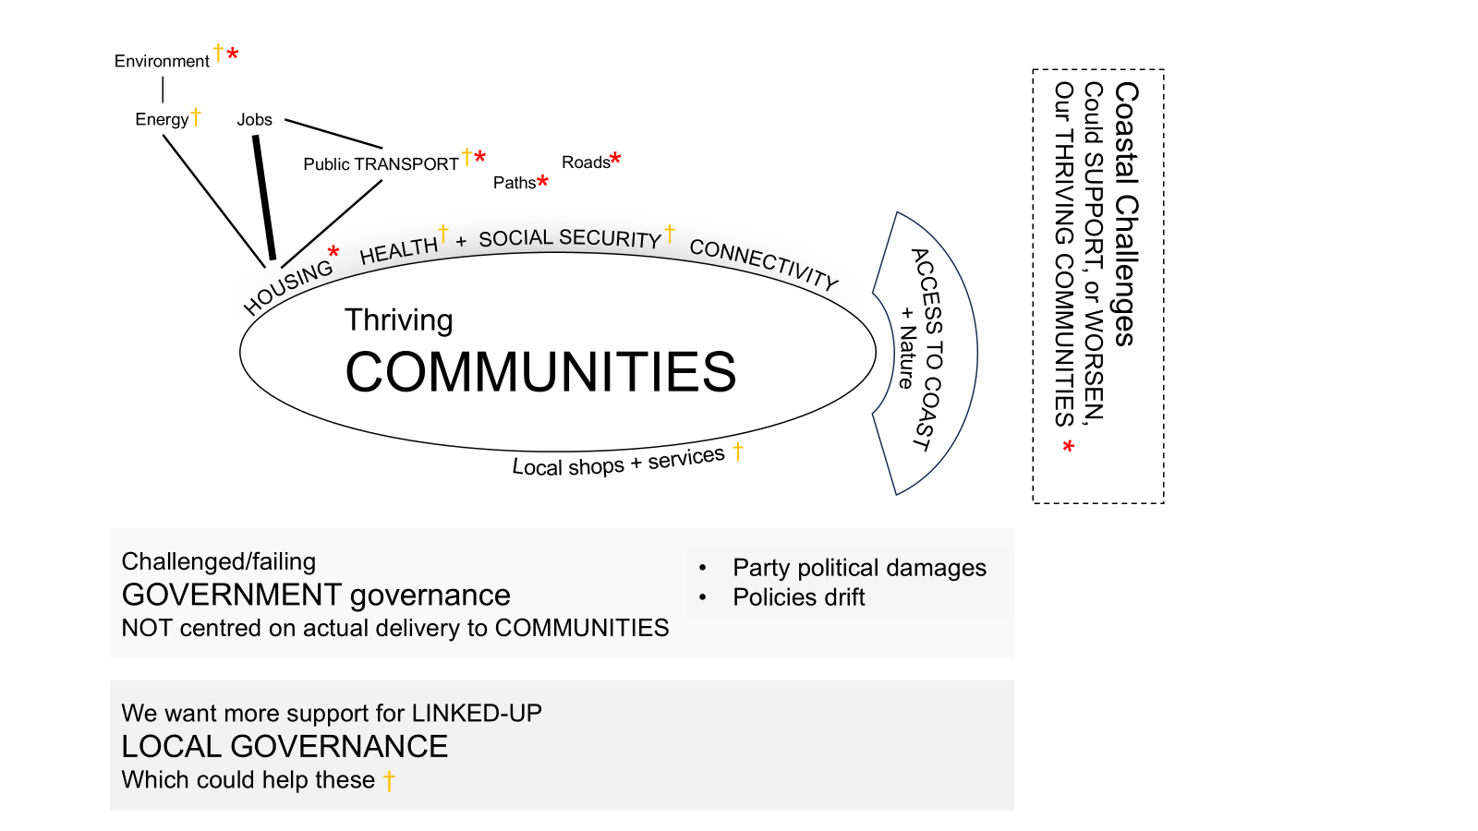

*Figure 1. A schematic representation of the relationship of the major themes found in answer to a query about, “What infrastructures do you think need more investment?”*

*“… issues of maintaining the shops and the post office and the infrastructure and all that sort of thing…” Group #1*

* *“I think everything is expected to be online now and not certainly not the elderly; a lot of people.” Group #7*

One group emphasised the need for an infrastructure of off-road **Paths** for effective walking and cycling, especially within villages:

* *“…you hear people, “i've got to get in the car to take my children even to the village school” ” Group #3*
* *[green corridors, within a village] …”That's certainly part of the puzzle to do with accessibility and transport. It's giving someone that option…” Group #3*
* *“You also need safe cycling. So it's the cycleway, cycle routes, but it's actually then about limiting cars; the way car drivers use their cars. There's infrastructure having a dedicated path that there's a huge network of lanes.” Group #3*

**Public Transport** infrastructure and **Roads** were mentioned, mostly with respect to this central theme of **Community** life:

* *“You are a mile and a half from a town centre, but you have no access to that town centre. ” Group #6*
* *“…we couldn't go into Holt, which is 3 miles away for an evening, because the last bus was 6:30. ” Group #8*
* *“As I say, you have to go for 5 minutes regular therapy: yeah, it's 3-4 hours of your day gone [if you try to use Public Transport]. ” Group #8*
* *“In the village I live in, we've got a [big road] going through us, and that's where people walk, but there's no room for footpath. There's no way to get round it.” Group #5*
* *“Norfolk Council have been pushing, they're talking about… encouraging people to cycle and walk, which is great. There's no issue, but: there's nowhere to do it. ” Group #5*

**Health and social care** infrastructures were mentioned in rather disparaging tones of resignation, including judgements on need for better management/governance of them:

* *“I think [more] health and social care, and mental health… mental health IS JUST AJOKE; terrible. There is no access to mental health care.” Group #8*
* *“I think there's a huge need for more social prescribing, community connectors.” Group #6*
* *“…for example, with a terrible shortage of dentists around there.” Group #8*
* *I think there is a general short of GPs. And not necessarily just here, but it's countrywide.” Group #6*
* *“…services need to be more connected strategically to prevent gaps and repetitions.” Group #6*
* “*No use to try to change systems like health or environment: no-one listened to the Dimbleby Report!” Group #4*

The next infrastructure area of greatest concern to the participants seemed to be **Housing.** The problem was portrayed as severe, and predominantly one of Housing infrastructure management:

* *“We've got huge, huge housing crisis, here: huge. I would consider us to have tipped the balance now on second homes in that we don't have enough people to work in hospitality. We have pubs that are shut 2 days a week because they can't get enough staff. We have pubs that are running microwave meals, because they can't get chefs.” Group #6*
* *“We've got 30 % in [our town] second homes or holiday rents.” Group #6*
* *“…the local infrastructure somewhere like here… It's sort of, ‘retirement people infrastructure’. It is not homes for local people and young people. There is that struggle. It's just nothing.” Group #2*
* *“More than 50% of the share of houses are empty in some places. I think there are issues to do the infrastructure, that, because it doesn't help if youngsters can't afford…” Group #8*

Lesser needs were referred to in discussions about **Jobs** and **Energy**. For **Jobs** the emphasis was that many more were needed for local people and with high enough wages to pay the impossible housing costs driven by tourism and second homes. For **Energy** the emphasis was on local energy infrastructures for more renewable energy and diversity of supply for security, and home insulation, overlapping with environmental concerns.

**2.2 Government and Local Governance**

A major perceived need for infrastructure improvements was Government and Local Governance. Current and longstanding issues with Government infrastructure were clearly articulated, with very little indication of hopes for upcoming changes. These included damaging Party Politics, Accountability, and a single group’s mention of representative democracy, de-growth economy, and environmental governance concerns.

Participants were clear and articulate about the damage done by the intrinsic nature of

**Government** **Party Politics**:

* *“…we've got a lot of what I call puppet MPs, regardless of what party really they'll follow. “ Group #6*
* *“…future generations - that any big infrastructure project or political decision has to have as its heart. What is the benefit the future generations? Yeah. Because you can't just live in 5 year windows because otherwise you go nowhere.“ Group #5*
* *“Everybody's really was looking at whether they're gonna get re-elected or not…“ Group #5*
* *“P1: Is [Town name] town council is supposed to be a non party-political council? P2: That's what they're supposed to be, but because then it happens covertly… That really gets me, because that means that nothing ever gets done properly, because they're all fighting their own fights.“ Group #6*
* *“…our district council is still emerging from a very, very bad time of disagreement and resignations …. And this has been going off years with infighting, pettiness, and absurd stuff….” [Moves on to a related topic: says that staff should be externally appraised so that excellent officers are acknowledged and stay on.] Group #5*
* *“…accountability of the people who…counsellors [accountable] to each other and [accountable] to the community. Really. But that's where we struggle because there's not a framework nationally to support that.” Group #4*

There were lesser comments about **Degrowth** and **Representative Demography:**

* *“I feel the most major infrastructure change - but it's dream land - is to have a totally different organization in society. Like a more equal distribution of wealth, a more equal distribution of power, a completely different ethos that isn't about producing and buying and consuming.” Group #4*
* *“…we're not a representative democracy. So we're looking at electoral change, all sorts, of um, big issues [would be involved]…” Group #4*
* *“Well, an economy that isn't based on growth, so de-growth economy…” Group #4*

There was a common intrinsic attitude across the groups that local resources could and were being used to plug many gaps in Community life that government-based infrastructures were not covering. In the context of the research topic of this study, “*What infrastructures do you think need more investment by the government*”, the respondents found it straightforward to point out multiple aspects of local governance which, if invested in, could make significant changes to their central desire – Community life. The themes they raised are loosely presented below in terms of the coordination/**Local Governance Platform** they thought was vital; resources; and implementation aspects:

* *It's about connectivity, and it's about enabling localism to really work #6*
* *…that a community, in a neighbourhood plan that they write, can be much more dynamic in that, than [the council] could ever be…”Group #3*
* *it's really important at this local level that we have a strong strategic view of what we need as a community. And someone has to have responsibility for that. #6*
* *P1: Because this country it depends on volunteer volunteers and charities, without those two…P2: Basically some huge amount of social work, societal work is done by volunteers. Yeah. P3: We have food banks, now and… all kinds of different banks and a volunteer bank? P4:Yes. ”Group #5*
* *What it needs is a sort of an integrated approach at the moment. I think something a big district council like North Norfolk, mhm… will listen to all of us sort of flying our particular kites and jumping on our particular hobby horses yeah, but I'm not sure that they have yet, a sort of grasp the need to sort of try and integrate these barriers…And there's no way to end to do it. Yeah. Like we haven't got the funding for it… But integration is a very good thing. #5*
* *P1: And then we've got very good things being done by the likes of us [A LOCAL INTEREST GROUP]. It must be other lots of other groups not doing that, so… Yes. P2: Yeah. Some individual parishes are doing something, doing things: everybody's doing something…P3: There's a number of these sort of quasi-environmental groups that is active in around the area. And maybe there ought to be some sort of attempt to draw the lots together..” Group #5*
* *And we could have someone who could coordinate that [businesses trying to developing the town centre] and take the pressure of largely sole traders who, if they do anything, it's going to be detrimental to their business in terms of their time. But if we could have a coordinated approach to [developing] the town and making it successful for both residents and visitors, not just holiday events mhm, I think that would be really beneficial. #6*
* *“…communities being better able to help one another help themselves… So training, enabling guidance and actually providing the facilities and the means for communities to do it. … it most villages have got a reasonably serviceable hall, so maybe that becomes the village Hub, maybe the church is the village Hub…So maybe you've got a church that you could use or other community building sports facilities, whatever. ”Group #3*
* *Local infrastructure: that the neighbourhood plans could focus on making contributions to it. Because if you got Norfolk, you've got so many infrastructure needs …And so if there is a way to involve communities to get stronger and also contribute at the same time to their own say settlement infrastructures, they would even be win-win. ”Group #3*
* *I think there should be citizens assembly, and I think that should definitely be biased towards young.” Group #5*
* *P1…the planners still have the power. P2: That's very, very frustrating for individuals and parish councils and locals and small groups that they feel they don't actually really have that much of a voice which comes back to the gap that was talking about. P3: it needs to be a two way. It needs to be two way interface. So it's not just top down, it's not just bottom up: it actually is they're talking to [councils], [councils are] talking to them.” Group #5*

**2.3 Infrastructure needs from Coastal Defences**

Generally, participants expected limited further sea **Defences** and more adaptation (although they still expected coastal **Access**). There were several comments about the stress and mental health needs from this:

* *“So some of it is around sea defences as infrastructure in some locations. Some of it is around access and flexibility and be able to change access. And access to the beach for access along the coast, cliff top um things.” Group #2*
* *“…they really are now having to accept that it's not, okay, it's not viable to be protecting that coastline…. So the emphasis is going to be on about adaptation and relocation.” Group #6*
* *“Health and well being on the coast, particularly around erosion isn't well understood. … the anxiety of it: people suffer.” Group #2*
* *“What's coming out loud and clear to me is the need for counseling or access to counseling might actually be at such a level that is beyond your local GP’s remit. It .. there might be a natural, bigger need in Norfolk and so on, or learning how to accept the fact you're going to have new neighbors.” Group #3*

On **Access:** *“Actually access to beaches is something which could be looked at and maintaining and continuing access to the beach, whether you got defences or not.” Group #*

* *there was those wheelchairs and that we know north. [REFERRING TO SOMETHING SEEN ON TV OR HEARD ABOUT ELSEWEHRE] made a load of beach or port, a lot of beach wheelchairs that allowed to save people to go right away into the sea. So they could even swim and say and that is saying disabled people are people and that comes down to the ‘people first’.” Group #2*
* *“Like the coast is a really intrinsically important: being on the [?] sea is really important for people who come here, who live here: …to get to the cliff or the beach or whatever. So actually, that’s physical from an infrastructural point of view:* ***…*** *access to the coast and on the coast and literally to the beaches.” Group #1*

The coastal challenges were thus mostly viewed in terms of their threats and opportunities to **thriving** **Communities:**

* *“… in the future we’ll have dead end villages… So, is there infrastructure needed to keep that connectivity for thriving places? What do we need to thrive from infrastructure?” Group #2*
* *“… I think its connectivity to highways, I think is a really hard one to crack.” Group #2*
* *“P1:…it costs a lot to do rollback and it costs a lot to do something with green land. In a way we've left it too late. P2: Yes, definitely. Talking about fragmentation of groups.” Group #5*
* *“…managing the coast as a kind of way of enabling people, people and nature to be viable and live HAPPILY.” Group #1*
* *“But then how are they sustainable community and vibrant and living communities？Or do they just become things where people move away [FROM THE EDGE] knowing that it's gonna be rolled back [INLAND, LATER].” Group #1*

Similarly, the inherent threats and opportunities for **Environment, Housing**, were mentioned:

* *“The other thing that is, I think quite important is when new physical infrastructure is put in place so that doesn't further fragment the environment. Because if fragmented environment… we need to really be increasing connectivity, not decreasing it, and nearly all development will in almost inevitably make it [ENVIRONMENT] worse, although they're talking about 10 % net biodiversity gain. I don't know you can achieve that. … you chop down a load of ancient trees …. 10 % more saplings… it doesn't work.” Group #5*
* *“I think the idea for me, having somewhere to live, it wouldn't have to be bricks and mortar. It could be like, like one of those chalets. And those chalets cost a fraction of the cost of a house… hook them up, and then movable, which is obviously the preference on the cliff.” Group #2*

1. **Cultural themes found for North Norfolk**

Eight groups in the Sheringham-Cromer area of North Norfolk underwent the WeValue InSitu process to crystallise their group shared values, and they produced concise explicit statements of those and placed them in a Framework, with a Narrative.

The following shared values were found across those groups, thus providing a rough estimate of the local cultural shared values (although data from more groups is needed until saturation of concepts is found, before they can be representative):

* Community interactions
* Local activities
* Some diversity of life experiences
* Togetherness and interactions and consulting together
* Personal growth and acknowledgment
* Experiencing the skies, beaches, Nature
* Embedded diversity and equality
* Balanced, flexible and encouraging work environments
* Kindness and empathy and respect
* The chance to serve others and to nurture

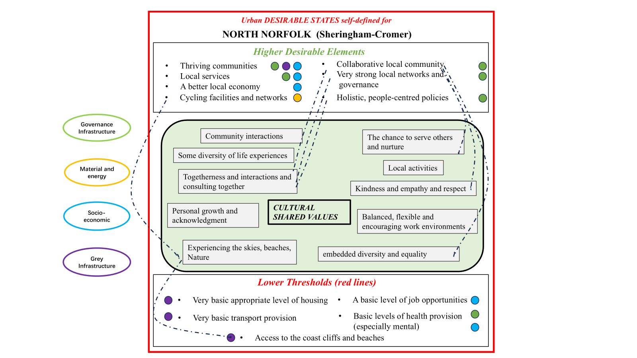

*Figure 2. A schematic indication of different resilience sub-systems within North Norfolk’s urban system, and their relation to the Desirable States topics.*

Previous research has shown that these kind of shared values across groups can be used to indicate what the ‘Desirable States’ of the area are to those people. In other words, by clarifying that these shared values are key to them, the people have provided criteria by which there settlements can be rated. In Figure 2 we show these in the centre box.

The comments from the focus group discussions – which are in the context of a specific topic, i.e. infrastructures needed investment – provide indications of ‘red line’ lower thresholds’ which indicate scenarios that would make people more inclined to leave the area, and ‘higher desirable elements’ which might attract them to come/stay. These are shown in Figure 2. What is noticeable is that, the perspectives on infrastructure weaknesses is very relatable to the shared values of the people.

In terms of infrastructure types, it is noteworthy that socio-economic and ‘grey’ infrastructures (such as jobs and housing, and transport) are key to lower thresholds, whereas governance infrastructure is key to higher desirable elements.

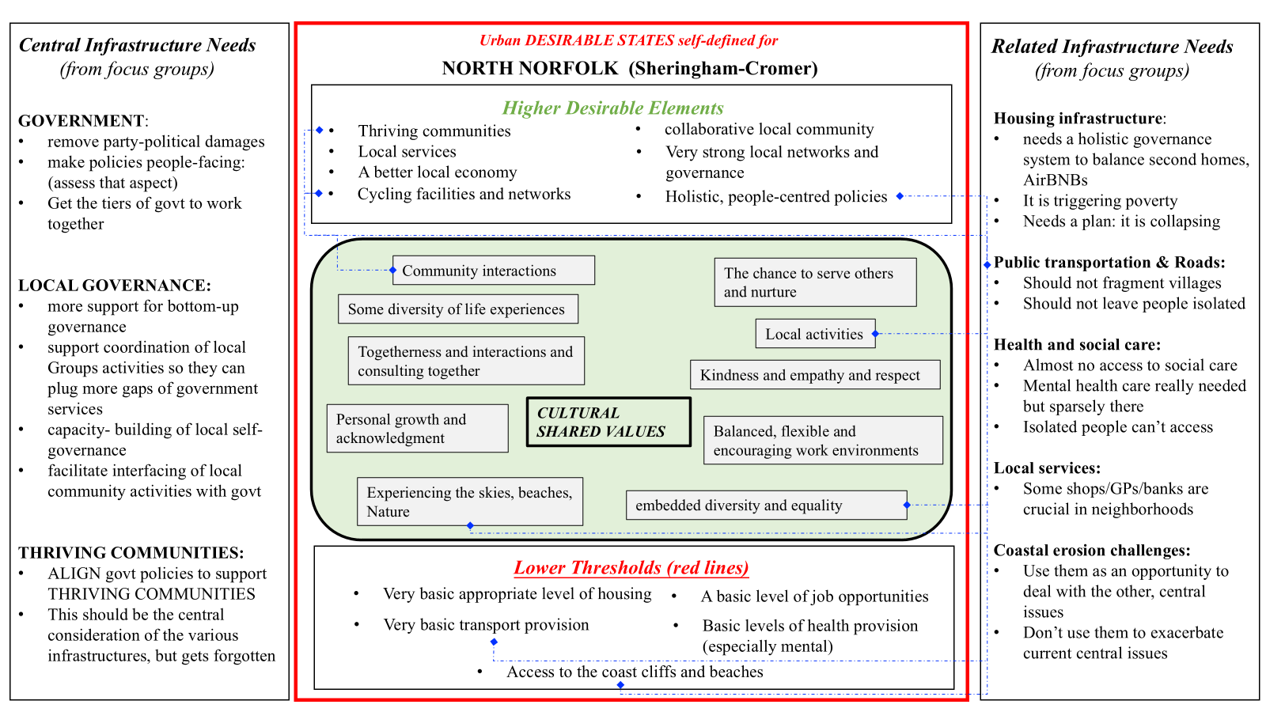

*Figure 3. The perceived infrastructure concerns (‘Central concerns’ in the left box, ‘Related concerns’ in the right box). They can be examined with respect to the self-defined DESIRABLE STATES of the settlements in the central box, which are constructed from the Cultural Shared Values elicited. The dotted lines show an example of the links between them: in this case relating to Public transportation & Roads.*

**Appendix 1. Related information**

1. **Groups recruited** in June/July 2022 for the work described here (the methodology requires groups which have common interests):

* environmental interest group
* District Council officers
* Coastal planning interest group
* Coastal management interest group
* Church group
* Common community interest and support groups
* Elderly group
* Town Council members

|  |  |  |  |  |  |  |  |  |
| --- | --- | --- | --- | --- | --- | --- | --- | --- |
| MALE | FEMALE | 18-24 | 25-34 | 35-44 | 45-54 | 55-64 | 65+ | **TOTAL** |
| 13 | 13 | 2 | 0 | 5 | 7 | 8 | 4 | **26** |

1. **Area of data collection:** Sheringham to Cromer and inland around 5 miles
2. **Emerged Themes and subthemes from the focus group discussions** on the topic of “Your perceptions of infrastructure needs, locally. Where infrastructure can be any area of life too complex to be planned locally, including grey (roads, transport); socio-economic; resources and energy, and governance”.

**Community**

general

roads

paths

**Local Governance**

environment

links

platform

implementation

resources

**Government**

party politics

tiers

representative democracy

de-growth

environment

**Connectivity**

isolation

internet

**Local Services**

general

bank(post office)

**Health + social care**

more

more mental

governance

**Housing**

affordable

management

**Jobs**

more

housing

**Energy**

diversification

house energy

renewable

**Environment**

local governance

costal

**Public Transportation**

general

green

health

**ACCESS TO COAST**

**Coastal Challenges**

defend/not

connectivity